PRE-ALGEBRA (7TH) · UNIT 8: LINEAR FUNCTIONS AND GRAPHING  Bike Share Showdown  Graph linear functions to choose the best bike or scooter rental. | CP2  2–3 class periods

Name: ________________________________ Date: ______________ Period: ______
The Scenario
Your city just launched three ways to get around downtown: a bike share, an electric scooter company, and a monthly pass. Each has a different starting fee and price per minute.
You will graph each option as a linear function, compare them, and write a guide that helps riders choose.
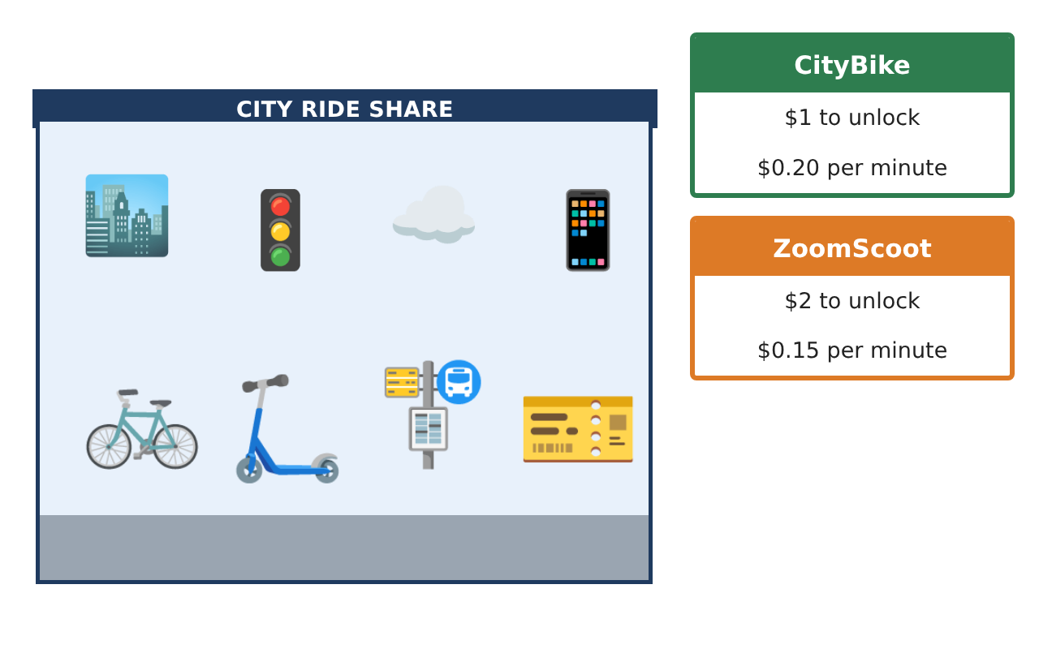
Learning Goals
- I can make a table and graph for a linear function.
- I can find the slope and y-intercept.
- I can compare two functions on a graph.
Project Timeline
When | What you will do
Day 1 | Tables & Functions
Day 2 | Slope & Intercept
Day 3 | Compare
Final | Rental Comparison Guide + reflection
Part 1: Tables & Functions
Day 1 · CityBike: $1 to unlock and $0.20 per minute.
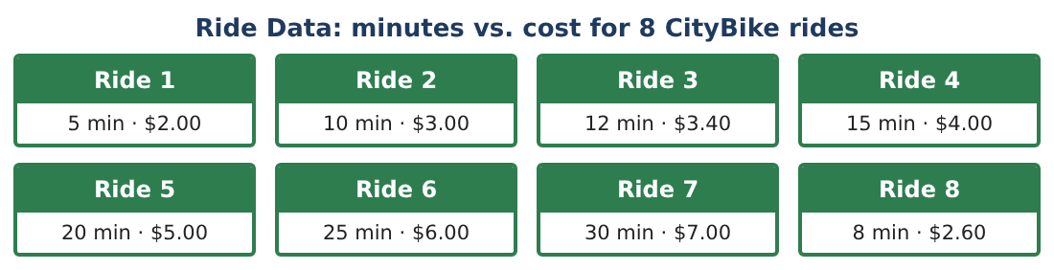
1. Complete a table of cost for 0, 5, 10, 15, and 20 minutes.
Starter: cost = 1 + 0.20 × minutes

2. Write a rule for the cost y after x minutes.

3. Is cost a function of minutes? Explain.

4. Graph the CityBike rule.

Part 2: Slope & Intercept
Day 2 · Use the rules.
5. What is the slope of the CityBike line? What does it mean?

6. What is the y-intercept? What does it mean?

7. ZoomScoot costs $2 to unlock and $0.15 per minute. Write its rule.

8. Find the slope between (10, 3.50) and (20, 5) for ZoomScoot.

Part 3: Compare
Day 3 · Graph both rules on the same axes.
9. Which is cheaper for a 10-minute ride? For a 30-minute ride?

10. At how many minutes do they cost the same? Use your graph or a table.

11. Write two sentences for your guide telling riders which to choose.

Final Product: Rental Comparison Guide
Your final product must include:
- Tables and rules for both companies
- Both lines graphed on one set of axes
- Slope and y-intercept meanings
- The break-even point
- Rider guide
Reflection
R1. What does a steeper line mean in this situation?

R2. Why do the two lines cross?

Scoring Rubric
Criteria | 4 – Exceeds | 3 – Meets | 2 – Approaching | 1 – Beginning
Mathematical Accuracy | All calculations and solutions are correct; answers include units and are checked. | Nearly all work is correct; minor errors do not change conclusions. | Several errors; some conclusions are affected. | Many errors or missing work.
Reasoning & Justification | Clear, complete explanations connect every answer to the situation; uses precise vocabulary. | Explanations are mostly clear and connected to the situation. | Explanations are brief or partly unclear. | Little or no explanation.
Application & Design | Linear functions, slopes, intercepts, systems, and inequalities are modeled and used correctly to compare options. Goes beyond the minimum with a creative, realistic choice. | Linear functions, slopes, intercepts, systems, and inequalities are modeled and used correctly to compare options. | Design is incomplete or only partly uses the math from the unit. | Design is missing or unrelated to the unit math.
Communication & Presentation | Rider Guide includes graphs, rules, intersection points, and a clear decision chart. Polished, organized, and visually engaging. | Rider Guide includes graphs, rules, intersection points, and a clear decision chart. Organized and easy to follow. | Product is missing required parts or is hard to follow. | Product is mostly missing.

