PRE-ALGEBRA (7TH) · UNIT 8: LINEAR FUNCTIONS AND GRAPHING  Bike Share Showdown  Graph linear functions to choose the best bike or scooter rental. | Honors  2–3 class periods

Name: ________________________________ Date: ______________ Period: ______
The Scenario
Your city just launched three ways to get around downtown: a bike share, an electric scooter company, and a monthly pass. Each has a different starting fee and price per minute.
You will graph each option as a linear function, compare them, and write a guide that helps riders choose.
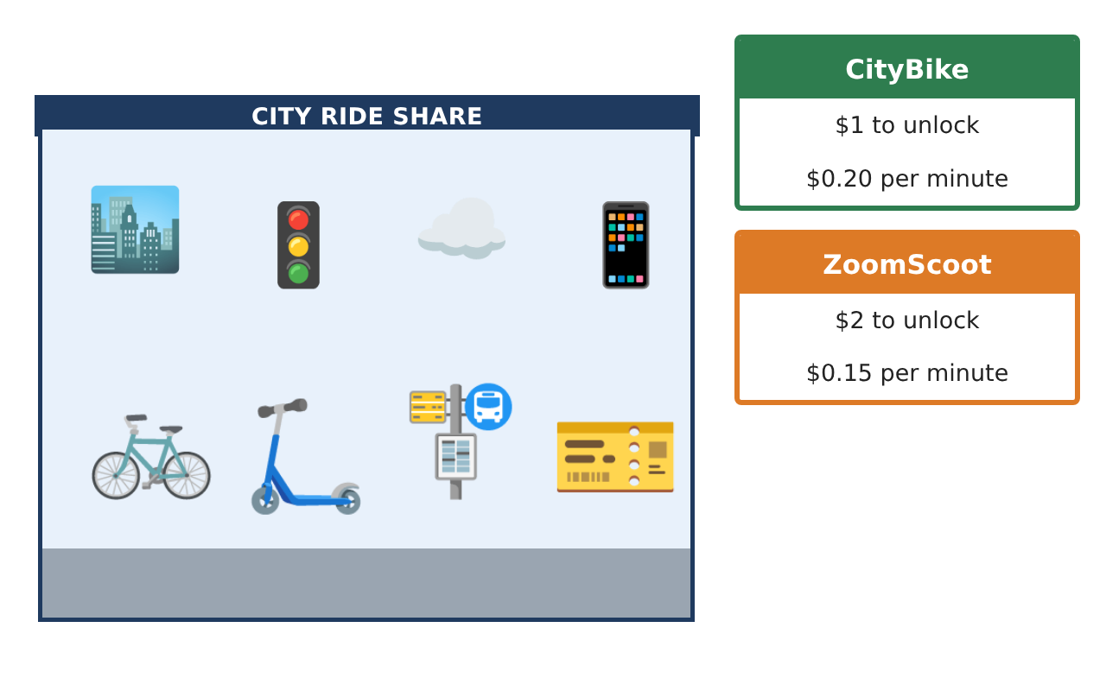
Learning Goals
- I can model situations with linear functions and interpret parameters.
- I can analyze data with a trend line and residuals.
- I can solve systems and graph inequalities to make decisions.
Project Timeline
When | What you will do
Day 1 | Model Building
Day 2 | Systems
Day 3 | Budget Region
Final | Rental Comparison Guide + reflection
Part 1: Model Building
Day 1 · Use the Ride Data card.
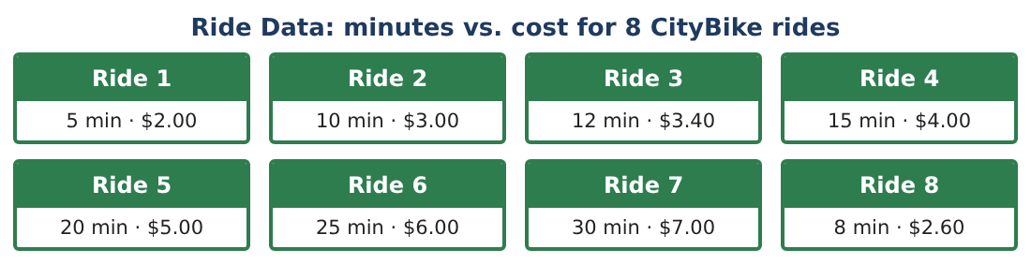
1. Check every ride against CityBike’s rule (y = 0.20x + 1). Do any rides not fit? What does the scatter plot look like?

2. Find the slope between rides 1 and 7 and write the rule in slope-intercept form.

3. CityBike adds a surge price: after 20 minutes, the rate becomes $0.30 per minute. Write a rule for rides longer than 20 minutes.

4. Is the surge-priced cost still a function? Is it still linear? Explain.

Part 2: Systems
Day 2 · ZoomScoot: y = 0.15x + 2. CityBike with surge: as above.
5. Find all ride lengths where CityBike (with surge) is cheaper than ZoomScoot.

6. A new company, GoLime, charges $0 to unlock and $0.25 per minute. Find where GoLime equals CityBike and where it equals ZoomScoot.

7. Explain what it means that all three lines pass through (20, 5).

8. Rank the three companies for a 6-minute and a 40-minute ride.

Part 3: Budget Region
Day 3 · Weekly budget $15. Short rides (10 min) on GoLime cost $2.50; long rides (30 min) on ZoomScoot cost $6.50.
9. Write an inequality for s short rides and l long rides within the budget and graph it.
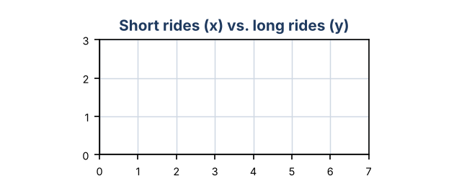

10. List every whole-number combination (s, l) in the region with l ≥ 1.

11. Write the Rider Guide with a decision chart for short, medium, and long rides, citing the systems you solved.

Final Product: Rental Comparison Guide
Your final product must include:
- Model of the ride data and surge pricing
- Systems of three companies solved and interpreted
- Rankings for different ride lengths
- Budget inequality region with combinations
- Rider Guide with a decision chart
Reflection
R1. Why might a company change its rate after 20 minutes?

R2. How does the graph of a two-variable inequality show all possible plans?

Scoring Rubric
Criteria | 4 – Exceeds | 3 – Meets | 2 – Approaching | 1 – Beginning
Mathematical Accuracy | All calculations and solutions are correct; answers include units and are checked. | Nearly all work is correct; minor errors do not change conclusions. | Several errors; some conclusions are affected. | Many errors or missing work.
Reasoning & Justification | Clear, complete explanations connect every answer to the situation; uses precise vocabulary. | Explanations are mostly clear and connected to the situation. | Explanations are brief or partly unclear. | Little or no explanation.
Application & Design | Linear functions, slopes, intercepts, systems, and inequalities are modeled and used correctly to compare options. Goes beyond the minimum with a creative, realistic choice. | Linear functions, slopes, intercepts, systems, and inequalities are modeled and used correctly to compare options. | Design is incomplete or only partly uses the math from the unit. | Design is missing or unrelated to the unit math.
Communication & Presentation | Rider Guide includes graphs, rules, intersection points, and a clear decision chart. Polished, organized, and visually engaging. | Rider Guide includes graphs, rules, intersection points, and a clear decision chart. Organized and easy to follow. | Product is missing required parts or is hard to follow. | Product is mostly missing.

