PRE-ALGEBRA (7TH) · UNIT 5: OPERATIONS WITH FRACTIONS  Birdhouse Builders  Measure, cut, and assemble birdhouses using fraction and mixed-number operations. | CP1  2–3 class periods

Name: ________________________________ Date: ______________ Period: ______
The Scenario
The science club is putting birdhouses around the school garden. Each birdhouse is cut from wooden boards measured in feet and inches, and the measurements use fractions of an inch.
You will use fraction operations to plan every cut, avoid wasting wood, and design your own birdhouse.
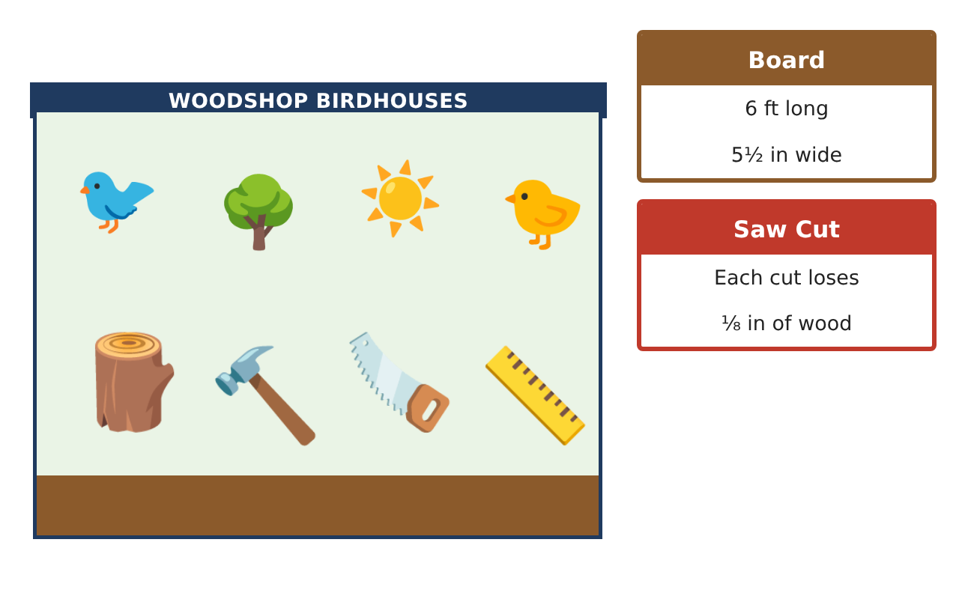
Learning Goals
- I can add, subtract, multiply, and divide mixed numbers in context.
- I can convert customary units.
- I can write and solve equations with fractions.
Project Timeline
When | What you will do
Day 1 | Cut Planning
Day 2 | Many Birdhouses
Day 3 | Equations & Design
Final | Birdhouse Build Plan + reflection
Part 1: Cut Planning
Day 1 · Each saw cut removes $\frac{1}{8}$ in. A board is 6 ft long.
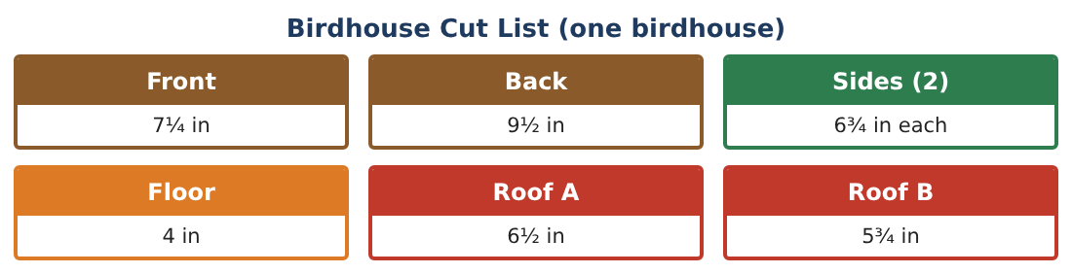
1. Find the total length of the seven pieces.

2. Cutting seven pieces from one board makes 7 cuts. Find the total wood used including saw cuts.

3. How much of the 6 ft board is left? Is it enough for a second front and back?

4. What fraction of the board is wasted as sawdust for one birdhouse?

Part 2: Many Birdhouses
Day 2 · The club wants 12 birdhouses.
5. How many inches of wood (with saw cuts) are needed for 12 birdhouses? How many feet?

6. If each 6-ft board is used for one birdhouse, how many boards are needed, and how much wood is left over in all?

7. Each birdhouse needs $\frac{3}{4}$ oz of glue. A bottle holds 4 oz. How many bottles?

8. Each roof is 6$\frac{1}{2}$ in by 5$\frac{1}{2}$ in. What is the area of one roof piece?

Part 3: Equations & Design
Day 3 · Write and solve an equation for each.
9. A back piece plus a perch of length p is 11$\frac{1}{4}$ in total. Find p.

10. $\frac{2}{3}$ of a board is 48 in. How long is the board?

11. Design a bigger birdhouse by multiplying every length by 1$\frac{1}{2}$. Find the new back and side lengths and the total wood.

Final Product: Birdhouse Build Plan
Your final product must include:
- Cut list with saw cuts
- Board count and leftovers
- Glue and area calculations
- Fraction equations solved
- A scaled birdhouse design
Reflection
R1. Why does multiplying by 1$\frac{1}{2}$ make every piece longer but multiplying by $\frac{2}{3}$ make it shorter?

R2. How did the $\frac{1}{8}$-inch saw cuts change your plan?

Scoring Rubric
Criteria | 4 – Exceeds | 3 – Meets | 2 – Approaching | 1 – Beginning
Mathematical Accuracy | All calculations and solutions are correct; answers include units and are checked. | Nearly all work is correct; minor errors do not change conclusions. | Several errors; some conclusions are affected. | Many errors or missing work.
Reasoning & Justification | Clear, complete explanations connect every answer to the situation; uses precise vocabulary. | Explanations are mostly clear and connected to the situation. | Explanations are brief or partly unclear. | Little or no explanation.
Application & Design | Cut plans, scaling, and equations use fraction operations correctly and produce a buildable birdhouse. Goes beyond the minimum with a creative, realistic choice. | Cut plans, scaling, and equations use fraction operations correctly and produce a buildable birdhouse. | Design is incomplete or only partly uses the math from the unit. | Design is missing or unrelated to the unit math.
Communication & Presentation | Build plan includes the drawing, cut list, board plan, and materials. Polished, organized, and visually engaging. | Build plan includes the drawing, cut list, board plan, and materials. Organized and easy to follow. | Product is missing required parts or is hard to follow. | Product is mostly missing.

