PRE-ALGEBRA (7TH) · UNIT 5: OPERATIONS WITH FRACTIONS  Birdhouse Builders  Measure, cut, and assemble birdhouses using fraction and mixed-number operations. | CP2  2–3 class periods

Name: ________________________________ Date: ______________ Period: ______
The Scenario
The science club is putting birdhouses around the school garden. Each birdhouse is cut from wooden boards measured in feet and inches, and the measurements use fractions of an inch.
You will use fraction operations to plan every cut, avoid wasting wood, and design your own birdhouse.
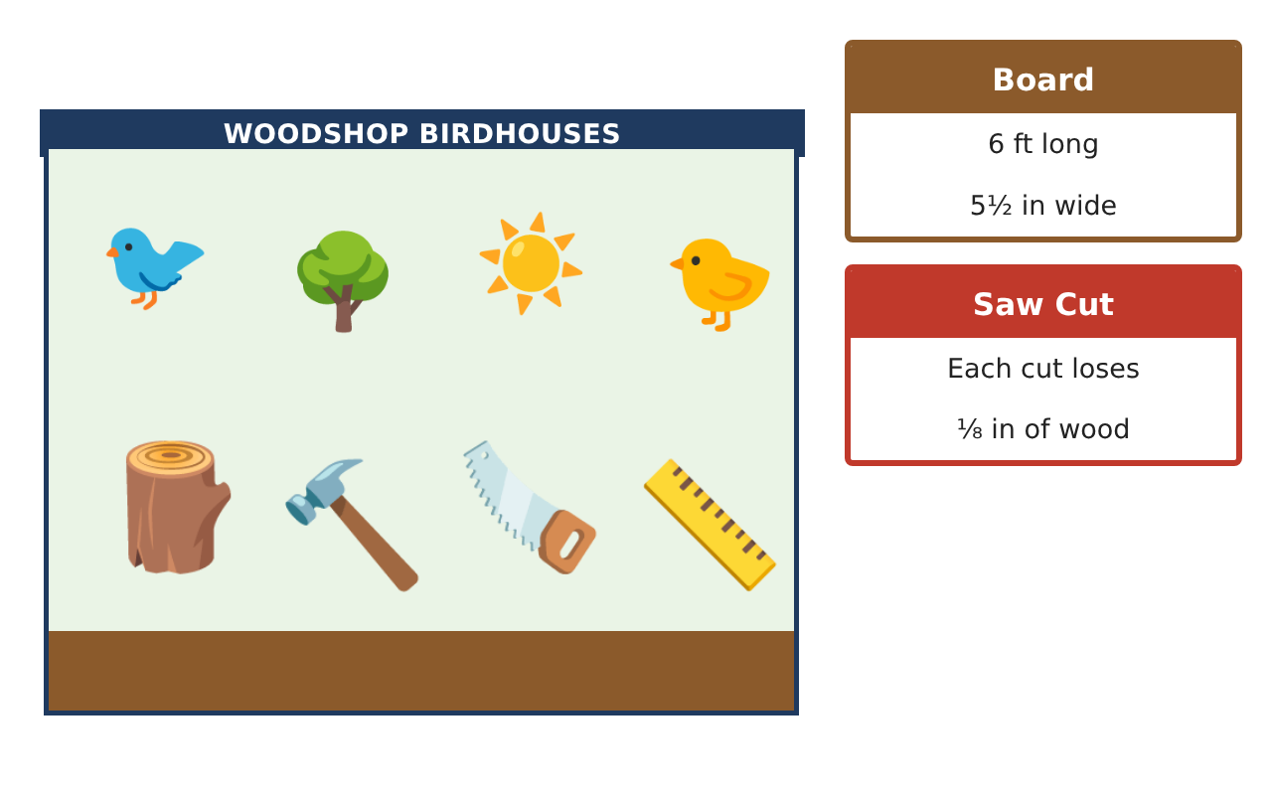
Learning Goals
- I can compare and order fractions and mixed numbers.
- I can add and subtract mixed numbers to plan cuts.
- I can multiply and divide fractions to find how many pieces fit.
Project Timeline
When | What you will do
Day 1 | Read the Measurements
Day 2 | Plan the Cuts
Day 3 | Customary Units
Final | Birdhouse Build Plan + reflection
Part 1: Read the Measurements
Day 1 · Use the Cut List.
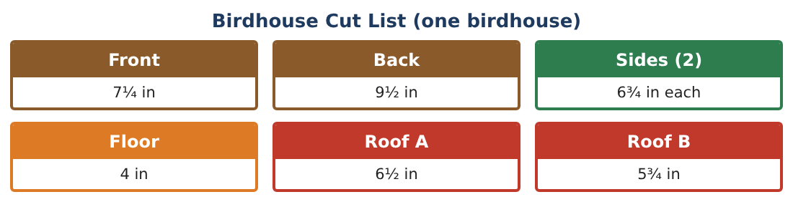
1. Order the pieces from shortest to longest.

2. Write 7$\frac{1}{4}$ and 6$\frac{3}{4}$ as decimals.

3. Which is longer, Roof A (6$\frac{1}{2}$ in) or a side (6$\frac{3}{4}$ in)? By how much?

4. Write 9$\frac{1}{2}$ as an improper fraction.

Part 2: Plan the Cuts
Day 2 · Add and subtract mixed numbers.
5. Find the total length of the front and back.
Starter: 7$\frac{1}{4}$ + 9$\frac{2}{4}$ = ___

6. Find the total length of all seven pieces (two sides).

7. A board is 72 inches long. How much is left after cutting one birdhouse (ignore the saw cuts)?

8. How many 6$\frac{3}{4}$-inch sides can you cut from 25$\frac{1}{2}$ inches?

Part 3: Customary Units
Day 3 · 12 inches = 1 foot.
9. How many feet is 46$\frac{1}{2}$ inches?

10. Paint covers 2$\frac{1}{2}$ birdhouses per can. How many cans for 10 birdhouses?

11. Draw your own birdhouse and label every piece with a fraction measurement. Find the total length of wood.

Final Product: Birdhouse Build Plan
Your final product must include:
- Your birdhouse drawing with labeled pieces
- Ordered list of pieces
- Total wood needed in inches and feet
- Leftover wood from one board
- Paint plan
Reflection
R1. How do you add mixed numbers with different denominators?

R2. Why do you round DOWN when finding how many pieces you can cut?

Scoring Rubric
Criteria | 4 – Exceeds | 3 – Meets | 2 – Approaching | 1 – Beginning
Mathematical Accuracy | All calculations and solutions are correct; answers include units and are checked. | Nearly all work is correct; minor errors do not change conclusions. | Several errors; some conclusions are affected. | Many errors or missing work.
Reasoning & Justification | Clear, complete explanations connect every answer to the situation; uses precise vocabulary. | Explanations are mostly clear and connected to the situation. | Explanations are brief or partly unclear. | Little or no explanation.
Application & Design | Cut plans, scaling, and equations use fraction operations correctly and produce a buildable birdhouse. Goes beyond the minimum with a creative, realistic choice. | Cut plans, scaling, and equations use fraction operations correctly and produce a buildable birdhouse. | Design is incomplete or only partly uses the math from the unit. | Design is missing or unrelated to the unit math.
Communication & Presentation | Build plan includes the drawing, cut list, board plan, and materials. Polished, organized, and visually engaging. | Build plan includes the drawing, cut list, board plan, and materials. Organized and easy to follow. | Product is missing required parts or is hard to follow. | Product is mostly missing.

