PRE-ALGEBRA (7TH) · UNIT 12: DATA ANALYSIS AND PROBABILITY  Board Game Inventor  Use probability, counting, and data to invent and test a fair board game. | CP1  2–3 class periods

Name: ________________________________ Date: ______________ Period: ______
The Scenario
A game company is holding a contest for the best new family board game. Your game must use dice, a spinner, and a deck of cards, and it must be fair and fun.
You will use probability and data to design the rules, test the game, and prove it is fair.
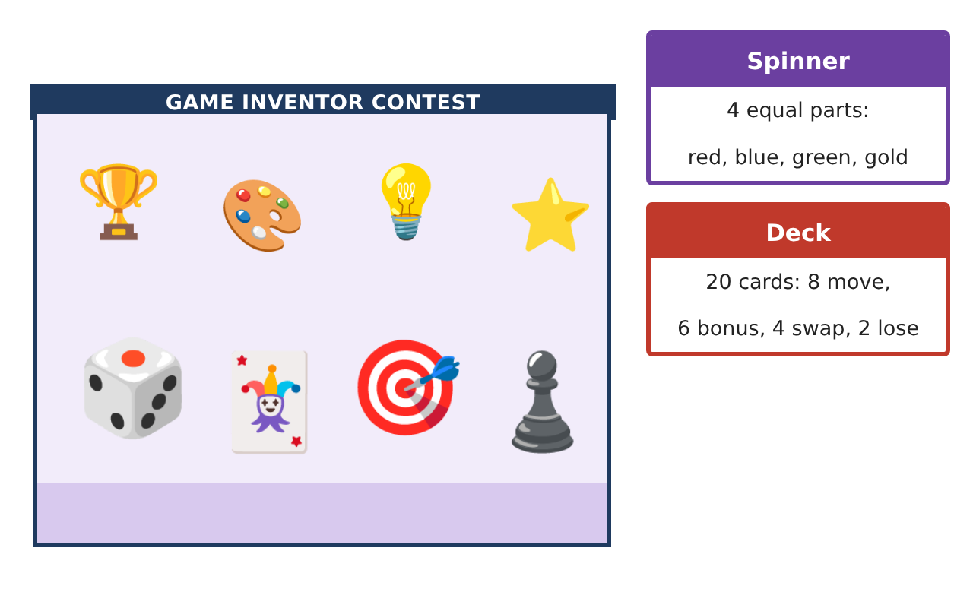
Learning Goals
- I can compute probabilities of independent and dependent events.
- I can use permutations and combinations to count.
- I can analyze playtest data with displays and statistics.
Project Timeline
When | What you will do
Day 1 | Compound Events
Day 2 | Counting
Day 3 | Test & Fix
Final | Game Box & Rule Book + reflection
Part 1: Compound Events
Day 1 · Spinner (4 equal colors), deck of 20 cards (8 move, 6 bonus, 4 swap, 2 lose), two dice.
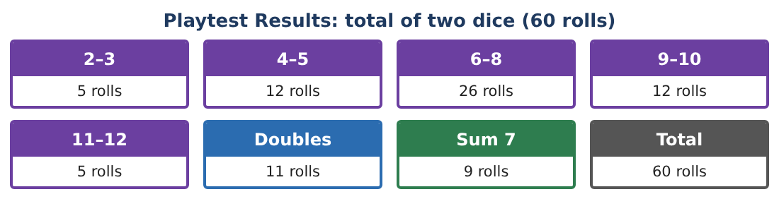
1. Find P(sum of two dice is 8 or more).

2. Find P(spin red and draw a bonus card).

3. Draw two cards without replacement. Find P(both bonus).

4. Draw two cards with replacement. Find P(both bonus). Why is it different?

Part 2: Counting
Day 2 · Players choose tokens and turn order.
5. In how many orders can 4 players take turns?

6. There are 8 tokens. In how many ways can 4 players each choose a different token (order matters)?

7. A player chooses 3 of the 8 bonus powers (order does not matter). How many choices?

8. Explain why the token question is a permutation and the powers question is a combination.

Part 3: Test & Fix
Day 3 · Use the Playtest Results card.
9. Compare the experimental probability of rolling 6–8 with the theoretical probability.

10. In the current rules, Player 1 wins on doubles and Player 2 wins on a sum of 7. Is that fair? Use theoretical probabilities.

11. Write your rule book with at least three rules, each with its probability, and explain why your game is fair.

Final Product: Game Box & Rule Book
Your final product must include:
- Probabilities of compound events
- Counting with permutations and combinations
- Playtest comparison
- Fairness analysis
- Rule book and game board
Reflection
R1. How can you tell whether two events are independent?

R2. Why are more playtests better?

Scoring Rubric
Criteria | 4 – Exceeds | 3 – Meets | 2 – Approaching | 1 – Beginning
Mathematical Accuracy | All calculations and solutions are correct; answers include units and are checked. | Nearly all work is correct; minor errors do not change conclusions. | Several errors; some conclusions are affected. | Many errors or missing work.
Reasoning & Justification | Clear, complete explanations connect every answer to the situation; uses precise vocabulary. | Explanations are mostly clear and connected to the situation. | Explanations are brief or partly unclear. | Little or no explanation.
Application & Design | Probabilities, counts, and playtest analysis are correct and used to make the game fair. Goes beyond the minimum with a creative, realistic choice. | Probabilities, counts, and playtest analysis are correct and used to make the game fair. | Design is incomplete or only partly uses the math from the unit. | Design is missing or unrelated to the unit math.
Communication & Presentation | Rule book includes probabilities, the board, playtest displays, and a fairness argument. Polished, organized, and visually engaging. | Rule book includes probabilities, the board, playtest displays, and a fairness argument. Organized and easy to follow. | Product is missing required parts or is hard to follow. | Product is mostly missing.

