PRE-ALGEBRA (7TH) · UNIT 1: ALGEBRAIC EXPRESSIONS AND INTEGERS  Deep Sea Expedition  Use integers and expressions to guide a submarine to the ocean floor and back. | CP2  2–3 class periods

Name: ________________________________ Date: ______________ Period: ______
The Scenario
Your team is piloting the research submarine Nautilus II. Sea level is 0 feet, every depth below it is negative, and the ocean gets colder as you dive.
You will use integers and expressions to plan dives, track temperature changes, and map the creatures you discover.
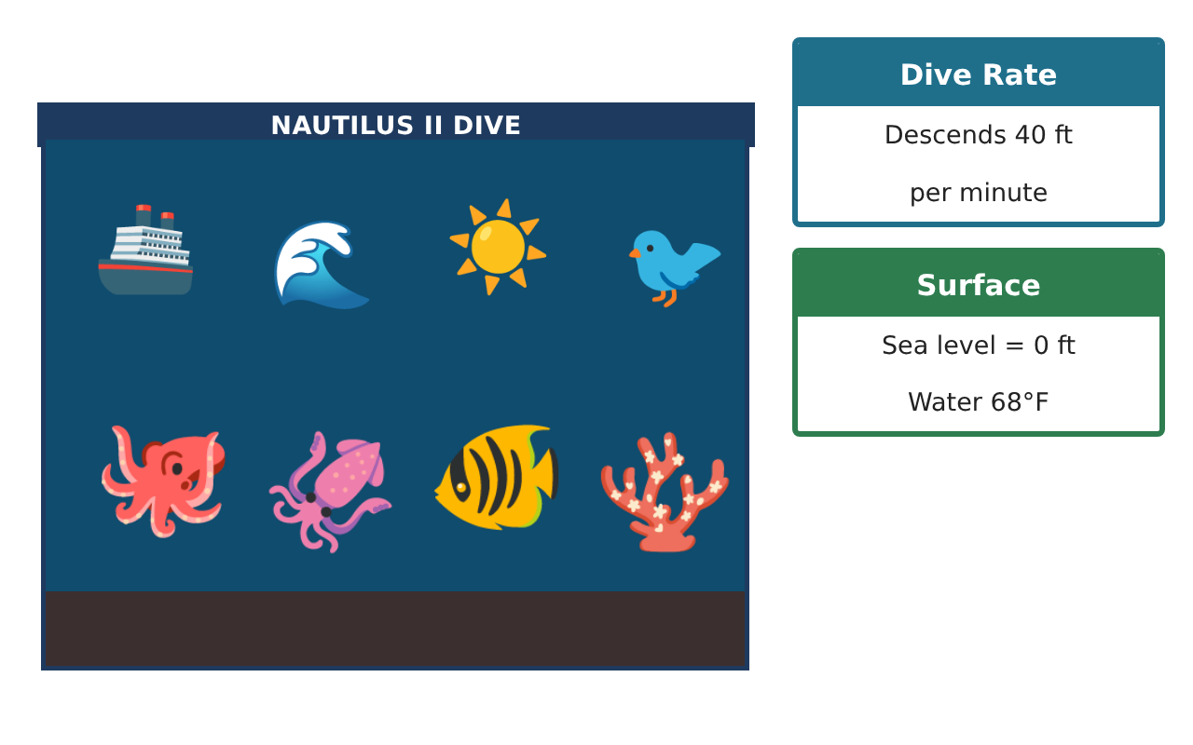
Learning Goals
- I can use integers to describe depths and changes.
- I can add, subtract, multiply, and divide integers.
- I can write and evaluate expressions for a dive.
Project Timeline
When | What you will do
Day 1 | Depths & Integers
Day 2 | Dive Expressions
Day 3 | Sonar Map
Final | Expedition Log + reflection
Part 1: Depths & Integers
Day 1 · Use the Discovery Cards.
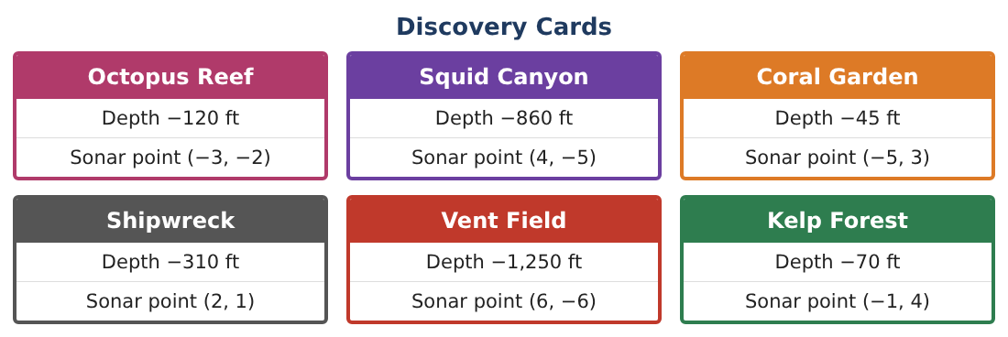
1. Order the six depths from deepest to shallowest.

2. How many feet deeper is Squid Canyon than Octopus Reef?

3. The sub goes from the Shipwreck (−310 ft) up 190 ft. What is its new depth?
Starter: −310 + 190 = ___

4. Find |−860| and explain what it means.

Part 2: Dive Expressions
Day 2 · The sub descends 40 ft per minute.
5. Write an expression for the depth after m minutes.
Starter: depth = ___ × m

6. Evaluate your expression for m = 3 and m = 8.

7. The water temperature drops 2°F for every 100 ft from 68°F. Find the temperature at −300 ft.

8. Evaluate 68 − 2 × 3 + (−4) using the order of operations.

Part 3: Sonar Map
Day 3 · Plot the Sonar points from the Discovery Cards.
9. Plot and label all six sonar points on a coordinate grid.
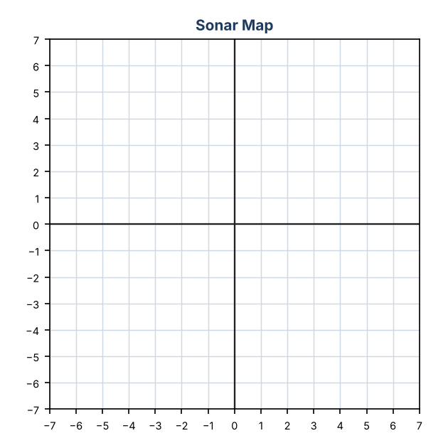

10. Which discoveries are in Quadrant IV? Quadrant II?

11. The pattern of dive depths is −40, −80, −120, … What are the next three terms? What is the rule?

Final Product: Expedition Log
Your final product must include:
- Ordered list of depths
- Your dive expression and two evaluations
- Temperature at one depth
- Sonar map with all discoveries
- Expedition log entry describing the deepest dive
Reflection
R1. Why are depths below sea level negative?

R2. How do you subtract a negative integer?

Scoring Rubric
Criteria | 4 – Exceeds | 3 – Meets | 2 – Approaching | 1 – Beginning
Mathematical Accuracy | All calculations and solutions are correct; answers include units and are checked. | Nearly all work is correct; minor errors do not change conclusions. | Several errors; some conclusions are affected. | Many errors or missing work.
Reasoning & Justification | Clear, complete explanations connect every answer to the situation; uses precise vocabulary. | Explanations are mostly clear and connected to the situation. | Explanations are brief or partly unclear. | Little or no explanation.
Application & Design | Integer calculations, expressions, and the sonar map correctly model the dive and support the route plan. Goes beyond the minimum with a creative, realistic choice. | Integer calculations, expressions, and the sonar map correctly model the dive and support the route plan. | Design is incomplete or only partly uses the math from the unit. | Design is missing or unrelated to the unit math.
Communication & Presentation | Expedition log includes depths, expressions, the sonar map, and a clear summary. Polished, organized, and visually engaging. | Expedition log includes depths, expressions, the sonar map, and a clear summary. Organized and easy to follow. | Product is missing required parts or is hard to follow. | Product is mostly missing.

