PRE-ALGEBRA (7TH) · UNIT 1: ALGEBRAIC EXPRESSIONS AND INTEGERS  Deep Sea Expedition  Use integers and expressions to guide a submarine to the ocean floor and back. | Honors  2–3 class periods

Name: ________________________________ Date: ______________ Period: ______
The Scenario
Your team is piloting the research submarine Nautilus II. Sea level is 0 feet, every depth below it is negative, and the ocean gets colder as you dive.
You will use integers and expressions to plan dives, track temperature changes, and map the creatures you discover.
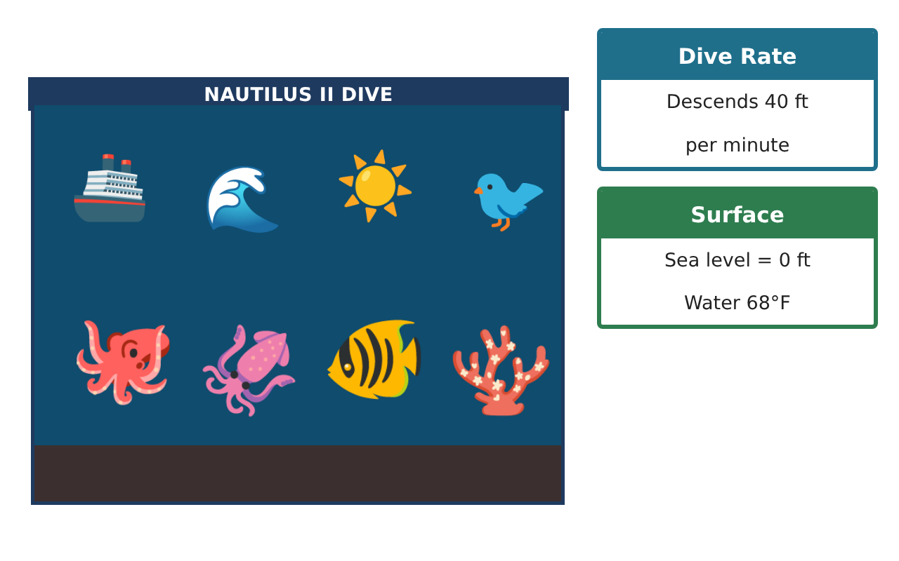
Learning Goals
- I can model multi-step situations with integer expressions.
- I can use patterns and inductive reasoning to predict.
- I can analyze a route on the coordinate plane.
Project Timeline
When | What you will do
Day 1 | Pressure & Temperature
Day 2 | Dive Patterns
Day 3 | Route Analysis
Final | Expedition Log + reflection
Part 1: Pressure & Temperature
Day 1 · Water pressure increases about 1 atmosphere every 33 ft. Surface pressure is 1 atmosphere.
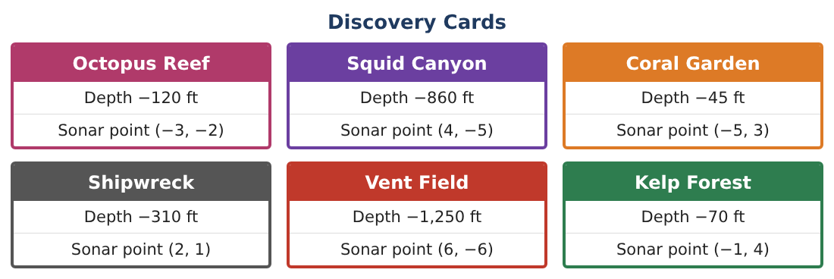
1. Write an expression for the pressure at depth −d ft (d > 0). Find the pressure at Squid Canyon to the nearest tenth.

2. Temperature falls 3°F per 100 ft from 68°F but never drops below 38°F. At what depth does it reach 38°F?

3. Find the temperature at the Vent Field (−1,250 ft) using your rule. Why might the real vent water be much hotter?

4. Evaluate $\frac{−3(−5)² + 4(−6)}{−3}$ and explain each step.

Part 2: Dive Patterns
Day 2 · Each dive goes 30 ft deeper than the one before. Dive 1 reaches −90 ft.
5. List the depths of dives 1–5 and write a rule for dive n.

6. Which dive first reaches Squid Canyon depth or deeper?

7. The crew notices the sum of depths after n dives: −90, −210, −360, … Find the sum after 5 dives, then explain how the pattern grows.

8. Is it always true that the sum of two negative integers is less than each of them? Justify.

Part 3: Route Analysis
Day 3 · Plot the sonar points. Each grid unit = 100 ft horizontally.
9. The sub travels from Coral Garden (−5, 3) to Vent Field (6, −6) moving only along grid lines. What is the shortest travel distance in feet?
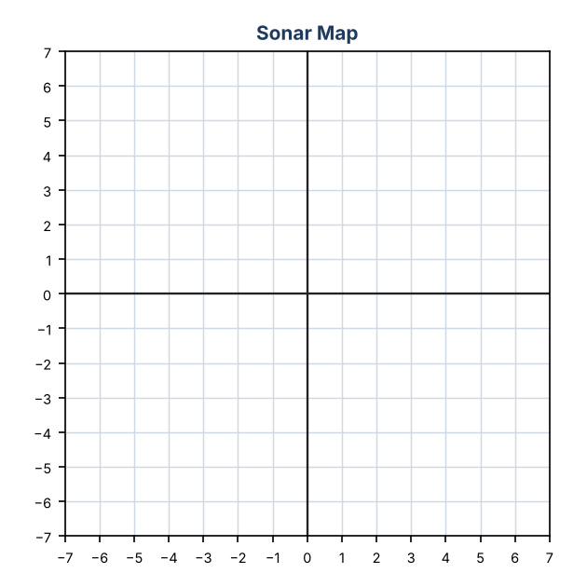

10. Reflect the Shipwreck (2, 1) across the x-axis and then the y-axis. Where does it land? Which quadrant?

11. Design a route that visits four discoveries and returns to (0, 0). Find its grid distance and its total depth change and explain how you chose the order.

Final Product: Expedition Log
Your final product must include:
- Pressure and temperature models with evaluations
- Dive pattern rule and predictions
- Grid route with distances
- Integer reasoning about sums
- Expedition log with recommendations
Reflection
R1. Explain why the temperature model needs a limit (38°F).

R2. How did inductive reasoning help you predict which dive reaches Squid Canyon?

Scoring Rubric
Criteria | 4 – Exceeds | 3 – Meets | 2 – Approaching | 1 – Beginning
Mathematical Accuracy | All calculations and solutions are correct; answers include units and are checked. | Nearly all work is correct; minor errors do not change conclusions. | Several errors; some conclusions are affected. | Many errors or missing work.
Reasoning & Justification | Clear, complete explanations connect every answer to the situation; uses precise vocabulary. | Explanations are mostly clear and connected to the situation. | Explanations are brief or partly unclear. | Little or no explanation.
Application & Design | Integer calculations, expressions, and the sonar map correctly model the dive and support the route plan. Goes beyond the minimum with a creative, realistic choice. | Integer calculations, expressions, and the sonar map correctly model the dive and support the route plan. | Design is incomplete or only partly uses the math from the unit. | Design is missing or unrelated to the unit math.
Communication & Presentation | Expedition log includes depths, expressions, the sonar map, and a clear summary. Polished, organized, and visually engaging. | Expedition log includes depths, expressions, the sonar map, and a clear summary. Organized and easy to follow. | Product is missing required parts or is hard to follow. | Product is mostly missing.

