PRECALCULUS · UNIT 4: TRIGONOMETRIC FUNCTIONS  Daylight and Seasons  Model hours of daylight and temperatures with sinusoidal functions. | CP2  2–3 class periods

Name: ________________________________ Date: ______________ Period: ______
The Scenario
The parks department wants to schedule outdoor events when there is plenty of daylight and comfortable weather. Daylight and temperature rise and fall every year in a repeating pattern.
You will use the unit circle and sinusoidal functions to model the seasons and recommend event dates.
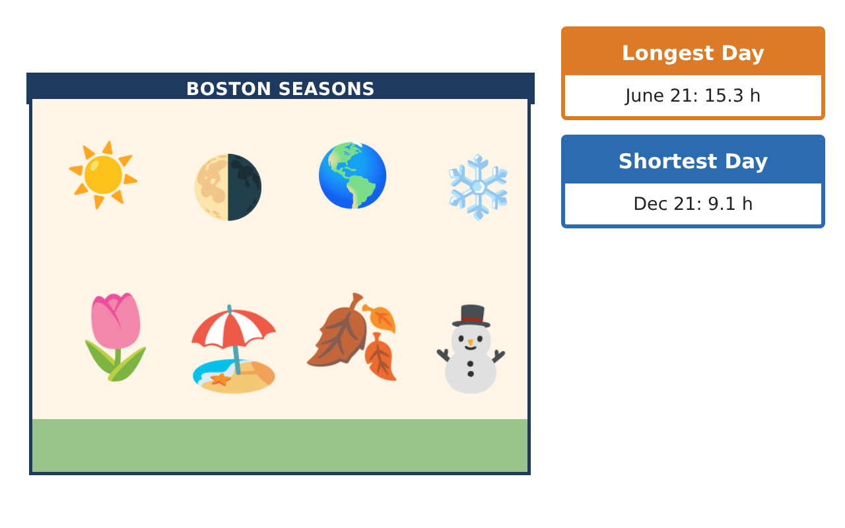
Learning Goals
- I can convert between degrees and radians and use the unit circle.
- I can find amplitude, midline, and period from data.
- I can use a sinusoidal model to make predictions.
Project Timeline
When | What you will do
Day 1 | Earth’s Orbit
Day 2 | Daylight Model
Day 3 | Plan Events
Final | Seasonal Planning Report + reflection
Part 1: Earth’s Orbit
Day 1 · Earth travels around the Sun once every 365 days.
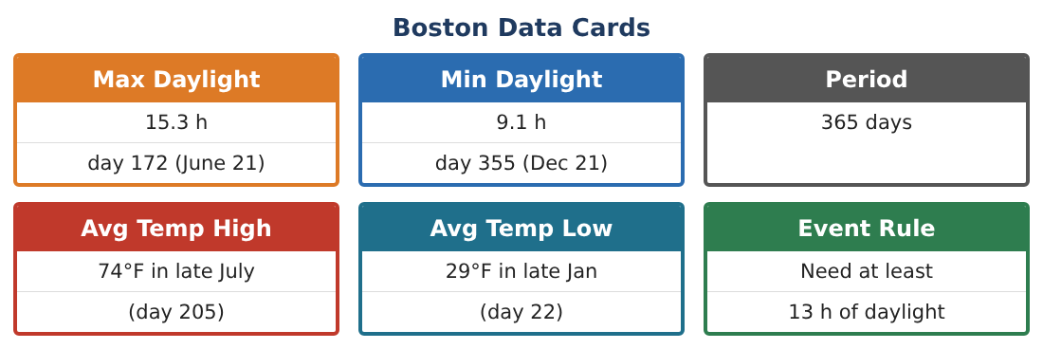
1. How many degrees does Earth travel in one day? (Round to two decimals.)

2. Convert 90° and 180° to radians.

3. Find sin $\frac{π}{6}$, cos $\frac{π}{3}$, and sin $\frac{π}{2}$ using the unit circle.

4. In which quadrant is an angle of $\frac{5π}{4}$? Give its sine and cosine signs.

Part 2: Daylight Model
Day 2 · Use the Boston Data Cards.
5. Find the midline (average of max and min daylight).
Starter: (max + min) ÷ 2

6. Find the amplitude.

7. What is the period in days?

8. A model is D(t) = 3.1 sin($\frac{2π}{365}$(t − 80)) + 12.2. Find D(80) and D(172).

Part 3: Plan Events
Day 3 · Use your model.
9. Find D(1) (January 1) and D(200) (mid-July).

10. Use a table to estimate the first day with at least 13 hours of daylight.

11. Recommend three event dates and explain using the model.

Final Product: Seasonal Planning Report
Your final product must include:
- Degree-radian conversions and unit-circle values
- Amplitude, midline, and period
- Daylight model with predictions
- Event dates
- Seasonal report
Reflection
R1. Why is a sine function a good model for daylight?

R2. What does the midline represent?

Scoring Rubric
Criteria | 4 – Exceeds | 3 – Meets | 2 – Approaching | 1 – Beginning
Mathematical Accuracy | All calculations and solutions are correct; answers include units and are checked. | Nearly all work is correct; minor errors do not change conclusions. | Several errors; some conclusions are affected. | Many errors or missing work.
Reasoning & Justification | Clear, complete explanations connect every answer to the situation; uses precise vocabulary. | Explanations are mostly clear and connected to the situation. | Explanations are brief or partly unclear. | Little or no explanation.
Application & Design | Sinusoidal models are built from data and used correctly to predict and solve for event dates. Goes beyond the minimum with a creative, realistic choice. | Sinusoidal models are built from data and used correctly to predict and solve for event dates. | Design is incomplete or only partly uses the math from the unit. | Design is missing or unrelated to the unit math.
Communication & Presentation | Report includes models, graphs, solutions, and a clear recommendation. Polished, organized, and visually engaging. | Report includes models, graphs, solutions, and a clear recommendation. Organized and easy to follow. | Product is missing required parts or is hard to follow. | Product is mostly missing.

