PRECALCULUS · UNIT 4: TRIGONOMETRIC FUNCTIONS  Daylight and Seasons  Model hours of daylight and temperatures with sinusoidal functions. | Honors  2–3 class periods

Name: ________________________________ Date: ______________ Period: ______
The Scenario
The parks department wants to schedule outdoor events when there is plenty of daylight and comfortable weather. Daylight and temperature rise and fall every year in a repeating pattern.
You will use the unit circle and sinusoidal functions to model the seasons and recommend event dates.
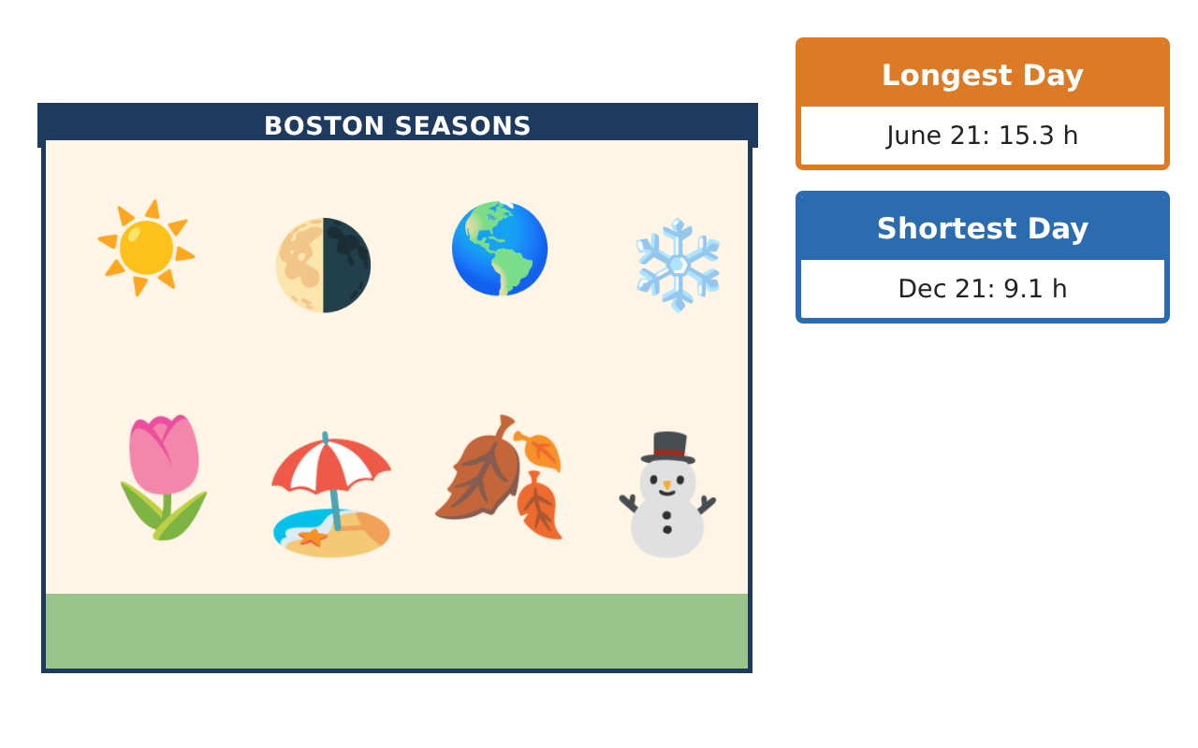
Learning Goals
- I can build and compare sinusoidal models from data.
- I can solve and interpret trigonometric equations and inequalities.
- I can use inverse trig functions and identities in context.
Project Timeline
When | What you will do
Day 1 | Model & Compare
Day 2 | Inverse Trig
Day 3 | Recommendation
Final | Seasonal Planning Report + reflection
Part 1: Model & Compare
Day 1 · Use the Boston Data Cards.
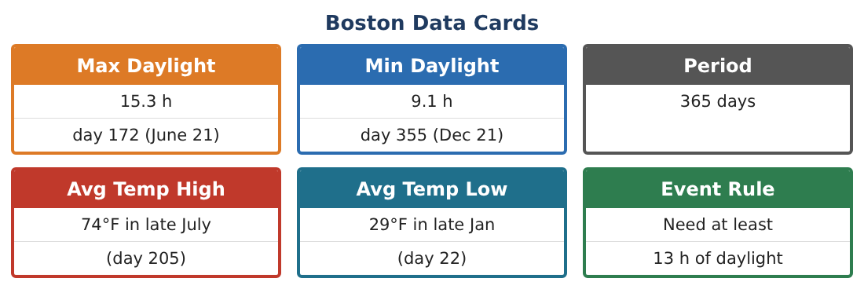
1. Write sine and cosine models for daylight with the same graph. Show they are equal with an identity.

2. Miami has max 13.7 h and min 10.5 h. Write its model (same phase) and compare amplitudes. What causes the difference?

3. On what days do Boston and Miami have the same daylight?

4. Find the rate of change of Boston daylight in minutes per day near the equinox (use the average rate from day 75 to 85).

Part 2: Inverse Trig
Day 2 · Solve with inverse functions.
5. Solve D(t) ≥ 14 for one year.

6. Explain why cos⁻¹ gives only one angle and how you found the second.

7. Write the daylight model as a function of the angle of Earth’s orbit θ (radians) instead of days.

8. Prove sin²x + cos²x = 1 with the unit circle and use it to find sin θ if cos θ = 0.6 and θ is in Quadrant IV.

Part 3: Recommendation
Day 3 · Combine daylight and temperature (T(t) = 22.5 cos($\frac{2π}{365}$(t − 205)) + 51.5).
9. Find the days with daylight ≥ 13 h AND temperature between 60°F and 72°F.

10. Convert your windows to calendar dates.

11. Write the seasonal planning report with graphs of both models and your recommendation.

Final Product: Seasonal Planning Report
Your final product must include:
- Equivalent sine and cosine models
- Boston vs. Miami comparison
- Inverse trig solutions and inequalities
- Combined event windows
- Report with graphs
Reflection
R1. What does the amplitude of the daylight model tell you about latitude?

R2. Why are trig inequalities solved by finding equality points first?

Scoring Rubric
Criteria | 4 – Exceeds | 3 – Meets | 2 – Approaching | 1 – Beginning
Mathematical Accuracy | All calculations and solutions are correct; answers include units and are checked. | Nearly all work is correct; minor errors do not change conclusions. | Several errors; some conclusions are affected. | Many errors or missing work.
Reasoning & Justification | Clear, complete explanations connect every answer to the situation; uses precise vocabulary. | Explanations are mostly clear and connected to the situation. | Explanations are brief or partly unclear. | Little or no explanation.
Application & Design | Sinusoidal models are built from data and used correctly to predict and solve for event dates. Goes beyond the minimum with a creative, realistic choice. | Sinusoidal models are built from data and used correctly to predict and solve for event dates. | Design is incomplete or only partly uses the math from the unit. | Design is missing or unrelated to the unit math.
Communication & Presentation | Report includes models, graphs, solutions, and a clear recommendation. Polished, organized, and visually engaging. | Report includes models, graphs, solutions, and a clear recommendation. Organized and easy to follow. | Product is missing required parts or is hard to follow. | Product is mostly missing.

