PRECALCULUS · UNIT 3: CONICS  Science Museum Conics  Design a science museum exhibit with a parabolic dish, an elliptical whispering gallery, and a hyperbolic tower. | Honors  2–3 class periods

Name: ________________________________ Date: ______________ Period: ______
The Scenario
The city science museum is adding a "Shapes of Science" wing. Each exhibit is built around a conic section: a round planetarium, a parabolic dish, an elliptical whispering room, and a hyperbolic cooling tower model.
You will write the equations, locate the foci, and make the measurements the builders need.
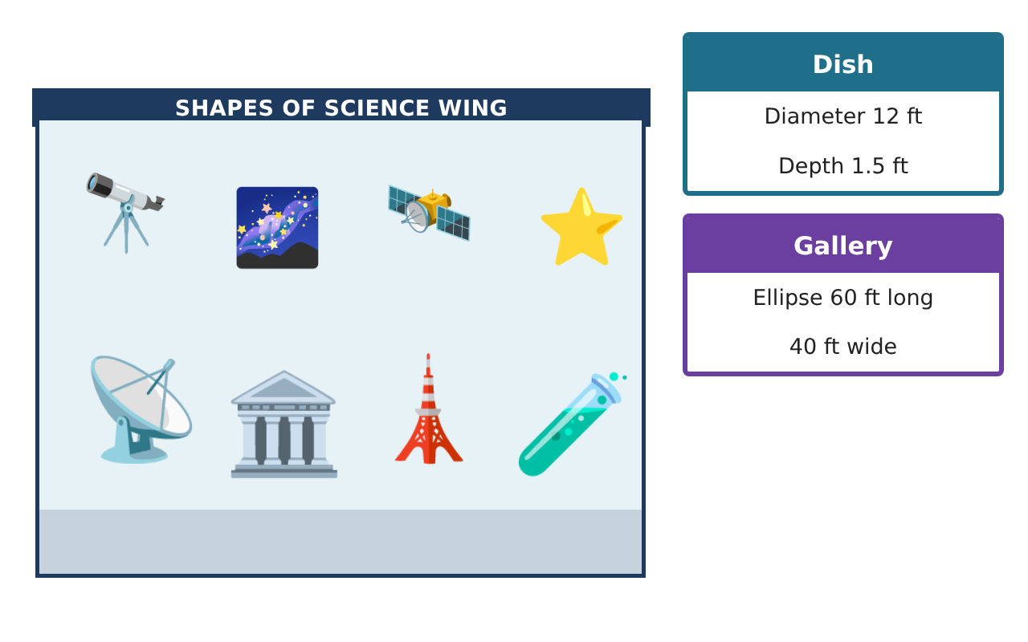
Learning Goals
- I can derive and use conic equations from geometric definitions.
- I can solve design problems involving foci, directrices, and eccentricity.
- I can solve systems involving conics.
Project Timeline
When | What you will do
Day 1 | Parabolic Engineering
Day 2 | Gallery & Planetarium
Day 3 | Hyperbolic Navigation
Final | Exhibit Design Packet + reflection
Part 1: Parabolic Engineering
Day 1 · Use the Specification Cards.
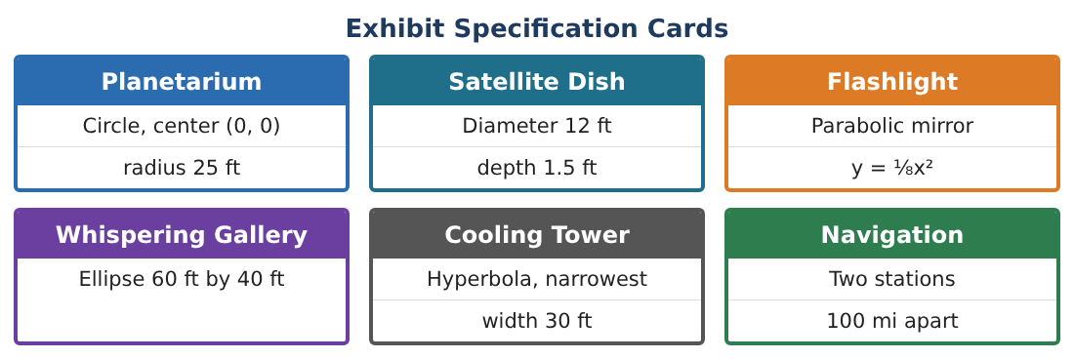
1. Use the definition of a parabola (equal distance from focus (0, p) and directrix y = −p) to derive x² = 4py.

2. A dish has focal length 4 ft and must be 1.25 ft deep. What diameter should it have?

3. A parabolic arch over the entrance is 30 ft wide and 18 ft tall. Write its equation with the vertex at the top (0, 18).

4. Can a 12-ft-tall truck that is 10 ft wide pass under the arch? Show your work.

Part 2: Gallery & Planetarium
Day 2 · Ellipse gallery 60 ft by 40 ft; planetarium circle radius 25 ft centered at (0, 0).
5. The museum wants the gallery foci exactly 40 ft apart and the room 50 ft long. Find the width.

6. Find the points where the circle x² + y² = 625 and the ellipse $\frac{x²}{900}$ + $\frac{y²}{400}$ = 1 intersect.

7. What does that intersection mean if the planetarium and gallery overlap on a floor plan?

8. Find the eccentricity of the new gallery from the first question and compare it to the original.

Part 3: Hyperbolic Navigation
Day 3 · Stations A(−50, 0) and B(50, 0), units in miles.
9. A ship receives B’s signal 0.000322 s before A’s. Signals travel 186,000 mi/s. Find the difference in distances and the hyperbola.

10. The ship is also on the line y = 20. Find its position (it is closer to B).

11. Write a design memo explaining one conic exhibit, with equations and measurements.

Final Product: Exhibit Design Packet
Your final product must include:
- Parabola derivation and arch clearance
- Ellipse redesign and circle intersection
- Hyperbolic navigation fix
- Eccentricity comparison
- Design memo
Reflection
R1. How does each conic’s geometric definition lead to its useful property?

R2. Why does eccentricity describe the shape of an ellipse?

Scoring Rubric
Criteria | 4 – Exceeds | 3 – Meets | 2 – Approaching | 1 – Beginning
Mathematical Accuracy | All calculations and solutions are correct; answers include units and are checked. | Nearly all work is correct; minor errors do not change conclusions. | Several errors; some conclusions are affected. | Many errors or missing work.
Reasoning & Justification | Clear, complete explanations connect every answer to the situation; uses precise vocabulary. | Explanations are mostly clear and connected to the situation. | Explanations are brief or partly unclear. | Little or no explanation.
Application & Design | Conic equations, foci, and measurements are correct and used to design working exhibits. Goes beyond the minimum with a creative, realistic choice. | Conic equations, foci, and measurements are correct and used to design working exhibits. | Design is incomplete or only partly uses the math from the unit. | Design is missing or unrelated to the unit math.
Communication & Presentation | Exhibit packet includes equations, labeled sketches, and builder measurements. Polished, organized, and visually engaging. | Exhibit packet includes equations, labeled sketches, and builder measurements. Organized and easy to follow. | Product is missing required parts or is hard to follow. | Product is mostly missing.

