PRECALCULUS · UNIT 5: TRIGONOMETRY OF GENERAL TRIANGLES  Search and Rescue  Use the Laws of Sines and Cosines and bearings to locate a lost hiker. | CP1  2–3 class periods

Name: ________________________________ Date: ______________ Period: ______
The Scenario
A hiker is lost in the White Mountains. Two ranger towers spot a signal flare, a helicopter is on the way, and search teams need to know how far to travel and how much area each team must cover.
You will use the trigonometry of all triangles, not just right triangles, to find the hiker and plan the search.
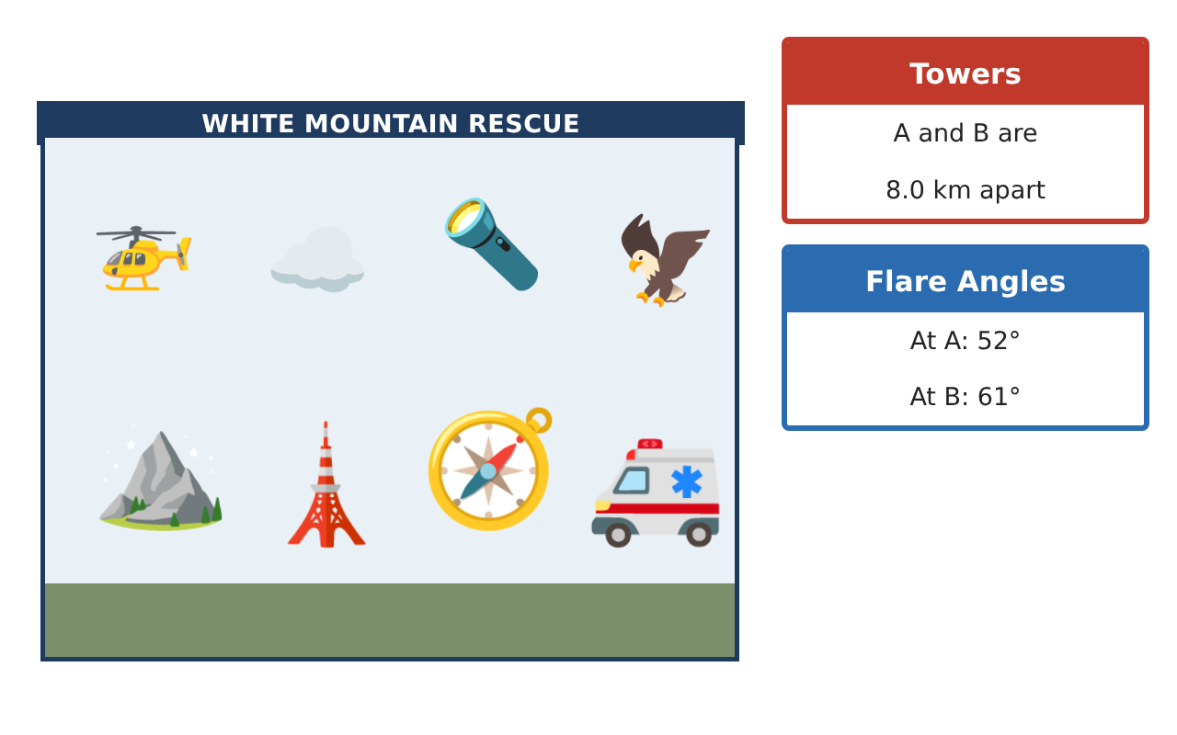
Learning Goals
- I can use the Laws of Sines and Cosines to solve triangles.
- I can work with bearings.
- I can find areas of triangles with trigonometry.
Project Timeline
When | What you will do
Day 1 | Locate the Flare
Day 2 | Team Positions
Day 3 | Search Areas
Final | Rescue Operations Brief + reflection
Part 1: Locate the Flare
Day 1 · Use the Field Data Cards.
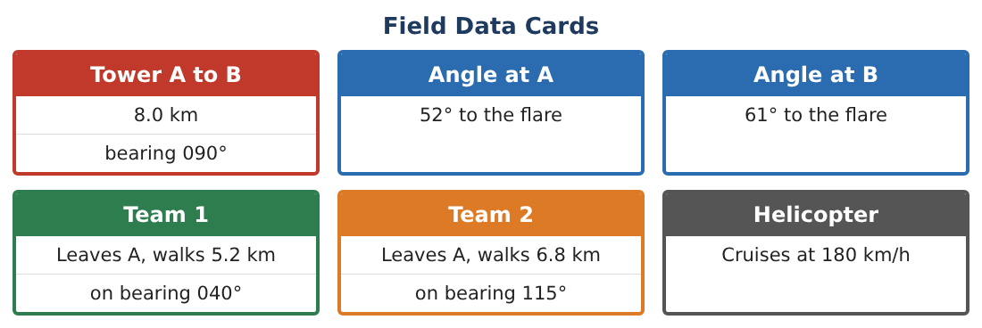
1. Find AF and BF.

2. Tower B is due east of A (bearing 090°). The flare is north of the line AB. What is the bearing from A to the flare?

3. The helicopter starts at Tower A. How long will it take to reach the flare at 180 km/h (in minutes)?

4. How far north of the line AB is the flare?

Part 2: Team Positions
Day 2 · Use the Field Data Cards (bearings from Tower A).
5. Find the angle between Team 1 (040°) and Team 2 (115°) at A.

6. Find the distance between Team 1 and Team 2.

7. Find the distance from Team 1 to the flare. (Angle at A between Team 1 and the flare: 40° vs. 38°.)

8. Which team should go to the flare?

Part 3: Search Areas
Day 3 · Divide the region into triangles.
9. Find the area of triangle A–Team 1–Team 2.

10. Find the area of triangle A–B–F using Heron’s formula (sides 8, 7.60, 6.85).

11. Split the search among 3 teams so each searches at most 10 km² of triangle ABF. Is that possible? Explain.

Final Product: Rescue Operations Brief
Your final product must include:
- Flare location and bearing
- Helicopter time
- Team distances with the Law of Cosines
- Search areas
- Rescue operations brief
Reflection
R1. How do bearings help you find angles inside triangles?

R2. Why did you use the Law of Cosines for team distances?

Scoring Rubric
Criteria | 4 – Exceeds | 3 – Meets | 2 – Approaching | 1 – Beginning
Mathematical Accuracy | All calculations and solutions are correct; answers include units and are checked. | Nearly all work is correct; minor errors do not change conclusions. | Several errors; some conclusions are affected. | Many errors or missing work.
Reasoning & Justification | Clear, complete explanations connect every answer to the situation; uses precise vocabulary. | Explanations are mostly clear and connected to the situation. | Explanations are brief or partly unclear. | Little or no explanation.
Application & Design | Triangles are solved correctly with the appropriate law, and results locate the hiker and divide the search. Goes beyond the minimum with a creative, realistic choice. | Triangles are solved correctly with the appropriate law, and results locate the hiker and divide the search. | Design is incomplete or only partly uses the math from the unit. | Design is missing or unrelated to the unit math.
Communication & Presentation | Brief includes a labeled map, calculations, bearings, and team assignments. Polished, organized, and visually engaging. | Brief includes a labeled map, calculations, bearings, and team assignments. Organized and easy to follow. | Product is missing required parts or is hard to follow. | Product is mostly missing.

