PRECALCULUS · UNIT 5: TRIGONOMETRY OF GENERAL TRIANGLES  Search and Rescue  Use the Laws of Sines and Cosines and bearings to locate a lost hiker. | Honors  2–3 class periods

Name: ________________________________ Date: ______________ Period: ______
The Scenario
A hiker is lost in the White Mountains. Two ranger towers spot a signal flare, a helicopter is on the way, and search teams need to know how far to travel and how much area each team must cover.
You will use the trigonometry of all triangles, not just right triangles, to find the hiker and plan the search.
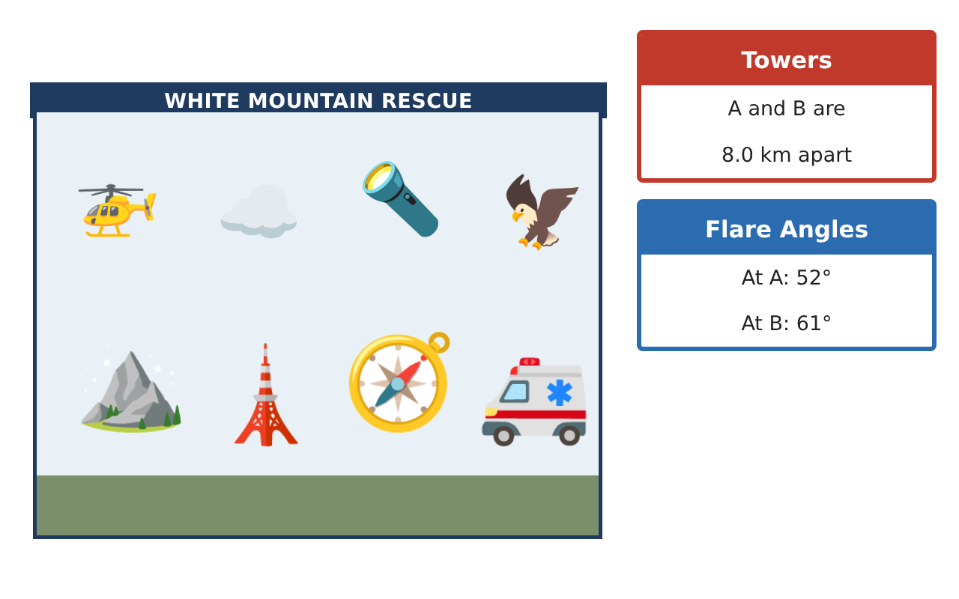
Learning Goals
- I can solve any triangle, including the ambiguous case.
- I can combine bearings with the Laws of Sines and Cosines.
- I can optimize a search plan with trigonometry.
Project Timeline
When | What you will do
Day 1 | Ambiguous Signals
Day 2 | Navigation
Day 3 | Search Plan
Final | Rescue Operations Brief + reflection
Part 1: Ambiguous Signals
Day 1 · A radio fix gives side lengths and angles that may form 0, 1, or 2 triangles.
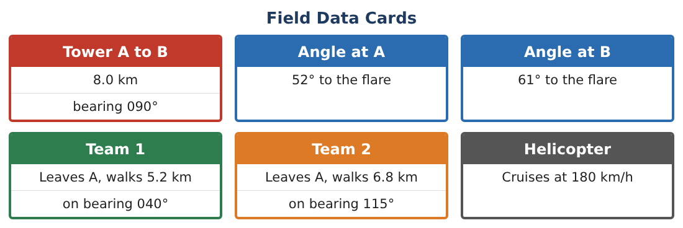
1. A beacon is 7 km from Tower A. Tower B is 9 km from A, and angle B is 40°. How many triangles are possible? Find the possible angles at the beacon.

2. Find the two possible distances from B to the beacon.

3. A second ranger says the beacon is more than 5 km from B. Which triangle is correct?

4. Explain why the SSA case can give two triangles but SAS cannot.

Part 2: Navigation
Day 2 · Use the Field Data Cards.
5. Find the bearing and distance from Team 2 to the flare.

6. Team 1 walks to the flare at 4 km/h and Team 2 at 5 km/h. Which arrives first?

7. The helicopter must land 1 km from the flare in a clearing at bearing 200° from the flare. Find the clearing’s distance from Tower A.

8. Verify one answer using the Law of Cosines instead of coordinates.

Part 3: Search Plan
Day 3 · Triangle ABF: AB = 8, AF ≈ 7.60, BF ≈ 6.85.
9. Find the area of triangle ABF two ways ($\frac{1}{2}$ab sin C and Heron).

10. A median from F splits the triangle into two equal areas. Find the length of the median to AB.

11. Write the operations brief: assignments, routes with bearings, times, and areas.

Final Product: Rescue Operations Brief
Your final product must include:
- Ambiguous-case analysis
- Team routes with bearings and times
- Helicopter landing location
- Area and median split of the search region
- Operations brief
Reflection
R1. How did you decide which of the two ambiguous triangles was real?

R2. Compare coordinates and the Law of Cosines for finding distances.

Scoring Rubric
Criteria | 4 – Exceeds | 3 – Meets | 2 – Approaching | 1 – Beginning
Mathematical Accuracy | All calculations and solutions are correct; answers include units and are checked. | Nearly all work is correct; minor errors do not change conclusions. | Several errors; some conclusions are affected. | Many errors or missing work.
Reasoning & Justification | Clear, complete explanations connect every answer to the situation; uses precise vocabulary. | Explanations are mostly clear and connected to the situation. | Explanations are brief or partly unclear. | Little or no explanation.
Application & Design | Triangles are solved correctly with the appropriate law, and results locate the hiker and divide the search. Goes beyond the minimum with a creative, realistic choice. | Triangles are solved correctly with the appropriate law, and results locate the hiker and divide the search. | Design is incomplete or only partly uses the math from the unit. | Design is missing or unrelated to the unit math.
Communication & Presentation | Brief includes a labeled map, calculations, bearings, and team assignments. Polished, organized, and visually engaging. | Brief includes a labeled map, calculations, bearings, and team assignments. Organized and easy to follow. | Product is missing required parts or is hard to follow. | Product is mostly missing.

