PRECALCULUS · UNIT 8: PROBABILITY  Sports Draft Analytics  Use counting, conditional probability, and expected value to run a basketball team’s draft room. | CP2  2–3 class periods

Name: ________________________________ Date: ______________ Period: ______
The Scenario
The Boston Comets just hired you as their lead analyst. The coach needs lineups, the general manager wants to know the team’s draft lottery odds, and the owner wants to know whether a trade is worth it.
You will use probability and counting to give data-driven answers.
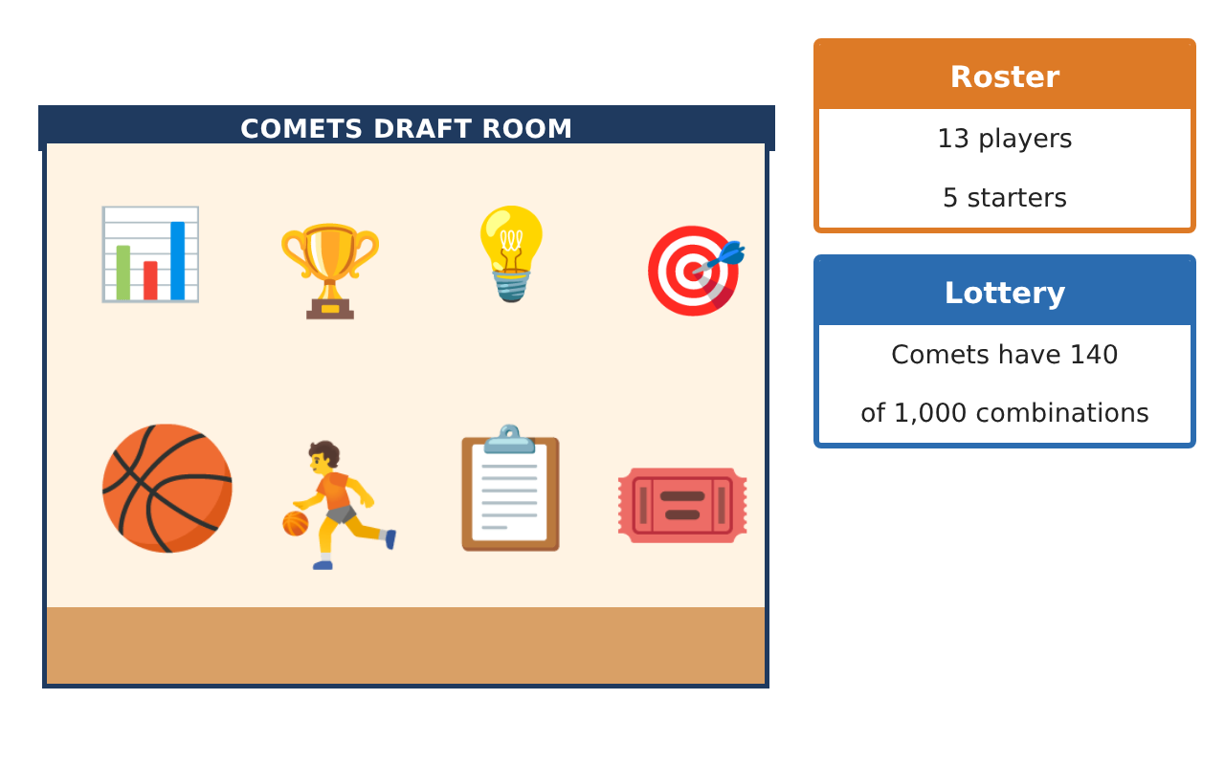
Learning Goals
- I can count outcomes with the counting principle, permutations, and combinations.
- I can find simple and conditional probabilities from data.
- I can compute expected value.
Project Timeline
When | What you will do
Day 1 | Count the Options
Day 2 | Draft Data
Day 3 | Expected Value
Final | Draft Room Report + reflection
Part 1: Count the Options
Day 1 · The roster has 13 players.
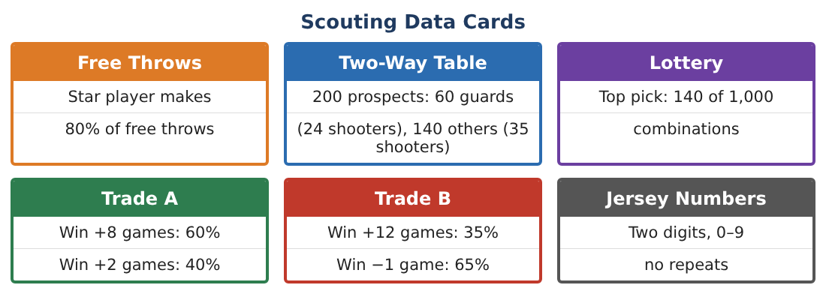
1. How many two-digit jersey numbers with no repeated digit are possible (first digit can be 0)?
Starter: ___ choices × ___ choices

2. In how many ways can the coach choose 5 starters from 13 players (order does not matter)?

3. In how many ways can the coach choose a captain and a co-captain from 13 players?

4. Explain why the captains question is a permutation and the starters question is a combination.

Part 2: Draft Data
Day 2 · Use the Two-Way Table card.
5. Make a two-way table: guards/others and shooters/non-shooters.

6. What is P(shooter)?

7. What is P(shooter | guard)?

8. What is the probability that the Comets win the top pick in the lottery?

Part 3: Expected Value
Day 3 · Use the Trade cards.
9. Find the expected extra wins for Trade A.

10. Find the expected extra wins for Trade B.

11. Which trade would you recommend? Why?

Final Product: Draft Room Report
Your final product must include:
- Counting results with explanations
- Two-way table and probabilities
- Lottery probability
- Expected value of each trade
- Draft room report
Reflection
R1. How is P(shooter | guard) different from P(shooter)?

R2. What does expected value tell the owner?

Scoring Rubric
Criteria | 4 – Exceeds | 3 – Meets | 2 – Approaching | 1 – Beginning
Mathematical Accuracy | All calculations and solutions are correct; answers include units and are checked. | Nearly all work is correct; minor errors do not change conclusions. | Several errors; some conclusions are affected. | Many errors or missing work.
Reasoning & Justification | Clear, complete explanations connect every answer to the situation; uses precise vocabulary. | Explanations are mostly clear and connected to the situation. | Explanations are brief or partly unclear. | Little or no explanation.
Application & Design | Counts, probabilities, and expected values are correct and used to support draft and trade decisions. Goes beyond the minimum with a creative, realistic choice. | Counts, probabilities, and expected values are correct and used to support draft and trade decisions. | Design is incomplete or only partly uses the math from the unit. | Design is missing or unrelated to the unit math.
Communication & Presentation | Report includes tables, calculations, and clear recommendations. Polished, organized, and visually engaging. | Report includes tables, calculations, and clear recommendations. Organized and easy to follow. | Product is missing required parts or is hard to follow. | Product is mostly missing.

