PRECALCULUS · UNIT 8: PROBABILITY  Sports Draft Analytics  Use counting, conditional probability, and expected value to run a basketball team’s draft room. | Honors  2–3 class periods

Name: ________________________________ Date: ______________ Period: ______
The Scenario
The Boston Comets just hired you as their lead analyst. The coach needs lineups, the general manager wants to know the team’s draft lottery odds, and the owner wants to know whether a trade is worth it.
You will use probability and counting to give data-driven answers.
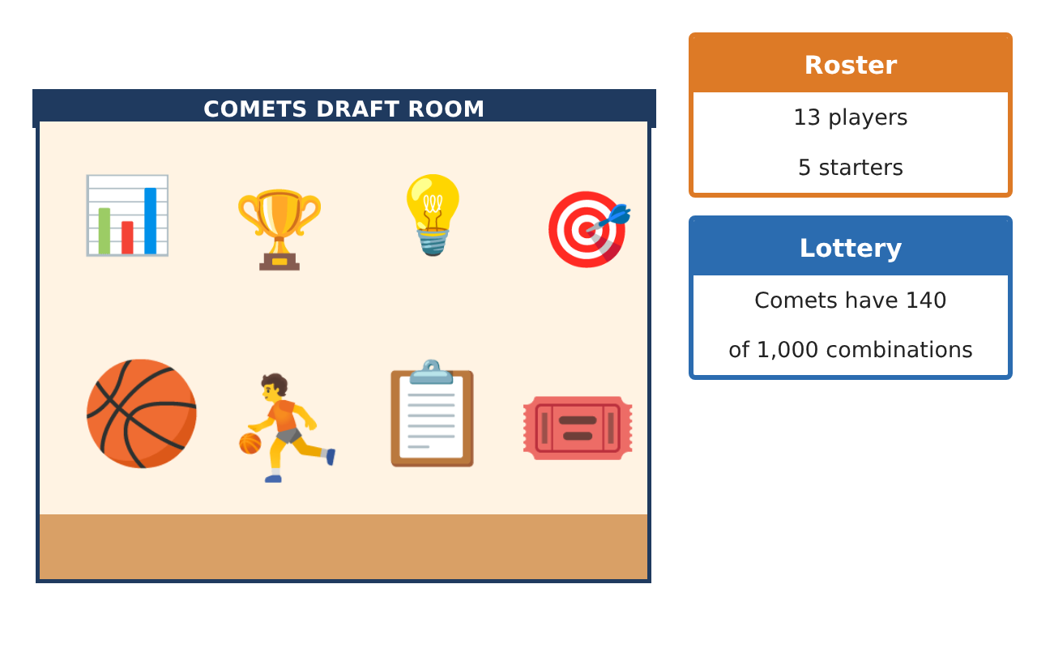
Learning Goals
- I can solve complex counting and probability problems.
- I can use conditional probability and Bayes-style reasoning with data.
- I can analyze decisions with expected value and the binomial distribution.
Project Timeline
When | What you will do
Day 1 | Lineup Probability
Day 2 | Scouting with Conditional Probability
Day 3 | Decisions
Final | Draft Room Report + reflection
Part 1: Lineup Probability
Day 1 · 13 players: 5 guards, 5 forwards, 3 centers.
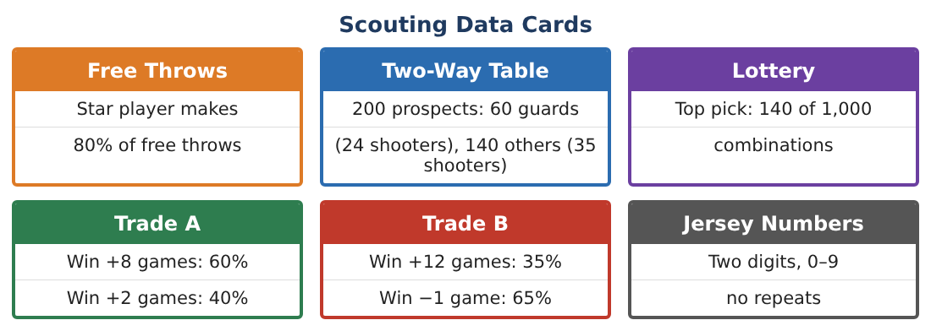
1. How many 5-player lineups have at least one center?

2. What is the probability a random lineup has more guards than forwards?

3. The 5 starters line up for photos with the 2 tallest at the ends. How many arrangements?

4. Explain how you used complements in the first question.

Part 2: Scouting with Conditional Probability
Day 2 · Use the Two-Way Table card.
5. A prospect is a shooter. Find P(guard | shooter) and P(other | shooter).

6. A scouting test flags 90% of shooters but also flags 10% of non-shooters. If a prospect is flagged, what is the probability they are a shooter?

7. Find P(Comets get a top-3 pick) if the second-pick chance is 134 of the remaining 860 and the third-pick chance is 127 of the remaining combinations after two picks (assume 726 remain).

8. Explain why the second-pick probability depends on the first pick.

Part 3: Decisions
Day 3 · Star free-throw rate 80%; Trades A and B.
9. Find the expected number and standard deviation of made free throws in 10 attempts.

10. Find the variance of extra wins for Trade A and Trade B. Which is riskier?

11. Write the Draft Room Report with recommendations backed by counting, conditional probability, and expected value.

Final Product: Draft Room Report
Your final product must include:
- Lineup counts with complements
- Scouting test (Bayes) analysis
- Lottery top-3 probability
- Binomial mean and standard deviation
- Risk-aware trade recommendation
Reflection
R1. Why can a test that is 90% accurate still produce many false flags?

R2. Why should decisions consider variance as well as expected value?

Scoring Rubric
Criteria | 4 – Exceeds | 3 – Meets | 2 – Approaching | 1 – Beginning
Mathematical Accuracy | All calculations and solutions are correct; answers include units and are checked. | Nearly all work is correct; minor errors do not change conclusions. | Several errors; some conclusions are affected. | Many errors or missing work.
Reasoning & Justification | Clear, complete explanations connect every answer to the situation; uses precise vocabulary. | Explanations are mostly clear and connected to the situation. | Explanations are brief or partly unclear. | Little or no explanation.
Application & Design | Counts, probabilities, and expected values are correct and used to support draft and trade decisions. Goes beyond the minimum with a creative, realistic choice. | Counts, probabilities, and expected values are correct and used to support draft and trade decisions. | Design is incomplete or only partly uses the math from the unit. | Design is missing or unrelated to the unit math.
Communication & Presentation | Report includes tables, calculations, and clear recommendations. Polished, organized, and visually engaging. | Report includes tables, calculations, and clear recommendations. Organized and easy to follow. | Product is missing required parts or is hard to follow. | Product is mostly missing.

