PRECALCULUS · UNIT 6: MATRICES  Spy Agency Codes  Use matrices to manage inventory, encode secret messages, and solve systems. | CP1  2–3 class periods

Name: ________________________________ Date: ______________ Period: ______
The Scenario
Welcome to the Cipher Division. Agents carry gadgets from three warehouses, field reports must be encoded so enemies cannot read them, and supply problems arrive as systems of equations.
You will use matrices to track gadgets, encode and decode messages, and solve supply problems.
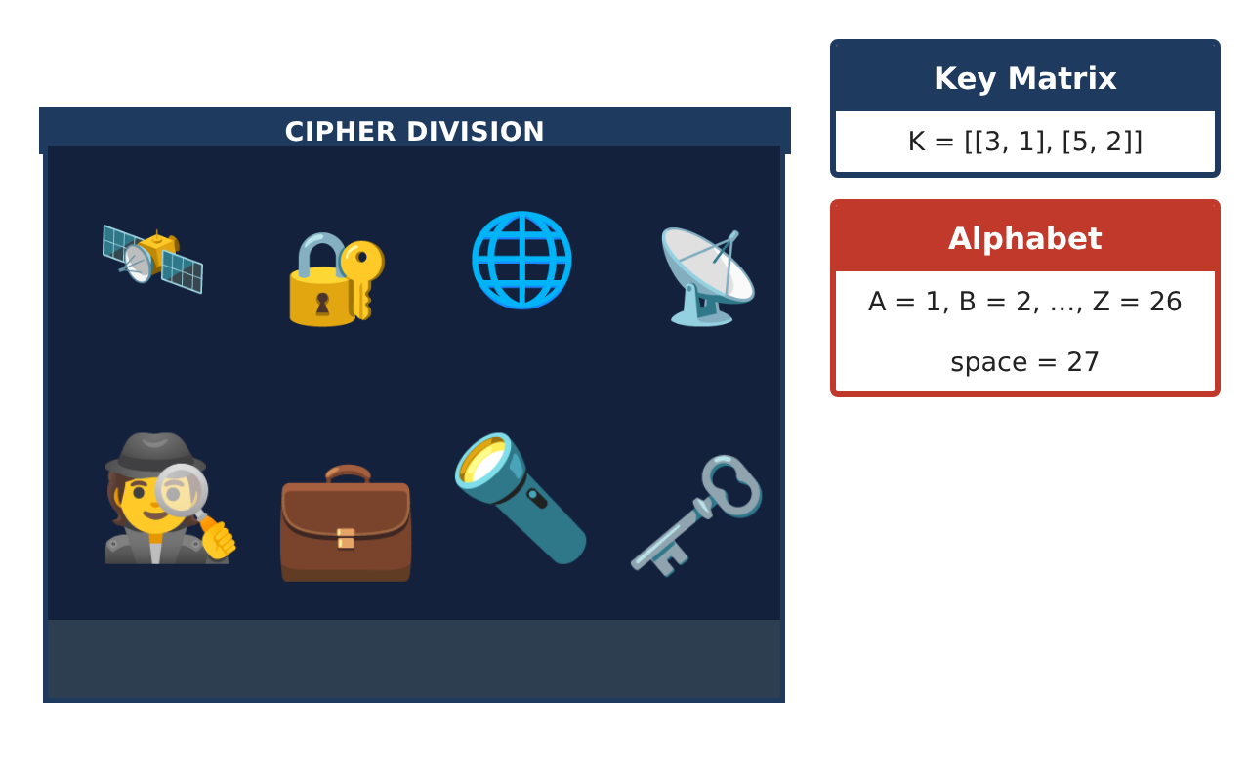
Learning Goals
- I can perform matrix operations in context.
- I can find determinants and inverses of 2 × 2 matrices.
- I can encode, decode, and solve systems with matrices.
Project Timeline
When | What you will do
Day 1 | Inventory & Value
Day 2 | Encode & Decode
Day 3 | Supply Systems
Final | Agent Mission File + reflection
Part 1: Inventory & Value
Day 1 · Use the Gadget Inventory.
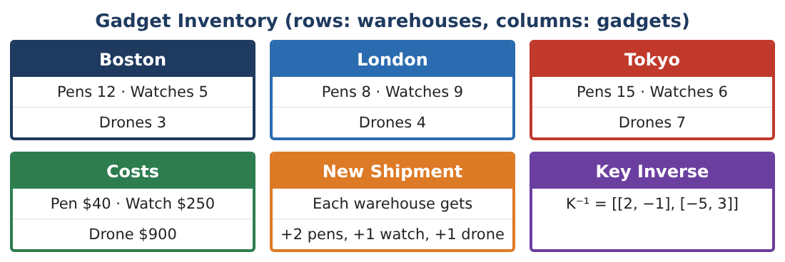
1. Find I + S and the value of each warehouse after the shipment.

2. Prices rise 10%. Write the new cost matrix and find the new Tokyo value for the original inventory.

3. Is I · C the same as C · I? Explain using dimensions.

4. Find the total of each gadget across all warehouses using [1, 1, 1] · I.

Part 2: Encode & Decode
Day 2 · Key K = [[3, 1], [5, 2]], A = 1, …, Z = 26, space = 27.
5. Find det K and K⁻¹.

6. Encode the message GO NOW in pairs (GO, _N, OW).

7. Decode the message [58, 97], [23, 40].

8. Why must the key have a nonzero determinant?

Part 3: Supply Systems
Day 3 · Use inverse matrices to solve.
9. A shipment of pens and watches has 30 items and costs $3,510. Write a matrix equation and solve it with an inverse matrix.

10. Check your answer by substitution.

11. Write your mission file with inventory, a coded message for a partner, and the system you solved.

Final Product: Agent Mission File
Your final product must include:
- Inventory operations and values
- Determinant and inverse
- Encoded message and decoding
- Matrix system solved and checked
- Mission file
Reflection
R1. What does the determinant tell you about a matrix?

R2. How is solving AX = B with an inverse like solving ax = b?

Scoring Rubric
Criteria | 4 – Exceeds | 3 – Meets | 2 – Approaching | 1 – Beginning
Mathematical Accuracy | All calculations and solutions are correct; answers include units and are checked. | Nearly all work is correct; minor errors do not change conclusions. | Several errors; some conclusions are affected. | Many errors or missing work.
Reasoning & Justification | Clear, complete explanations connect every answer to the situation; uses precise vocabulary. | Explanations are mostly clear and connected to the situation. | Explanations are brief or partly unclear. | Little or no explanation.
Application & Design | Matrix operations, inverses, and determinants are correct and used for inventory, codes, and systems. Goes beyond the minimum with a creative, realistic choice. | Matrix operations, inverses, and determinants are correct and used for inventory, codes, and systems. | Design is incomplete or only partly uses the math from the unit. | Design is missing or unrelated to the unit math.
Communication & Presentation | Mission file includes matrices, coded messages, solved systems, and explanations. Polished, organized, and visually engaging. | Mission file includes matrices, coded messages, solved systems, and explanations. Organized and easy to follow. | Product is missing required parts or is hard to follow. | Product is mostly missing.

