PRECALCULUS · UNIT 2: FUNCTIONS  Streaming Service Analyst  Use function families, transformations, compositions, and inverses to analyze a streaming business. | Honors  2–3 class periods

Name: ________________________________ Date: ______________ Period: ______
The Scenario
You are a data analyst at Wavelength, a new music streaming service. Leadership wants to know how pricing plans work, how fast subscribers are growing, and when the company will reach its goals.
You will use functions to model the business and present your findings.
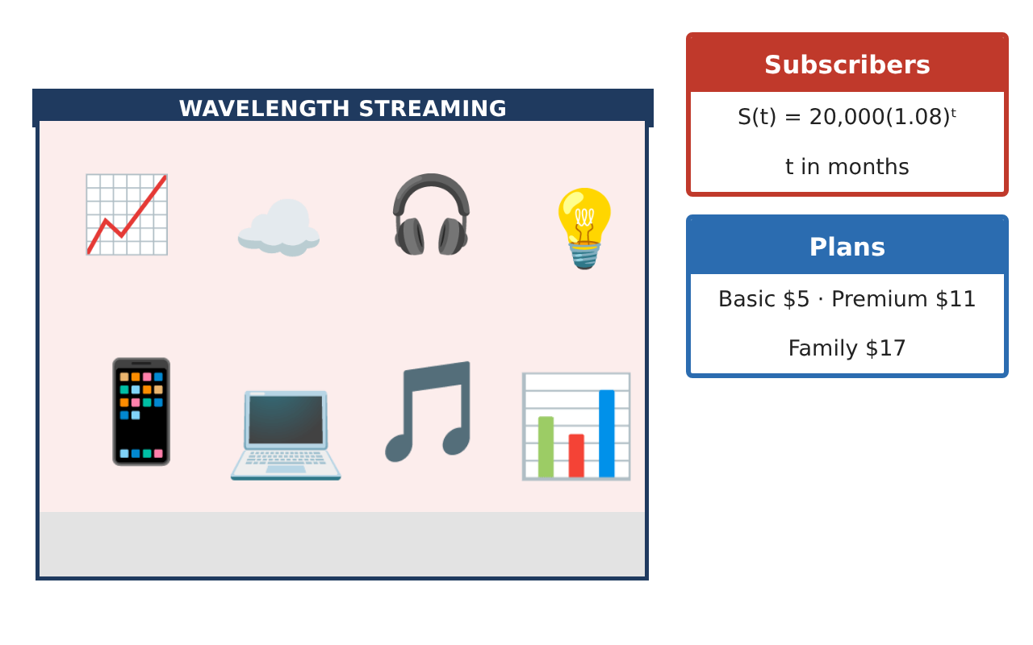
Learning Goals
- I can build, transform, and compose functions to model a business.
- I can find and interpret inverses and their domains.
- I can compare exponential and logarithmic models and solve for parameters.
Project Timeline
When | What you will do
Day 1 | Model Building
Day 2 | Growth Models
Day 3 | Strategy
Final | Analyst Briefing + reflection
Part 1: Model Building
Day 1 · Use the Business Data Cards.
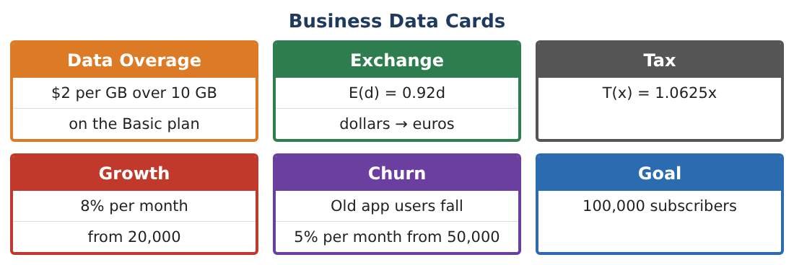
1. A Family plan is $17 for up to 4 users and $3.50 per extra user. Write F(u) as a piecewise function and find the average cost per user for 6 users.

2. For how many users is the Family plan’s average cost per user less than the $5 Basic price?

3. Find the inverse of C(g) = 5 + 2(g − 10) for g > 10 and state its domain.

4. Explain why the whole Basic-plan function C(g) (including 0 ≤ g ≤ 10) has no inverse.

Part 2: Growth Models
Day 2 · S(t) = 20,000(1.08)ᵗ, U(t) = 50,000(0.95)ᵗ.
5. Rewrite S(t) as a continuous model 20,000eᵏᵗ. Find k.

6. Find the doubling time of S and the half-life of U.

7. Total users are S(t) + U(t). Find the month when total users are lowest (use a table).

8. Find the inverse of S(t). What question does S⁻¹(n) answer?

Part 3: Strategy
Day 3 · Leadership has two strategies.
9. Strategy A: 10% monthly growth from 20,000. Strategy B: linear growth of 3,000 per month from 30,000. When does A pass B?

10. Which strategy reaches 100,000 first, and when?

11. Write a briefing recommending a strategy, with graphs and at least two function concepts.

Final Product: Analyst Briefing
Your final product must include:
- Piecewise Family plan with average cost
- Inverses with domains
- Continuous growth, doubling time, and half-life
- Strategy comparison
- Briefing with graphs
Reflection
R1. Why must a function be one-to-one to have an inverse function?

R2. How do the doubling time and half-life summarize growth and decay?

Scoring Rubric
Criteria | 4 – Exceeds | 3 – Meets | 2 – Approaching | 1 – Beginning
Mathematical Accuracy | All calculations and solutions are correct; answers include units and are checked. | Nearly all work is correct; minor errors do not change conclusions. | Several errors; some conclusions are affected. | Many errors or missing work.
Reasoning & Justification | Clear, complete explanations connect every answer to the situation; uses precise vocabulary. | Explanations are mostly clear and connected to the situation. | Explanations are brief or partly unclear. | Little or no explanation.
Application & Design | Functions, transformations, compositions, inverses, and exponential models are built and interpreted correctly. Goes beyond the minimum with a creative, realistic choice. | Functions, transformations, compositions, inverses, and exponential models are built and interpreted correctly. | Design is incomplete or only partly uses the math from the unit. | Design is missing or unrelated to the unit math.
Communication & Presentation | Briefing includes models, graphs, calculations, and a recommendation. Polished, organized, and visually engaging. | Briefing includes models, graphs, calculations, and a recommendation. Organized and easy to follow. | Product is missing required parts or is hard to follow. | Product is mostly missing.

