ALGEBRA 2 · UNIT 9: CONIC SECTIONS  Signals & Dishes  Use circles, parabolas, ellipses, and hyperbolas to design communication technology. | CP1  2–3 class periods

Name: ________________________________ Date: ______________ Period: ______
The Scenario
SignalWorks builds cell towers, satellite dishes, and even whispering galleries for science museums. Each design depends on one of the conic sections.
You will analyze each design with its equation, then create a coverage plan for a new town.
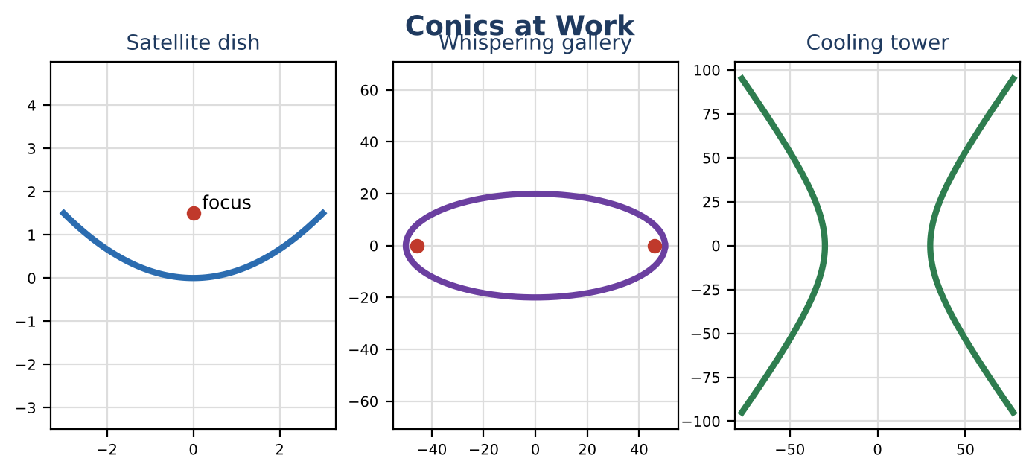
Learning Goals
- I can write conic equations in standard form by completing the square.
- I can find foci, vertices, and asymptotes.
- I can design with conic properties.
Project Timeline
When | What you will do
Day 1 | Towers & Dishes
Day 2 | Ellipses & Hyperbolas
Day 3 | Coverage Map
Final | Engineering Design Brief + reflection

Part 1: Towers & Dishes
Day 1 · Write each equation in standard form.
1. A tower's coverage boundary is x² + y² − 6x + 2y − 6 = 0. Complete the square to find its center and radius.

2. Design a dish that is 8 ft across and 1 ft deep. Write its equation x² = 4py and find the focus.

3. Write the equation of a circle centered at (−2, 4) that passes through (1, 8).

Part 2: Ellipses & Hyperbolas
Day 2 · Find all key features.
4. For x² ÷ 2500 + y² ÷ 400 = 1, find the vertices, co-vertices, and foci.

5. For x² ÷ 900 − y² ÷ 1600 = 1, find the vertices, foci, and asymptotes.

6. Classify each: 4x² + 9y² = 36; x² − y² = 16; y = 2x² − 3; x² + y² = 25.

Part 3: Coverage Map
Day 3 · Cover houses (0, 0), (4, 2), (−3, 5), and (6, −4) with as few 5-mile towers as possible.
7. Place the towers and write their equations.

8. Show every house is covered.

9. Explain why your number of towers is the minimum (or near it).

Final Product: Engineering Design Brief
Your final product must include:
- Standard-form equations
- Dish design
- Feature tables
- Coverage plan
Reflection
R1. Why does completing the square reveal a circle's center?

R2. How do ellipses and hyperbolas differ in the relationship among a, b, and c?

Scoring Rubric
Criteria | 4 – Exceeds | 3 – Meets | 2 – Approaching | 1 – Beginning
Mathematical Accuracy | All calculations and solutions are correct; answers include units and are checked. | Nearly all work is correct; minor errors do not change conclusions. | Several errors; some conclusions are affected. | Many errors or missing work.
Reasoning & Justification | Clear, complete explanations connect every answer to the situation; uses precise vocabulary. | Explanations are mostly clear and connected to the situation. | Explanations are brief or partly unclear. | Little or no explanation.
Application & Design | Coverage plan uses correct circle equations and point tests, and every conic feature is correct. Goes beyond the minimum with a creative, realistic choice. | Coverage plan uses correct circle equations and point tests, and every conic feature is correct. | Design is incomplete or only partly uses the math from the unit. | Design is missing or unrelated to the unit math.
Communication & Presentation | Brief includes each conic's equation, key features (center, foci, vertices, radius), and a coverage map. Polished, organized, and visually engaging. | Brief includes each conic's equation, key features (center, foci, vertices, radius), and a coverage map. Organized and easy to follow. | Product is missing required parts or is hard to follow. | Product is mostly missing.

