ALGEBRA 2 · UNIT 9: CONIC SECTIONS  Signals & Dishes  Use circles, parabolas, ellipses, and hyperbolas to design communication technology. | CP2  2–3 class periods

Name: ________________________________ Date: ______________ Period: ______
The Scenario
SignalWorks builds cell towers, satellite dishes, and even whispering galleries for science museums. Each design depends on one of the conic sections.
You will analyze each design with its equation, then create a coverage plan for a new town.
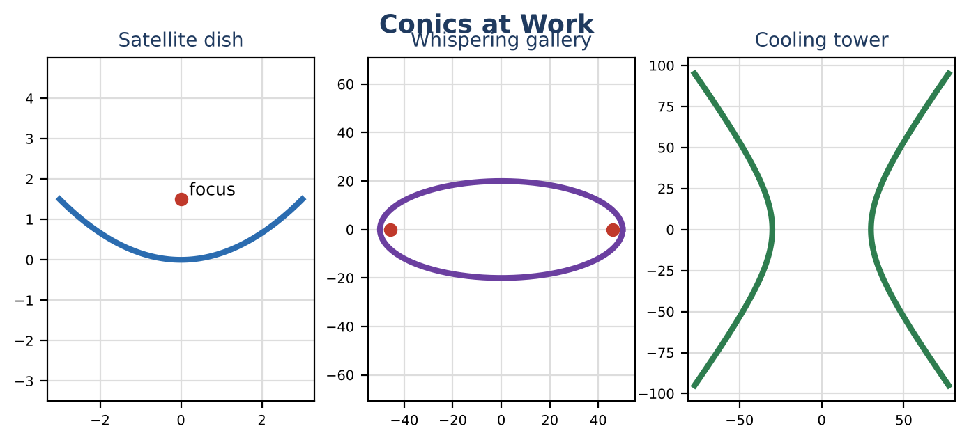
Learning Goals
- I can identify features of conics from their equations.
- I can test whether a point is inside a circle.
- I can use the focus of a parabola.
Project Timeline
When | What you will do
Day 1 | Towers & Dishes
Day 2 | Ellipses & Hyperbolas
Day 3 | Coverage Map
Final | Engineering Design Brief + reflection

Part 1: Towers & Dishes
Day 1 · A tower covers the region inside (x − 3)² + (y + 1)² = 16 (miles).
1. Find the tower's location (center) and coverage radius.

2. Is a house at (6, 2) covered? Is one at (5, 1)? Substitute to check.

3. A satellite dish has the shape x² = 6y. For x² = 4py the focus is at (0, p). Where should the receiver go?

4. How deep is the dish if it is 6 ft across (x from −3 to 3)?

Part 2: Ellipses & Hyperbolas
Day 2 · Use the formulas.
5. A whispering gallery has the shape x² ÷ 2500 + y² ÷ 400 = 1 (feet). Find a, b, and c = √(a² − b²). Where should two people stand to hear whispers?

6. A cooling tower's side has the shape x² ÷ 900 − y² ÷ 1600 = 1. Find a, b, and c = √(a² + b²).

7. Match each conic to its real-world use and say why the shape is useful.

Part 3: Coverage Map
Day 3 · Plan coverage for a town with houses at (0, 0), (4, 2), (−3, 5), and (6, −4).
8. Place one or two towers (radius 5 miles each). Write each equation.

9. Test every house.

10. Draw the map.

Final Product: Engineering Design Brief
Your final product must include:
- Coverage map with circle equations
- Dish focus and depth
- Gallery and tower features
- Design brief
Reflection
R1. Why is the receiver placed at the focus?

R2. How does a circle equation come from the distance formula?

Scoring Rubric
Criteria | 4 – Exceeds | 3 – Meets | 2 – Approaching | 1 – Beginning
Mathematical Accuracy | All calculations and solutions are correct; answers include units and are checked. | Nearly all work is correct; minor errors do not change conclusions. | Several errors; some conclusions are affected. | Many errors or missing work.
Reasoning & Justification | Clear, complete explanations connect every answer to the situation; uses precise vocabulary. | Explanations are mostly clear and connected to the situation. | Explanations are brief or partly unclear. | Little or no explanation.
Application & Design | Coverage plan uses correct circle equations and point tests, and every conic feature is correct. Goes beyond the minimum with a creative, realistic choice. | Coverage plan uses correct circle equations and point tests, and every conic feature is correct. | Design is incomplete or only partly uses the math from the unit. | Design is missing or unrelated to the unit math.
Communication & Presentation | Brief includes each conic's equation, key features (center, foci, vertices, radius), and a coverage map. Polished, organized, and visually engaging. | Brief includes each conic's equation, key features (center, foci, vertices, radius), and a coverage map. Organized and easy to follow. | Product is missing required parts or is hard to follow. | Product is mostly missing.

