ALGEBRA 2 · UNIT 9: CONIC SECTIONS  Signals & Dishes  Use circles, parabolas, ellipses, and hyperbolas to design communication technology. | Honors  2–3 class periods

Name: ________________________________ Date: ______________ Period: ______
The Scenario
SignalWorks builds cell towers, satellite dishes, and even whispering galleries for science museums. Each design depends on one of the conic sections.
You will analyze each design with its equation, then create a coverage plan for a new town.
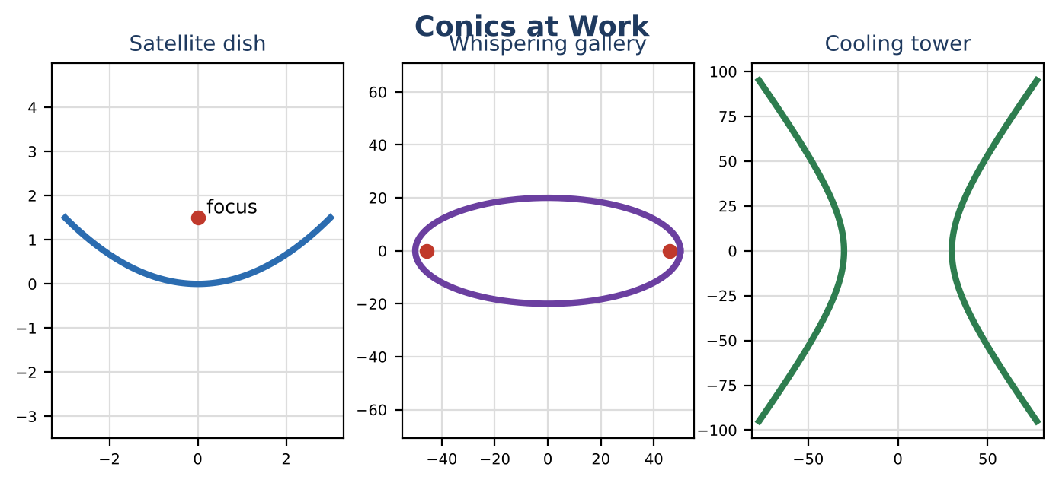
Learning Goals
- I can derive conic equations from geometric definitions.
- I can use distance differences to locate points (hyperbolas).
- I can optimize a design.
Project Timeline
When | What you will do
Day 1 | Definitions
Day 2 | Locating a Ship
Day 3 | Optimized Coverage
Final | Engineering Design Brief + reflection

Part 1: Definitions
Day 1 · Use the distance formula.
1. Derive the equation of the parabola with focus (0, p) and directrix y = −p.

2. A dish is 10 ft across and 1.25 ft deep. Find the focus.

3. Show that every point on x² ÷ 2500 + y² ÷ 400 = 1 has distances to the foci that add to 100.

Part 2: Locating a Ship
Day 2 · Two stations are at (−50, 0) and (50, 0) (miles). A ship's signal arrives at the right station first, and the difference in distances is 60 miles.
4. Explain why the ship is on a hyperbola and write its equation.

5. The ship is also on the line y = 32. Find its location (on the right branch).

6. Write the asymptotes and explain what they mean far from the stations.

Part 3: Optimized Coverage
Day 3 · Houses: (0, 0), (4, 2), (−3, 5), (6, −4), (8, 3).
7. Find the smallest single circle that covers all houses, or show two towers are needed with radius 5.

8. Write the equations and test every house.

9. Write a brief explaining the design.

Final Product: Engineering Design Brief
Your final product must include:
- Derivations
- Ship location
- Optimized coverage plan
- Brief
Reflection
R1. Why is a hyperbola the set of points with a constant difference of distances?

R2. How do conic definitions lead to real designs?

Scoring Rubric
Criteria | 4 – Exceeds | 3 – Meets | 2 – Approaching | 1 – Beginning
Mathematical Accuracy | All calculations and solutions are correct; answers include units and are checked. | Nearly all work is correct; minor errors do not change conclusions. | Several errors; some conclusions are affected. | Many errors or missing work.
Reasoning & Justification | Clear, complete explanations connect every answer to the situation; uses precise vocabulary. | Explanations are mostly clear and connected to the situation. | Explanations are brief or partly unclear. | Little or no explanation.
Application & Design | Coverage plan uses correct circle equations and point tests, and every conic feature is correct. Goes beyond the minimum with a creative, realistic choice. | Coverage plan uses correct circle equations and point tests, and every conic feature is correct. | Design is incomplete or only partly uses the math from the unit. | Design is missing or unrelated to the unit math.
Communication & Presentation | Brief includes each conic's equation, key features (center, foci, vertices, radius), and a coverage map. Polished, organized, and visually engaging. | Brief includes each conic's equation, key features (center, foci, vertices, radius), and a coverage map. Organized and easy to follow. | Product is missing required parts or is hard to follow. | Product is mostly missing.

