ALGEBRA 2 · UNIT 4: POLYNOMIAL FUNCTIONS  Water Slide Designer  Design a smooth water slide with polynomial zeros, multiplicity, and end behavior. | CP1  2–3 class periods

Name: ________________________________ Date: ______________ Period: ______
The Scenario
Splash Canyon Water Park is building a new slide. The profile is h(x) = 0.001(x − 40)²(x + 20), where x is the horizontal distance in feet and h is the height in feet.
The double zero at x = 40 makes the slide level out smoothly at the pool. You will analyze this design and then create your own.
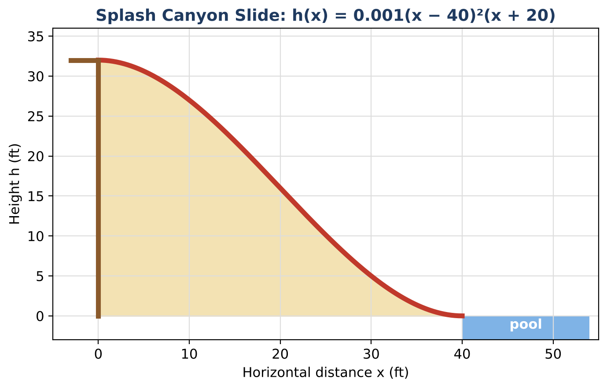
Learning Goals
- I can move between factored and standard forms of polynomials.
- I can use the Remainder, Factor, and Rational Root Theorems.
- I can describe end behavior and sketch graphs.
Project Timeline
When | What you will do
Day 1 | Read the Slide
Day 2 | Theorems at Work
Day 3 | Design a Slide
Final | Slide Design Report + reflection

Part 1: Read the Slide
Day 1 · h(x) = 0.001(x − 40)²(x + 20)
1. Expand to standard form. Check with x = 10.

2. Describe the end behavior of h (ignore the slide's domain).

3. Give the zeros, multiplicities, and the slide's domain and range.

4. Rule: the slide must be at least 10 ft high for the first 25 ft. Does it follow the rule?

Part 2: Theorems at Work
Day 2 · Use p(x) = x³ − 60x² + 32,000.
5. Use the Remainder Theorem to find p(30) with synthetic division. Then find h(30).

6. List the possible rational roots of p according to the Rational Root Theorem (just describe the set). Then test x = −20.

7. Use the Factor Theorem and division to factor p completely.

Part 3: Design a Slide
Day 3 · Start height 24 ft, smooth landing 30 ft away.
8. Write h(x) = a(x − 30)²(x + 15) and find a.

9. Expand your polynomial to standard form.

10. Use synthetic division to verify a height at x = 10.

Final Product: Slide Design Report
Your final product must include:
- Both forms of each slide
- Theorem checks
- End behavior and graph
- Design report
Reflection
R1. How do the Factor and Remainder Theorems save time?

R2. Why does the factor (x + 20) matter even though x = −20 is off the slide?

Scoring Rubric
Criteria | 4 – Exceeds | 3 – Meets | 2 – Approaching | 1 – Beginning
Mathematical Accuracy | All calculations and solutions are correct; answers include units and are checked. | Nearly all work is correct; minor errors do not change conclusions. | Several errors; some conclusions are affected. | Many errors or missing work.
Reasoning & Justification | Clear, complete explanations connect every answer to the situation; uses precise vocabulary. | Explanations are mostly clear and connected to the situation. | Explanations are brief or partly unclear. | Little or no explanation.
Application & Design | Original slide polynomial starts at the required height and lands smoothly (double zero), with work shown. Goes beyond the minimum with a creative, realistic choice. | Original slide polynomial starts at the required height and lands smoothly (double zero), with work shown. | Design is incomplete or only partly uses the math from the unit. | Design is missing or unrelated to the unit math.
Communication & Presentation | Report includes the polynomial in factored and standard form, a graph with zeros and multiplicity, division checks, and a design. Polished, organized, and visually engaging. | Report includes the polynomial in factored and standard form, a graph with zeros and multiplicity, division checks, and a design. Organized and easy to follow. | Product is missing required parts or is hard to follow. | Product is mostly missing.

