ALGEBRA 2 · UNIT 4: POLYNOMIAL FUNCTIONS  Water Slide Designer  Design a smooth water slide with polynomial zeros, multiplicity, and end behavior. | CP2  2–3 class periods

Name: ________________________________ Date: ______________ Period: ______
The Scenario
Splash Canyon Water Park is building a new slide. The profile is h(x) = 0.001(x − 40)²(x + 20), where x is the horizontal distance in feet and h is the height in feet.
The double zero at x = 40 makes the slide level out smoothly at the pool. You will analyze this design and then create your own.
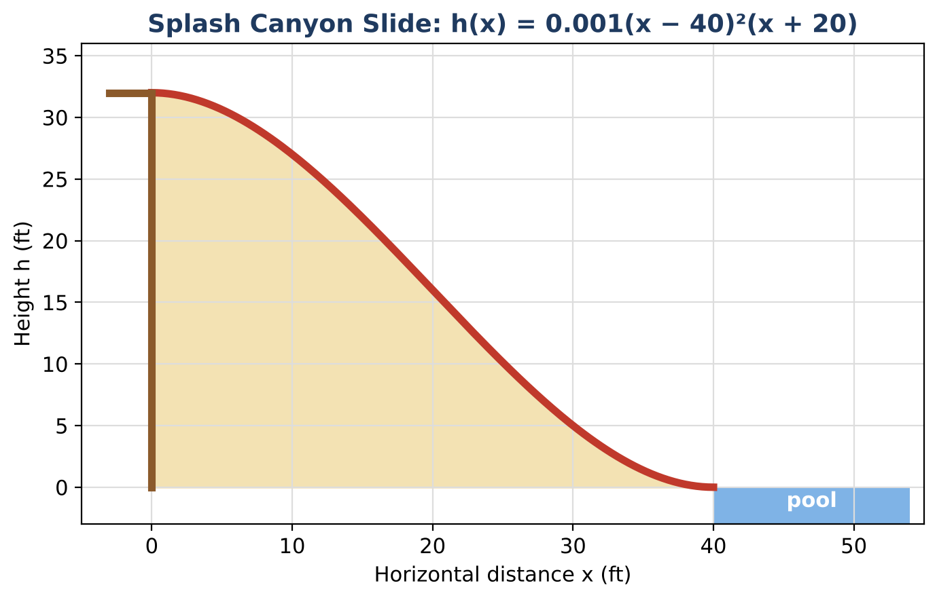
Learning Goals
- I can evaluate and graph a polynomial function.
- I can relate zeros and multiplicity to the graph.
- I can use synthetic division to check factors.
Project Timeline
When | What you will do
Day 1 | Read the Slide
Day 2 | Check with Division
Day 3 | Design a Slide
Final | Slide Design Report + reflection

Part 1: Read the Slide
Day 1 · h(x) = 0.001(x − 40)²(x + 20)
1. Complete the table.
x (ft) | 0 | 10 | 20 | 30 | 40
h(x) (ft)

2. How tall is the top of the slide? Where does the slide reach the pool?

3. List the zeros of h and the multiplicity of each. Which zero is part of the slide?

4. Explain why a double zero at x = 40 makes a smooth landing.

Part 2: Check with Division
Day 2 · The standard form is h(x) = 0.001(x³ − 60x² + 32,000).
5. Use synthetic division to divide x³ − 60x² + 0x + 32,000 by (x − 40). What is the remainder? What does it tell you?

6. Factor the quotient to get all the factors.

7. Use synthetic division to find the remainder when dividing by (x − 10). Compare 0.001 × remainder with h(10).

Part 3: Design a Slide
Day 3 · Your slide must start 27 ft high and land smoothly 30 ft away.
8. Use the form h(x) = a(x − 30)²(x + 15). Find a so that h(0) = 27.

9. Make a table for x = 0, 10, 20, 30.

10. Sketch your slide and compare it with Splash Canyon's.

Final Product: Slide Design Report
Your final product must include:
- Graph of both slides
- Zeros with multiplicity
- Synthetic division work
- Design summary
Reflection
R1. What would a slide with a single zero at the pool look like?

R2. How does synthetic division show that (x − 40) is a factor?

Scoring Rubric
Criteria | 4 – Exceeds | 3 – Meets | 2 – Approaching | 1 – Beginning
Mathematical Accuracy | All calculations and solutions are correct; answers include units and are checked. | Nearly all work is correct; minor errors do not change conclusions. | Several errors; some conclusions are affected. | Many errors or missing work.
Reasoning & Justification | Clear, complete explanations connect every answer to the situation; uses precise vocabulary. | Explanations are mostly clear and connected to the situation. | Explanations are brief or partly unclear. | Little or no explanation.
Application & Design | Original slide polynomial starts at the required height and lands smoothly (double zero), with work shown. Goes beyond the minimum with a creative, realistic choice. | Original slide polynomial starts at the required height and lands smoothly (double zero), with work shown. | Design is incomplete or only partly uses the math from the unit. | Design is missing or unrelated to the unit math.
Communication & Presentation | Report includes the polynomial in factored and standard form, a graph with zeros and multiplicity, division checks, and a design. Polished, organized, and visually engaging. | Report includes the polynomial in factored and standard form, a graph with zeros and multiplicity, division checks, and a design. Organized and easy to follow. | Product is missing required parts or is hard to follow. | Product is mostly missing.

