ALGEBRA 2 · UNIT 4: POLYNOMIAL FUNCTIONS  Water Slide Designer  Design a smooth water slide with polynomial zeros, multiplicity, and end behavior. | Honors  2–3 class periods

Name: ________________________________ Date: ______________ Period: ______
The Scenario
Splash Canyon Water Park is building a new slide. The profile is h(x) = 0.001(x − 40)²(x + 20), where x is the horizontal distance in feet and h is the height in feet.
The double zero at x = 40 makes the slide level out smoothly at the pool. You will analyze this design and then create your own.
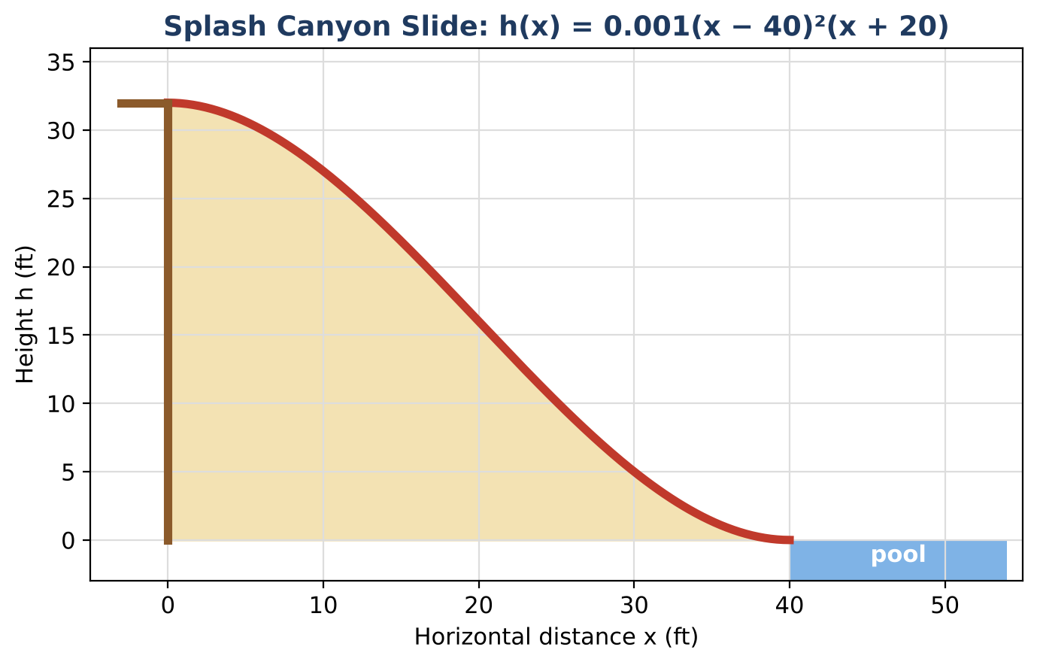
Learning Goals
- I can derive a general polynomial model from design conditions.
- I can prove properties of the model algebraically.
- I can design under several constraints.
Project Timeline
When | What you will do
Day 1 | General Slide Formula
Day 2 | Theorems
Day 3 | Design Within Constraints
Final | Slide Design Report + reflection

Part 1: General Slide Formula
Day 1 · Slides of the form h(x) = a(x − L)²(x + 0.5L) start at height H and land at x = L.
1. Show that h(0) = 0.5aL³ and find a in terms of H and L. Check with Splash Canyon (H = 32, L = 40).

2. Expand h(x) and show h(x) − H = a x²(x − 1.5L).

3. Use the identity to prove that the start (x = 0) is the highest point of the slide for 0 ≤ x ≤ L.

Part 2: Theorems
Day 2 · Use p(x) = x³ − 60x² + 32,000.
4. Use the Rational Root Theorem and synthetic division to factor p completely.

5. Find the remainder when p is divided by (x − 30) and interpret it.

6. Find the average rate of change of h from 0 to 20 and from 20 to 40. Where is the slide steeper?

Part 3: Design Within Constraints
Day 3 · Start height 30 ft; the slide must be at least 12 ft high at x = 15; the landing must be smooth.
7. Find the smallest L that satisfies the constraints (test values or solve).

8. Write the final polynomial and graph it.

9. Write the report with your proofs.

Final Product: Slide Design Report
Your final product must include:
- General formula and proof
- Factoring and rate analysis
- Constrained design
- Report
Reflection
R1. How does a general formula help the park design many slides?

R2. Why is the start the highest point?

Scoring Rubric
Criteria | 4 – Exceeds | 3 – Meets | 2 – Approaching | 1 – Beginning
Mathematical Accuracy | All calculations and solutions are correct; answers include units and are checked. | Nearly all work is correct; minor errors do not change conclusions. | Several errors; some conclusions are affected. | Many errors or missing work.
Reasoning & Justification | Clear, complete explanations connect every answer to the situation; uses precise vocabulary. | Explanations are mostly clear and connected to the situation. | Explanations are brief or partly unclear. | Little or no explanation.
Application & Design | Original slide polynomial starts at the required height and lands smoothly (double zero), with work shown. Goes beyond the minimum with a creative, realistic choice. | Original slide polynomial starts at the required height and lands smoothly (double zero), with work shown. | Design is incomplete or only partly uses the math from the unit. | Design is missing or unrelated to the unit math.
Communication & Presentation | Report includes the polynomial in factored and standard form, a graph with zeros and multiplicity, division checks, and a design. Polished, organized, and visually engaging. | Report includes the polynomial in factored and standard form, a graph with zeros and multiplicity, division checks, and a design. Organized and easy to follow. | Product is missing required parts or is hard to follow. | Product is mostly missing.

