GEOMETRY · UNIT 6: RIGHT TRIANGLES AND TRIGONOMETRY  Accessible Ramp Engineer  Design wheelchair ramps that meet the rules with the Pythagorean Theorem and trigonometry. | CP1  2–3 class periods

Name: ________________________________ Date: ______________ Period: ______
The Scenario
The school is adding wheelchair ramps to two entrances. Building codes allow at most 1 inch of rise for every 12 inches of run, and long ramps need flat landings.
Your team will compute the run, ramp length, and angle for each entrance, check other right-triangle situations on campus, and present a plan.
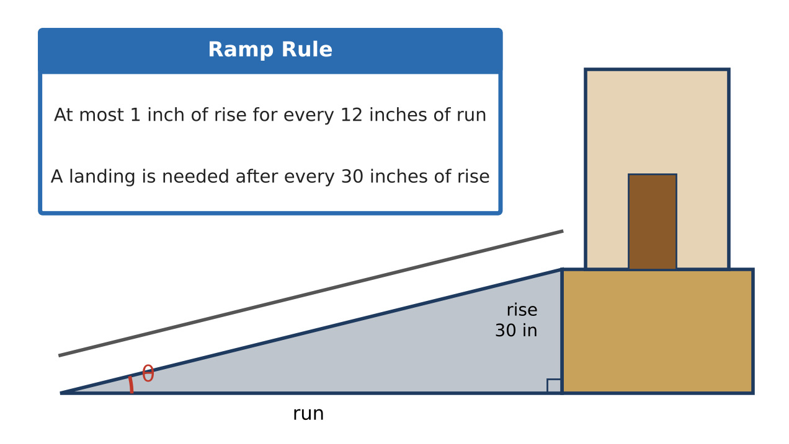
Learning Goals
- I can solve right triangles with trig ratios and inverse trig.
- I can use special right triangles.
- I can design a ramp with landings that meets the code.
Project Timeline
When | What you will do
Day 1 | Rise, Run & Length
Day 2 | Elevation & Depression
Day 3 | Design the Gym Ramp
Final | Ramp Design Plan + reflection

Part 1: Rise, Run & Length
Day 1 · Use the Ramp Rule card.
1. For the 30-inch entrance, find the shortest run, the ramp length, and the ramp angle.

2. A contractor proposes a ramp with a 24-foot run for the 30-inch entrance. Does it meet the rule? Find its angle.

3. A 6-foot shelf needs a 45° diagonal brace from the top corner to the floor. Find the brace length exactly and as a decimal.

4. A lift's support strut makes a 30-60-90 triangle with a 10-foot hypotenuse. Find both legs exactly.

Part 2: Elevation & Depression
Day 2 · Draw a diagram for each.
5. From the roof (40 ft high), a worker sees a delivery truck at an angle of depression of 25°. How far is the truck from the building?

6. From 50 ft away, eyes 5 ft high, the angle of elevation to the top of the gym is 32°. Find the gym's height.

7. A ramp rises 30 inches over a 40-foot run. Find its angle and its length in feet.

Part 3: Design the Gym Ramp
Day 3 · The gym entrance is 45 inches high. A landing is needed after every 30 inches of rise.
8. Plan the ramp in two equal sections. Find the rise and the shortest run of each section.

9. Find each section's length and the total run including a 5-foot landing.

10. Sketch a switchback design and give its footprint.

Final Product: Ramp Design Plan
Your final product must include:
- Calculations for every ramp, including the contractor check
- Special right triangle solutions
- Elevation and depression diagrams
- Two-section gym ramp design
Reflection
R1. Why do the 30-inch and 21-inch ramps have the same angle?

R2. When do special right triangles let you skip the calculator?

Scoring Rubric
Criteria | 4 – Exceeds | 3 – Meets | 2 – Approaching | 1 – Beginning
Mathematical Accuracy | All calculations and solutions are correct; answers include units and are checked. | Nearly all work is correct; minor errors do not change conclusions. | Several errors; some conclusions are affected. | Many errors or missing work.
Reasoning & Justification | Clear, complete explanations connect every answer to the situation; uses precise vocabulary. | Explanations are mostly clear and connected to the situation. | Explanations are brief or partly unclear. | Little or no explanation.
Application & Design | Ramp design meets the rise-to-run rule and landing rule, with correct right-triangle calculations. Goes beyond the minimum with a creative, realistic choice. | Ramp design meets the rise-to-run rule and landing rule, with correct right-triangle calculations. | Design is incomplete or only partly uses the math from the unit. | Design is missing or unrelated to the unit math.
Communication & Presentation | Plan includes a scale drawing, run, ramp length, angle, landings, and a check against the rule. Polished, organized, and visually engaging. | Plan includes a scale drawing, run, ramp length, angle, landings, and a check against the rule. Organized and easy to follow. | Product is missing required parts or is hard to follow. | Product is mostly missing.

