GEOMETRY · UNIT 6: RIGHT TRIANGLES AND TRIGONOMETRY  Accessible Ramp Engineer  Design wheelchair ramps that meet the rules with the Pythagorean Theorem and trigonometry. | CP2  2–3 class periods

Name: ________________________________ Date: ______________ Period: ______
The Scenario
The school is adding wheelchair ramps to two entrances. Building codes allow at most 1 inch of rise for every 12 inches of run, and long ramps need flat landings.
Your team will compute the run, ramp length, and angle for each entrance, check other right-triangle situations on campus, and present a plan.
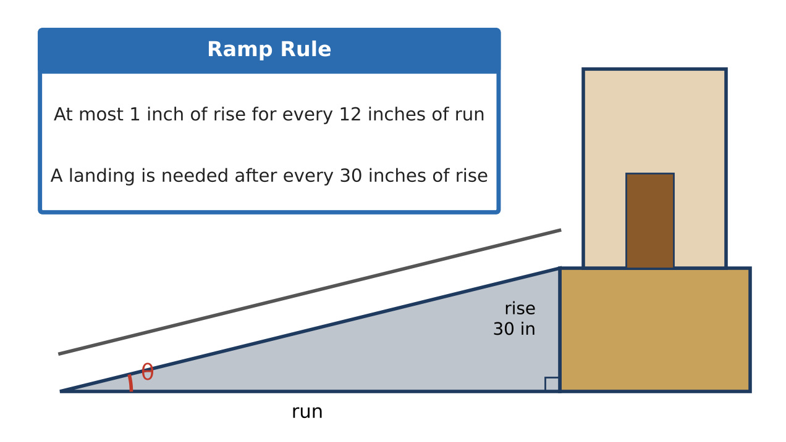
Learning Goals
- I can use the Pythagorean Theorem to find lengths.
- I can use sine, cosine, and tangent to find sides and angles.
- I can solve angle of elevation problems.
Project Timeline
When | What you will do
Day 1 | Rise, Run & Length
Day 2 | Angles & Trig
Day 3 | Design the Side Ramp
Final | Ramp Design Plan + reflection

Part 1: Rise, Run & Length
Day 1 · Use the Ramp Rule card.
1. The front entrance is 30 inches above the sidewalk. What is the shortest run allowed? Give your answer in inches and feet.

2. Use the Pythagorean Theorem to find the length of the ramp surface for that run.

3. Builders check square corners with a 6-8-10 triangle. Show that 6, 8, and 10 form a right triangle.

Part 2: Angles & Trig
Day 2 · Use a calculator in degree mode.
4. Find tan θ for the ramp (rise ÷ run). Then use tan⁻¹ to find the ramp's angle θ.

5. A 20-foot ladder leans against the gym at a 75° angle with the ground. How high does it reach? How far is its base from the wall?

6. From 50 feet away, a student sees the top of the gym at an angle of elevation of 32°. Her eyes are 5 feet above the ground. How tall is the gym?

Part 3: Design the Side Ramp
Day 3 · The side entrance is 21 inches high.
7. Find the shortest allowed run and the ramp length.

8. Find the ramp angle.

9. Draw a labeled scale drawing of your ramp (for example, 1 grid square = 1 foot).

Final Product: Ramp Design Plan
Your final product must include:
- Scale drawings of both ramps
- Run, length, and angle for each
- The ladder and gym answers
- A recommendation for the principal
Reflection
R1. Why does the rule use rise and run instead of the ramp's length?

R2. How are slope and the tangent ratio related?

Scoring Rubric
Criteria | 4 – Exceeds | 3 – Meets | 2 – Approaching | 1 – Beginning
Mathematical Accuracy | All calculations and solutions are correct; answers include units and are checked. | Nearly all work is correct; minor errors do not change conclusions. | Several errors; some conclusions are affected. | Many errors or missing work.
Reasoning & Justification | Clear, complete explanations connect every answer to the situation; uses precise vocabulary. | Explanations are mostly clear and connected to the situation. | Explanations are brief or partly unclear. | Little or no explanation.
Application & Design | Ramp design meets the rise-to-run rule and landing rule, with correct right-triangle calculations. Goes beyond the minimum with a creative, realistic choice. | Ramp design meets the rise-to-run rule and landing rule, with correct right-triangle calculations. | Design is incomplete or only partly uses the math from the unit. | Design is missing or unrelated to the unit math.
Communication & Presentation | Plan includes a scale drawing, run, ramp length, angle, landings, and a check against the rule. Polished, organized, and visually engaging. | Plan includes a scale drawing, run, ramp length, angle, landings, and a check against the rule. Organized and easy to follow. | Product is missing required parts or is hard to follow. | Product is mostly missing.

