GEOMETRY · UNIT 6: RIGHT TRIANGLES AND TRIGONOMETRY  Accessible Ramp Engineer  Design wheelchair ramps that meet the rules with the Pythagorean Theorem and trigonometry. | Honors  2–3 class periods

Name: ________________________________ Date: ______________ Period: ______
The Scenario
The school is adding wheelchair ramps to two entrances. Building codes allow at most 1 inch of rise for every 12 inches of run, and long ramps need flat landings.
Your team will compute the run, ramp length, and angle for each entrance, check other right-triangle situations on campus, and present a plan.
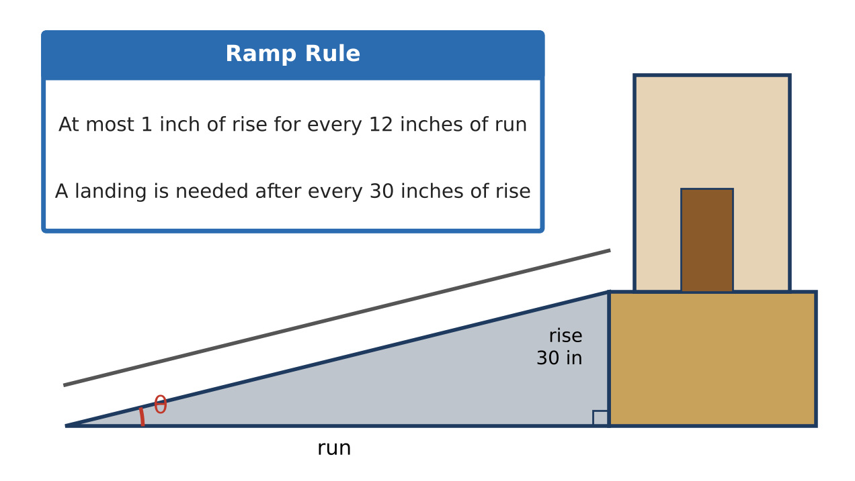
Learning Goals
- I can use exact trigonometric values and special right triangles.
- I can solve multi-step problems with two right triangles.
- I can optimize a design under code constraints.
Project Timeline
When | What you will do
Day 1 | Exact Steepness
Day 2 | Two Observations
Day 3 | Optimize the Gym Ramp
Final | Ramp Design Plan + reflection

Part 1: Exact Steepness
Day 1 · Give exact answers where possible.
1. Show that every ramp meeting the rule exactly has the same angle, θ = tan⁻¹(1 ÷ 12). Find sin θ and cos θ exactly.

2. Prove that sin θ = cos(90° − θ) using the ramp triangle.

3. A ramp must rise 30 inches but the space allows only 25 feet of run. What is the smallest number of inches the entrance must be lowered (or what else could change) to meet the rule?

Part 2: Two Observations
Day 2 · Draw both triangles carefully.
4. From point A the angle of elevation to the top of the gym is 30°. From point B, 40 ft closer, it is 45°. Find the height exactly and as a decimal (ignore eye height).

5. From the roof (40 ft high), the angles of depression to two cars in a line are 25° and 40°. How far apart are the cars?

6. Write a general formula for the height h if the angles are α and β (β > α) and the points are d apart.

Part 3: Optimize the Gym Ramp
Day 3 · Entrance height 45 inches; landings are 5 ft long; the lot is 30 ft deep.
7. Design a switchback ramp that fits in the 30-ft depth. How many sections and landings do you need?

8. Find the total ramp length and the total footprint area.

9. Justify that your design meets every rule and explain one trade-off.

Final Product: Ramp Design Plan
Your final product must include:
- Exact steepness analysis
- Two-observation solutions and the general formula
- Optimized ramp design with footprint
- Code compliance justification
Reflection
R1. How does a general formula help an engineer?

R2. Why is the ramp angle the same for every ramp that just meets the rule?

Scoring Rubric
Criteria | 4 – Exceeds | 3 – Meets | 2 – Approaching | 1 – Beginning
Mathematical Accuracy | All calculations and solutions are correct; answers include units and are checked. | Nearly all work is correct; minor errors do not change conclusions. | Several errors; some conclusions are affected. | Many errors or missing work.
Reasoning & Justification | Clear, complete explanations connect every answer to the situation; uses precise vocabulary. | Explanations are mostly clear and connected to the situation. | Explanations are brief or partly unclear. | Little or no explanation.
Application & Design | Ramp design meets the rise-to-run rule and landing rule, with correct right-triangle calculations. Goes beyond the minimum with a creative, realistic choice. | Ramp design meets the rise-to-run rule and landing rule, with correct right-triangle calculations. | Design is incomplete or only partly uses the math from the unit. | Design is missing or unrelated to the unit math.
Communication & Presentation | Plan includes a scale drawing, run, ramp length, angle, landings, and a check against the rule. Polished, organized, and visually engaging. | Plan includes a scale drawing, run, ramp length, angle, landings, and a check against the rule. Organized and easy to follow. | Product is missing required parts or is hard to follow. | Product is mostly missing.

