GEOMETRY · UNIT 8: TRANSFORMATIONS  Animation Studio  Animate a game sprite with translations, reflections, rotations, and dilations. | CP1  2–3 class periods

Name: ________________________________ Date: ______________ Period: ______
The Scenario
A small game studio needs an animator. Their sprite is a triangle with vertices A(1, 1), B(3, 1), and C(1, 4), and every move in the game is a transformation.
Game engines move sprites with coordinate rules, so you will write and apply rules, combine moves, and storyboard a short animation.
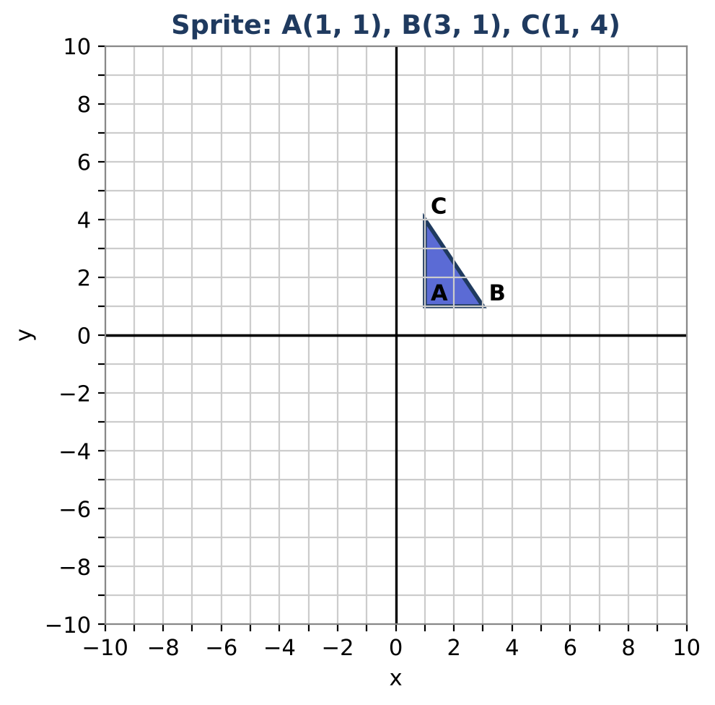
Learning Goals
- I can write and apply coordinate rules for transformations.
- I can compose transformations and find a single equivalent rule.
- I can describe a transformation from a figure and its image.
Project Timeline
When | What you will do
Day 1 | Single Moves
Day 2 | Combine Moves
Day 3 | Storyboard
Final | Animation Storyboard + reflection

Part 1: Single Moves
Day 1 · Write each rule, then apply it.
1. Apply rotations of 90°, 180°, and 270° counterclockwise about the origin to the sprite. Write each rule.

2. Reflect the sprite over the line y = x. Write the rule.

3. Dilate by ½ centered at the origin. Compare the side lengths and the area with the original.

Part 2: Combine Moves
Day 2 · Find single rules for combined moves.
4. Reflect over the x-axis, then over the y-axis. Write one rule for the result. Which single transformation is it?

5. Show that reflecting then translating gives a different result from translating then reflecting (use a reflection over the x-axis and a translation up 3).

6. The sprite's image is A′(4, −2), B′(6, −2), C′(4, 1). Describe the transformation and write its rule.

7. Describe a sequence of two transformations that maps the sprite to A″(−1, −1), B″(−3, −1), C″(−1, −4).

Part 3: Storyboard
Day 3 · Plan a six-frame animation that ends with the sprite back at the start.
8. Plan the moves and write each rule.

9. List the coordinates in each frame and show the last frame equals the first.

10. Explain why your sequence returns to the start.

Final Product: Animation Storyboard
Your final product must include:
- Six-frame storyboard
- Rules and coordinates
- Single-rule equivalents for two compositions
- Explanation of the return to start
Reflection
R1. Why is reflecting over both axes the same as a 180° rotation?

R2. How can you tell a rotation from a reflection by looking at vertex order?

Scoring Rubric
Criteria | 4 – Exceeds | 3 – Meets | 2 – Approaching | 1 – Beginning
Mathematical Accuracy | All calculations and solutions are correct; answers include units and are checked. | Nearly all work is correct; minor errors do not change conclusions. | Several errors; some conclusions are affected. | Many errors or missing work.
Reasoning & Justification | Clear, complete explanations connect every answer to the situation; uses precise vocabulary. | Explanations are mostly clear and connected to the situation. | Explanations are brief or partly unclear. | Little or no explanation.
Application & Design | Animation uses at least three different transformations with correct rules and coordinates. Goes beyond the minimum with a creative, realistic choice. | Animation uses at least three different transformations with correct rules and coordinates. | Design is incomplete or only partly uses the math from the unit. | Design is missing or unrelated to the unit math.
Communication & Presentation | Storyboard shows each frame on a grid with the coordinate rule and the image coordinates. Polished, organized, and visually engaging. | Storyboard shows each frame on a grid with the coordinate rule and the image coordinates. Organized and easy to follow. | Product is missing required parts or is hard to follow. | Product is mostly missing.

