GEOMETRY · UNIT 8: TRANSFORMATIONS  Animation Studio  Animate a game sprite with translations, reflections, rotations, and dilations. | CP2  2–3 class periods

Name: ________________________________ Date: ______________ Period: ______
The Scenario
A small game studio needs an animator. Their sprite is a triangle with vertices A(1, 1), B(3, 1), and C(1, 4), and every move in the game is a transformation.
Game engines move sprites with coordinate rules, so you will write and apply rules, combine moves, and storyboard a short animation.
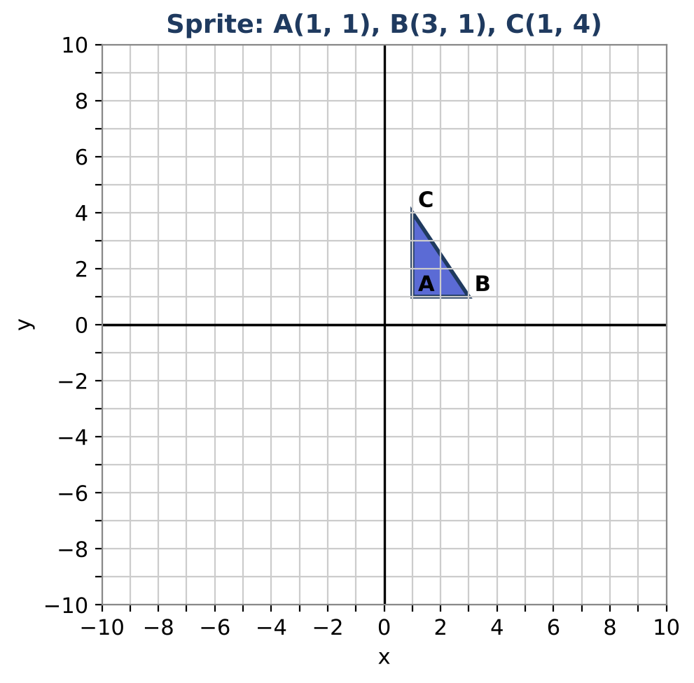
Learning Goals
- I can apply translations, reflections, rotations, and dilations with coordinate rules.
- I can identify which transformations preserve size and shape.
- I can plan a sequence of transformations.
Project Timeline
When | What you will do
Day 1 | Single Moves
Day 2 | Combine Moves
Day 3 | Storyboard
Final | Animation Storyboard + reflection

Part 1: Single Moves
Day 1 · Apply each rule to the sprite.
1. Complete the table. Rotate 90° counterclockwise about the origin with (x, y) → (−y, x).
Point | Translate (x + 5, y − 2) | Reflect over y-axis | Rotate 90° about origin | Dilate k = 2
A(1, 1)
B(3, 1)
C(1, 4)

2. Write the rule for a reflection over the y-axis and a dilation by 2 centered at the origin.

3. Which transformations keep the sprite the same size and shape (rigid motions)? Which one does not?

Part 2: Combine Moves
Day 2 · Apply the moves in order.
4. Reflect the sprite over the x-axis, then translate it up 3. Give the final coordinates.

5. Now translate up 3 first, then reflect over the x-axis. Are the results the same? What does this tell you?

6. A logo shaped like a regular hexagon looks the same after a rotation. What is the smallest rotation that works?

Part 3: Storyboard
Day 3 · Plan a four-frame animation.
7. Choose three different moves for frames 2, 3, and 4. Write each rule.

8. Give the coordinates of the sprite in every frame.

9. Draw the storyboard on graph paper.

Final Product: Animation Storyboard
Your final product must include:
- Four-frame storyboard on grids
- Coordinate rules for every move
- Coordinates in each frame
- A short description of the action
Reflection
R1. Why does the order of transformations matter?

R2. How is a dilation different from the other moves?

Scoring Rubric
Criteria | 4 – Exceeds | 3 – Meets | 2 – Approaching | 1 – Beginning
Mathematical Accuracy | All calculations and solutions are correct; answers include units and are checked. | Nearly all work is correct; minor errors do not change conclusions. | Several errors; some conclusions are affected. | Many errors or missing work.
Reasoning & Justification | Clear, complete explanations connect every answer to the situation; uses precise vocabulary. | Explanations are mostly clear and connected to the situation. | Explanations are brief or partly unclear. | Little or no explanation.
Application & Design | Animation uses at least three different transformations with correct rules and coordinates. Goes beyond the minimum with a creative, realistic choice. | Animation uses at least three different transformations with correct rules and coordinates. | Design is incomplete or only partly uses the math from the unit. | Design is missing or unrelated to the unit math.
Communication & Presentation | Storyboard shows each frame on a grid with the coordinate rule and the image coordinates. Polished, organized, and visually engaging. | Storyboard shows each frame on a grid with the coordinate rule and the image coordinates. Organized and easy to follow. | Product is missing required parts or is hard to follow. | Product is mostly missing.

