GEOMETRY · UNIT 8: TRANSFORMATIONS  Animation Studio  Animate a game sprite with translations, reflections, rotations, and dilations. | Honors  2–3 class periods

Name: ________________________________ Date: ______________ Period: ______
The Scenario
A small game studio needs an animator. Their sprite is a triangle with vertices A(1, 1), B(3, 1), and C(1, 4), and every move in the game is a transformation.
Game engines move sprites with coordinate rules, so you will write and apply rules, combine moves, and storyboard a short animation.
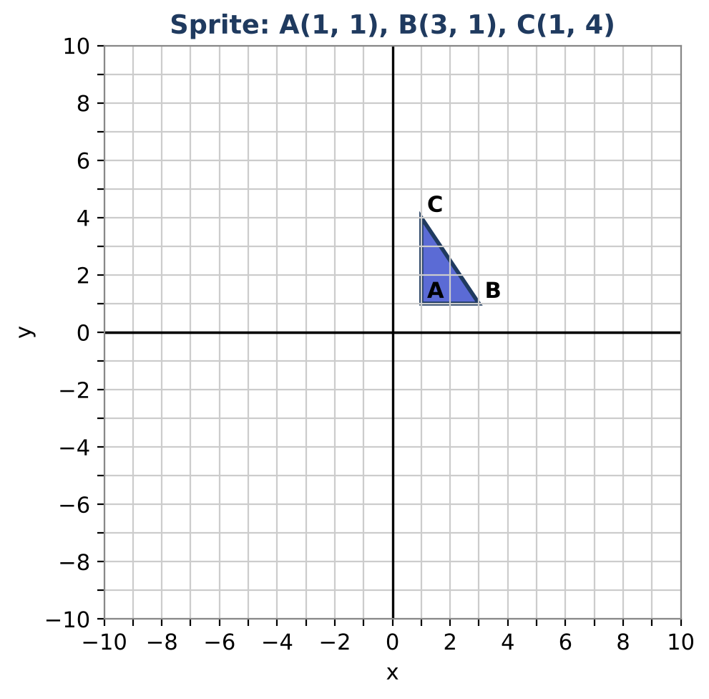
Learning Goals
- I can rotate and dilate about any center.
- I can find the line of reflection that maps a figure to its image.
- I can prove facts about compositions of reflections.
Project Timeline
When | What you will do
Day 1 | Moves About Any Point
Day 2 | Reflections & Compositions
Day 3 | Storyboard with Proof
Final | Animation Storyboard + reflection

Part 1: Moves About Any Point
Day 1 · Center the move at a vertex of the sprite.
1. Rotate the sprite 90° counterclockwise about A(1, 1).

2. Dilate the sprite by 3 with center A(1, 1). Is A′ different from A?

3. Write a general rule for rotating 90° counterclockwise about (h, k).

Part 2: Reflections & Compositions
Day 2 · Justify each answer.
4. A reflection maps A(1, 1) to (5, 3). Find the equation of the line of reflection.

5. Reflect the sprite over x = 2 and then over x = 5. Show that the result is a translation and find its distance.

6. Reflect over the x-axis and then over y = x. Show that the result is a rotation and find its angle.

Part 3: Storyboard with Proof
Day 3 · Design a looping animation of at least six frames that uses a rotation about a non-origin point.
7. Plan the frames and rules.

8. List all coordinates.

9. Prove that your loop returns to the start using compositions.

Final Product: Animation Storyboard
Your final product must include:
- Non-origin rotation and dilation
- Line of reflection
- Composition proofs
- Looping storyboard with proof
Reflection
R1. How are two reflections related to a translation or a rotation?

R2. Why does the center of a dilation stay fixed?

Scoring Rubric
Criteria | 4 – Exceeds | 3 – Meets | 2 – Approaching | 1 – Beginning
Mathematical Accuracy | All calculations and solutions are correct; answers include units and are checked. | Nearly all work is correct; minor errors do not change conclusions. | Several errors; some conclusions are affected. | Many errors or missing work.
Reasoning & Justification | Clear, complete explanations connect every answer to the situation; uses precise vocabulary. | Explanations are mostly clear and connected to the situation. | Explanations are brief or partly unclear. | Little or no explanation.
Application & Design | Animation uses at least three different transformations with correct rules and coordinates. Goes beyond the minimum with a creative, realistic choice. | Animation uses at least three different transformations with correct rules and coordinates. | Design is incomplete or only partly uses the math from the unit. | Design is missing or unrelated to the unit math.
Communication & Presentation | Storyboard shows each frame on a grid with the coordinate rule and the image coordinates. Polished, organized, and visually engaging. | Storyboard shows each frame on a grid with the coordinate rule and the image coordinates. Organized and easy to follow. | Product is missing required parts or is hard to follow. | Product is mostly missing.

