GEOMETRY · UNIT 3: TRIANGLE CONGRUENCE  Bridge Truss Inspector  Prove triangles congruent to inspect and design a footbridge truss. | CP1  2–3 class periods

Name: ________________________________ Date: ______________ Period: ______
The Scenario
The town's new footbridge uses a Warren truss: a chain of triangles between a top beam and a bottom beam. Triangles are rigid, so a truss made of congruent triangles spreads the load evenly.
The inspector needs proof that the triangles are congruent, plus the missing measurements. Then the town wants your design for a second bridge.
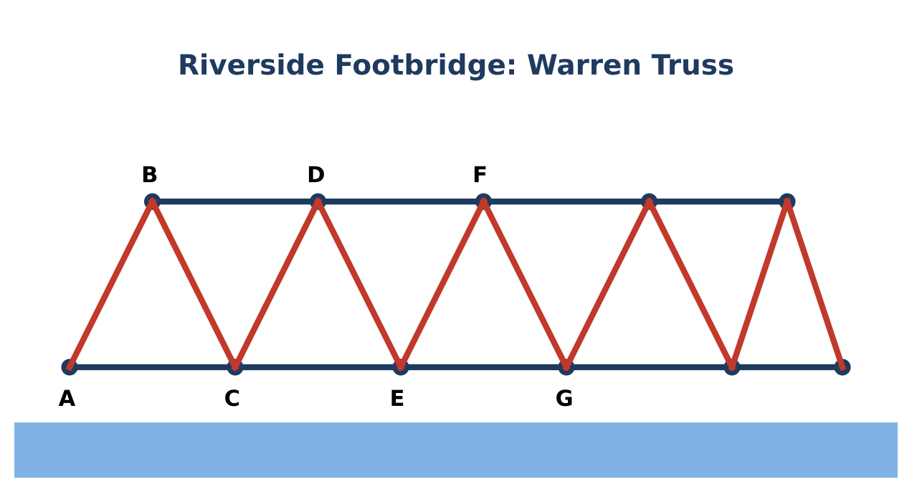
Learning Goals
- I can prove triangles congruent with SSS, SAS, ASA, AAS, and HL.
- I can use CPCTC to prove parts congruent.
- I can solve problems with isosceles triangles.
Project Timeline
When | What you will do
Day 1 | Inspect the Triangles
Day 2 | Proofs & Isosceles Triangles
Day 3 | Design a Truss
Final | Truss Inspection Report + reflection

Part 1: Inspect the Triangles
Day 1 · Justify every decision.
1. Name the shortcut for each pair or explain why there isn't one.
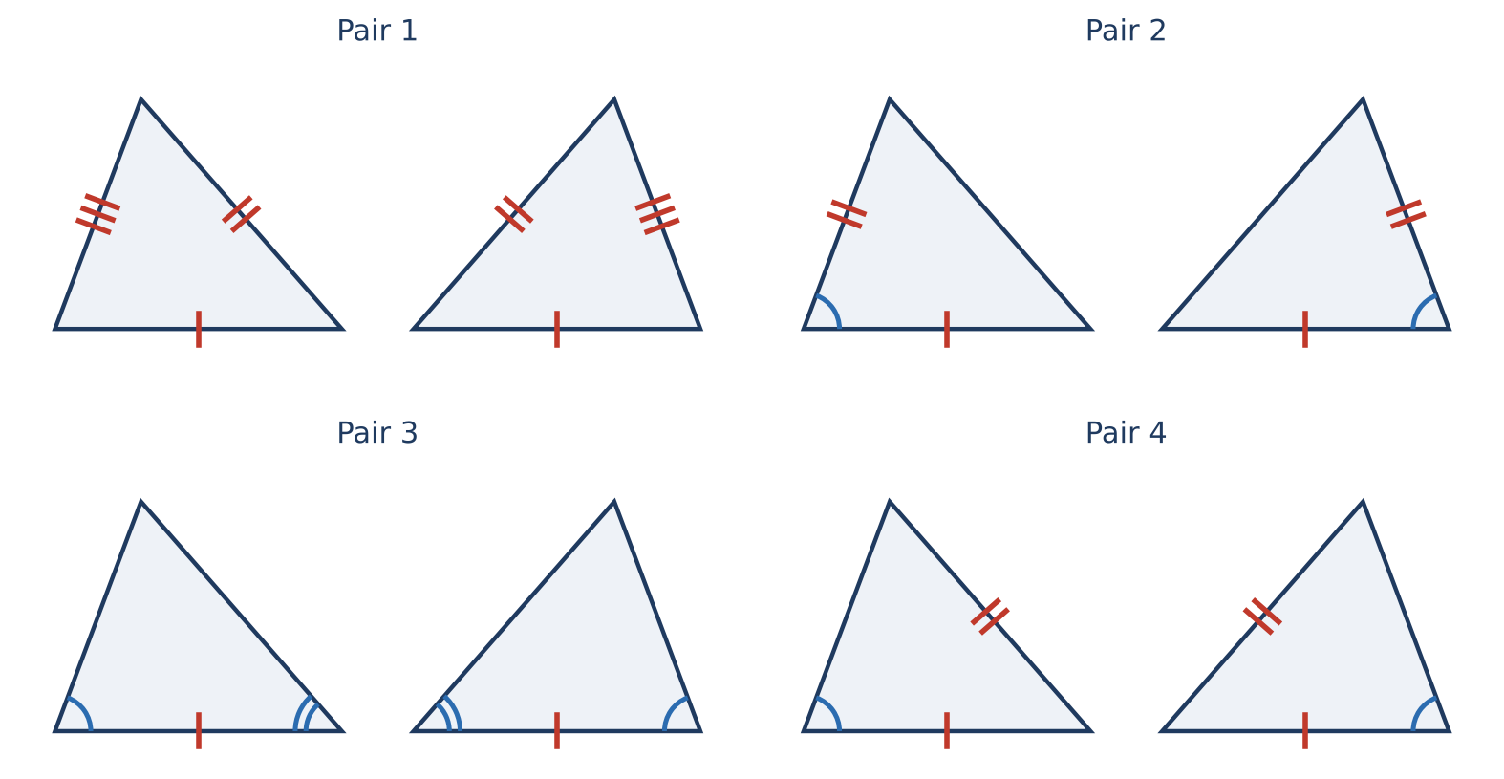

2. Two right triangles in the bridge's support have congruent hypotenuses and one pair of congruent legs. Which shortcut applies? Why does this not contradict "SSA doesn't work"?

3. Write a congruence statement for two triangles in the truss and list all six pairs of corresponding parts.

Part 2: Proofs & Isosceles Triangles
Day 2 · Use algebra and proof.
4. △ABC ≅ △DEF with AB = 3x − 2, DE = 2x + 5, m∠C = (5z − 10)°, and m∠F = (3z + 14)°. Find x, z, AB, and m∠C.

5. An isosceles truss triangle has base angles (3x + 5)° and (5x − 15)°. Find all three angles.

6. Given: B is the midpoint of AD and of CE (segments AD and CE cross at B). Prove: AC ∥ ED.

Part 3: Design a Truss
Day 3 · Design a 40-foot truss with congruent isosceles triangles.
7. Choose the base length and the height of each triangle. Sketch the truss with markings.

8. Prove that two adjacent triangles in your truss are congruent.

9. Find the total length of beam material you need (use the Pythagorean Theorem for the slanted members).

Final Product: Truss Inspection Report
Your final product must include:
- Congruence decisions and statements
- CPCTC proof
- Solved measurements
- Truss design with proof and material total
Reflection
R1. Why is HL a special case that works?

R2. How does CPCTC let you prove lines parallel?

Scoring Rubric
Criteria | 4 – Exceeds | 3 – Meets | 2 – Approaching | 1 – Beginning
Mathematical Accuracy | All calculations and solutions are correct; answers include units and are checked. | Nearly all work is correct; minor errors do not change conclusions. | Several errors; some conclusions are affected. | Many errors or missing work.
Reasoning & Justification | Clear, complete explanations connect every answer to the situation; uses precise vocabulary. | Explanations are mostly clear and connected to the situation. | Explanations are brief or partly unclear. | Little or no explanation.
Application & Design | Truss design uses congruent triangles with correct markings and a valid congruence justification. Goes beyond the minimum with a creative, realistic choice. | Truss design uses congruent triangles with correct markings and a valid congruence justification. | Design is incomplete or only partly uses the math from the unit. | Design is missing or unrelated to the unit math.
Communication & Presentation | Inspection report includes congruence decisions with shortcuts, solved measurements, at least one proof, and a labeled truss design. Polished, organized, and visually engaging. | Inspection report includes congruence decisions with shortcuts, solved measurements, at least one proof, and a labeled truss design. Organized and easy to follow. | Product is missing required parts or is hard to follow. | Product is mostly missing.

