GEOMETRY · UNIT 3: TRIANGLE CONGRUENCE  Bridge Truss Inspector  Prove triangles congruent to inspect and design a footbridge truss. | CP2  2–3 class periods

Name: ________________________________ Date: ______________ Period: ______
The Scenario
The town's new footbridge uses a Warren truss: a chain of triangles between a top beam and a bottom beam. Triangles are rigid, so a truss made of congruent triangles spreads the load evenly.
The inspector needs proof that the triangles are congruent, plus the missing measurements. Then the town wants your design for a second bridge.
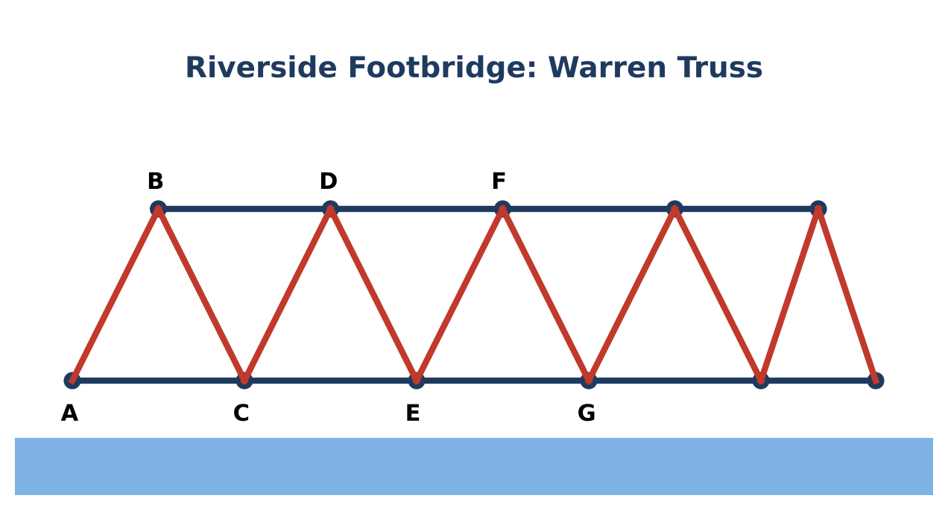
Learning Goals
- I can decide which congruence shortcut proves two triangles congruent.
- I can use corresponding parts to find unknown measures.
- I can complete a two-column proof.
Project Timeline
When | What you will do
Day 1 | Inspect the Triangles
Day 2 | Measure the Parts
Day 3 | Design a Truss
Final | Truss Inspection Report + reflection

Part 1: Inspect the Triangles
Day 1 · Look at the markings on each pair.
1. For each pair, name the shortcut (SSS, SAS, ASA, AAS) or write "not enough information".
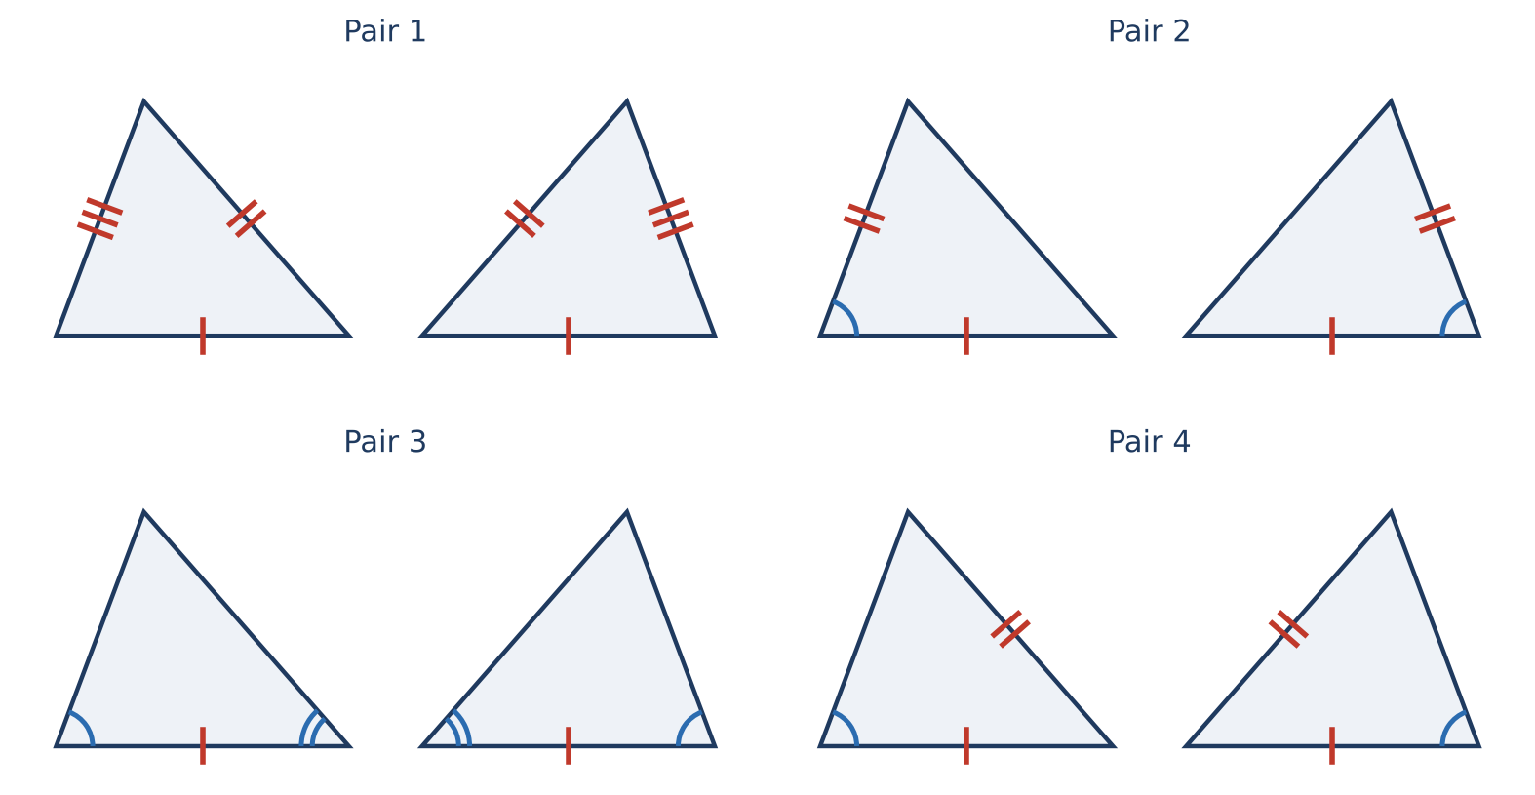

2. Why can't three pairs of congruent angles (AAA) prove two triangles congruent? Draw an example.

3. In the truss, AB ≅ CD, BC ≅ DE, and AC ≅ CE. Which shortcut proves △ABC ≅ △CDE?

4. Explain why a triangle frame is rigid but a square frame can wobble.

Part 2: Measure the Parts
Day 2 · △ABC ≅ △DEF. Corresponding parts are congruent.
5. AB = (3x − 2) ft and DE = (2x + 5) ft. Find x and AB.

6. m∠B = (4y + 6)° and m∠E = 62°. Find y.

7. A truss triangle is isosceles with a vertex angle of 40°. Find each base angle.

8. Complete the proof. Given: AB ≅ CB and BD bisects ∠ABC. Prove: △ABD ≅ △CBD.
Statement | Reason
1. AB ≅ CB | Given
2. BD bisects ∠ABC
3. ∠ABD ≅ ∠CBD
4. BD ≅ BD
5. △ABD ≅ △CBD

Part 3: Design a Truss
Day 3 · Design a truss for a 40-foot bridge.
9. Sketch a truss with at least four triangles. Mark the congruent sides and angles.

10. Name the shortcut that proves your triangles are congruent.

11. If every triangle is equilateral with 10-foot sides, how many triangles touch the bottom beam? What is each angle?

Final Product: Truss Inspection Report
Your final product must include:
- Labeled truss diagram with congruence markings
- Shortcut decisions for each pair
- Solved measurements
- Completed proof
- Recommendation to the town
Reflection
R1. Why is SSS the reason triangles are used in bridges?

R2. Why must you name the vertices in matching order?

Scoring Rubric
Criteria | 4 – Exceeds | 3 – Meets | 2 – Approaching | 1 – Beginning
Mathematical Accuracy | All calculations and solutions are correct; answers include units and are checked. | Nearly all work is correct; minor errors do not change conclusions. | Several errors; some conclusions are affected. | Many errors or missing work.
Reasoning & Justification | Clear, complete explanations connect every answer to the situation; uses precise vocabulary. | Explanations are mostly clear and connected to the situation. | Explanations are brief or partly unclear. | Little or no explanation.
Application & Design | Truss design uses congruent triangles with correct markings and a valid congruence justification. Goes beyond the minimum with a creative, realistic choice. | Truss design uses congruent triangles with correct markings and a valid congruence justification. | Design is incomplete or only partly uses the math from the unit. | Design is missing or unrelated to the unit math.
Communication & Presentation | Inspection report includes congruence decisions with shortcuts, solved measurements, at least one proof, and a labeled truss design. Polished, organized, and visually engaging. | Inspection report includes congruence decisions with shortcuts, solved measurements, at least one proof, and a labeled truss design. Organized and easy to follow. | Product is missing required parts or is hard to follow. | Product is mostly missing.

