GEOMETRY · UNIT 3: TRIANGLE CONGRUENCE  Bridge Truss Inspector  Prove triangles congruent to inspect and design a footbridge truss. | Honors  2–3 class periods

Name: ________________________________ Date: ______________ Period: ______
The Scenario
The town's new footbridge uses a Warren truss: a chain of triangles between a top beam and a bottom beam. Triangles are rigid, so a truss made of congruent triangles spreads the load evenly.
The inspector needs proof that the triangles are congruent, plus the missing measurements. Then the town wants your design for a second bridge.
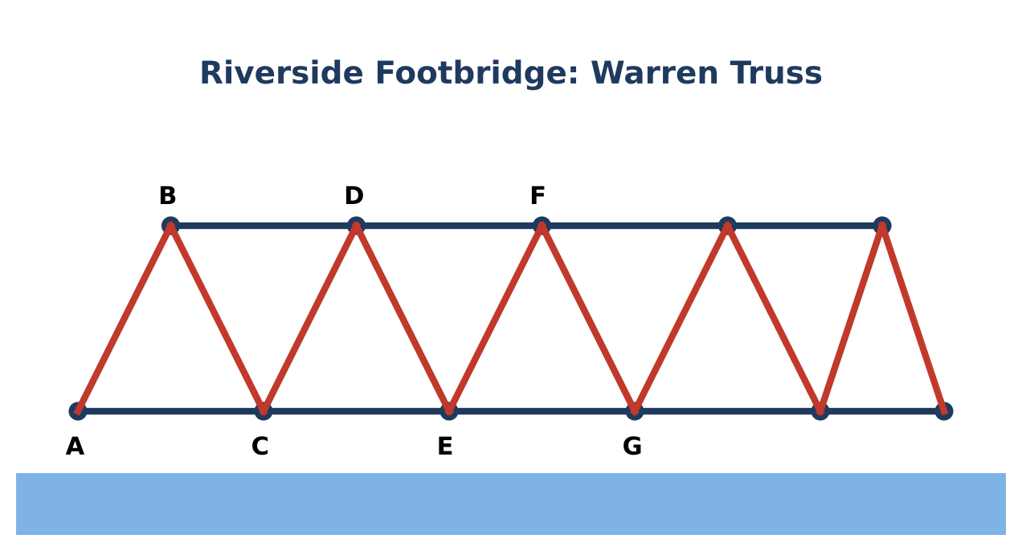
Learning Goals
- I can prove congruence with coordinates and with formal proofs.
- I can work with overlapping triangles.
- I can design a structure under angle constraints and justify it.
Project Timeline
When | What you will do
Day 1 | Coordinate Inspection
Day 2 | Proofs
Day 3 | Design Under Constraints
Final | Truss Inspection Report + reflection

Part 1: Coordinate Inspection
Day 1 · A model truss has A(0, 0), B(3, 6), C(6, 0), D(9, 6), and E(12, 0).
1. Use the distance formula to show △ABC ≅ △CDE by SSS.

2. Show that △BCD is also congruent to △ABC. Which vertex of △BCD matches A?

3. Prove BD ∥ AE using slopes. Then explain how congruent alternate interior angles also prove it.

Part 2: Proofs
Day 2 · Write formal proofs.
4. Given: B is the midpoint of AD and of CE. Prove: AC ∥ ED.

5. In the truss, AB ≅ BC, BC ≅ CD, and BD ∥ AC. Prove ∠BAC ≅ ∠BDC.

6. Explain why SSA fails by constructing two different triangles with sides 10 and 7 and a 40° angle opposite the 7.

Part 3: Design Under Constraints
Day 3 · Design a 48-foot bridge truss with congruent isosceles triangles whose base angles are between 50° and 70°.
7. Choose a base length that divides 48 and a height. Show with slopes (rise ÷ run) or a protractor that the base angles meet the rule.

8. Write a coordinate proof that two of your triangles are congruent.

9. Compute the total beam length and explain how the design spreads a load.

Final Product: Truss Inspection Report
Your final product must include:
- Coordinate proofs of congruence
- Two formal proofs
- SSA counterexample
- Constrained truss design with coordinate proof
Reflection
R1. How do coordinates turn a congruence proof into a calculation?

R2. Why does the truss need the top beam to be parallel to the bottom beam?

Scoring Rubric
Criteria | 4 – Exceeds | 3 – Meets | 2 – Approaching | 1 – Beginning
Mathematical Accuracy | All calculations and solutions are correct; answers include units and are checked. | Nearly all work is correct; minor errors do not change conclusions. | Several errors; some conclusions are affected. | Many errors or missing work.
Reasoning & Justification | Clear, complete explanations connect every answer to the situation; uses precise vocabulary. | Explanations are mostly clear and connected to the situation. | Explanations are brief or partly unclear. | Little or no explanation.
Application & Design | Truss design uses congruent triangles with correct markings and a valid congruence justification. Goes beyond the minimum with a creative, realistic choice. | Truss design uses congruent triangles with correct markings and a valid congruence justification. | Design is incomplete or only partly uses the math from the unit. | Design is missing or unrelated to the unit math.
Communication & Presentation | Inspection report includes congruence decisions with shortcuts, solved measurements, at least one proof, and a labeled truss design. Polished, organized, and visually engaging. | Inspection report includes congruence decisions with shortcuts, solved measurements, at least one proof, and a labeled truss design. Organized and easy to follow. | Product is missing required parts or is hard to follow. | Product is mostly missing.

