GEOMETRY · UNIT 4: TRIANGLE RELATIONSHIPS  Emergency Services Locator  Use points of concurrency to place a hospital, a warehouse, and a fire station. | CP1  2–3 class periods

Name: ________________________________ Date: ______________ Period: ______
The Scenario
The towns of Ashford, Brookside, and Cedar are building shared emergency services. The county wants a hospital the same distance from all three towns, a supply warehouse at the balance point of the region, and a fire station the same distance from the three main roads.
Each request matches a point of concurrency of the triangle formed by the towns. You will find the points, check road plans, and write a proposal.
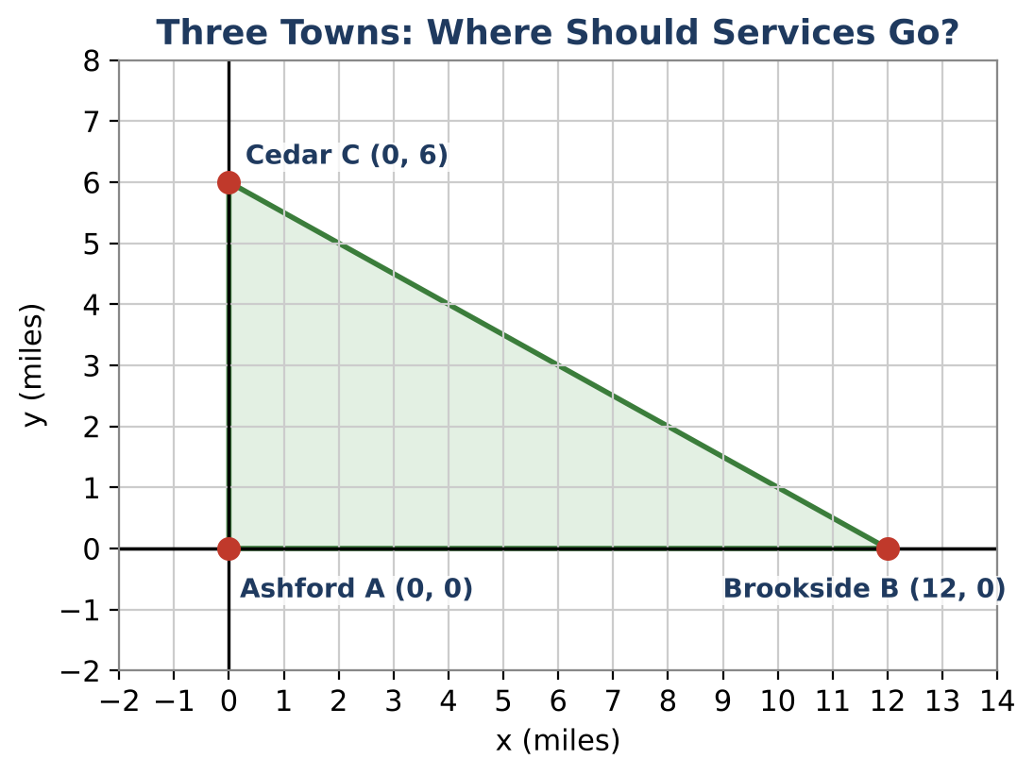
Learning Goals
- I can write equations of perpendicular bisectors and find their intersection.
- I can use medians and the centroid's 2 : 1 ratio.
- I can apply the Triangle Inequality, midsegments, and side–angle order.
Project Timeline
When | What you will do
Day 1 | Hospital & Warehouse
Day 2 | Roads & Bridges
Day 3 | Your Proposal
Final | Service Location Proposal + reflection

Part 1: Hospital & Warehouse
Day 1 · Ashford A(0, 0), Brookside B(12, 0), Cedar C(0, 6).
1. Write the equations of the perpendicular bisectors of AB, AC, and BC.

2. Find where they meet and verify it is equidistant from all three towns.

3. Find the centroid. Then show it is ⅔ of the way from A to the midpoint of BC.

Part 2: Roads & Bridges
Day 2 · Justify each answer.
4. Two roads from Ashford are 6 and 12 miles. What lengths are possible for a road that closes the triangle? Is BC's length in this range?

5. A bridge joins the midpoints of AC and BC. Prove it is parallel to AB and half as long, using slopes and distance.

6. Order the angles of triangle ABC from smallest to largest and the sides from shortest to longest. Explain the connection.

Part 3: Your Proposal
Day 3 · New towns: P(0, 0), Q(10, 0), R(4, 6).
7. Find the circumcenter using perpendicular bisectors.

8. Find the centroid. Is the circumcenter inside, on, or outside the triangle? Why?

9. Write a recommendation with a labeled map.

Final Product: Service Location Proposal
Your final product must include:
- Perpendicular bisector equations and the circumcenter
- Centroid with the 2 : 1 check
- Bridge proof
- Proposal for the new towns
Reflection
R1. Why do the three perpendicular bisectors always meet at one point?

R2. When is the circumcenter outside the triangle?

Scoring Rubric
Criteria | 4 – Exceeds | 3 – Meets | 2 – Approaching | 1 – Beginning
Mathematical Accuracy | All calculations and solutions are correct; answers include units and are checked. | Nearly all work is correct; minor errors do not change conclusions. | Several errors; some conclusions are affected. | Many errors or missing work.
Reasoning & Justification | Clear, complete explanations connect every answer to the situation; uses precise vocabulary. | Explanations are mostly clear and connected to the situation. | Explanations are brief or partly unclear. | Little or no explanation.
Application & Design | Locations are correct for the stated goal (equidistant from towns, balance point, equidistant from roads). Goes beyond the minimum with a creative, realistic choice. | Locations are correct for the stated goal (equidistant from towns, balance point, equidistant from roads). | Design is incomplete or only partly uses the math from the unit. | Design is missing or unrelated to the unit math.
Communication & Presentation | Proposal shows each point of concurrency on a map with calculations and a recommendation. Polished, organized, and visually engaging. | Proposal shows each point of concurrency on a map with calculations and a recommendation. Organized and easy to follow. | Product is missing required parts or is hard to follow. | Product is mostly missing.

