GEOMETRY · UNIT 4: TRIANGLE RELATIONSHIPS  Emergency Services Locator  Use points of concurrency to place a hospital, a warehouse, and a fire station. | CP2  2–3 class periods

Name: ________________________________ Date: ______________ Period: ______
The Scenario
The towns of Ashford, Brookside, and Cedar are building shared emergency services. The county wants a hospital the same distance from all three towns, a supply warehouse at the balance point of the region, and a fire station the same distance from the three main roads.
Each request matches a point of concurrency of the triangle formed by the towns. You will find the points, check road plans, and write a proposal.
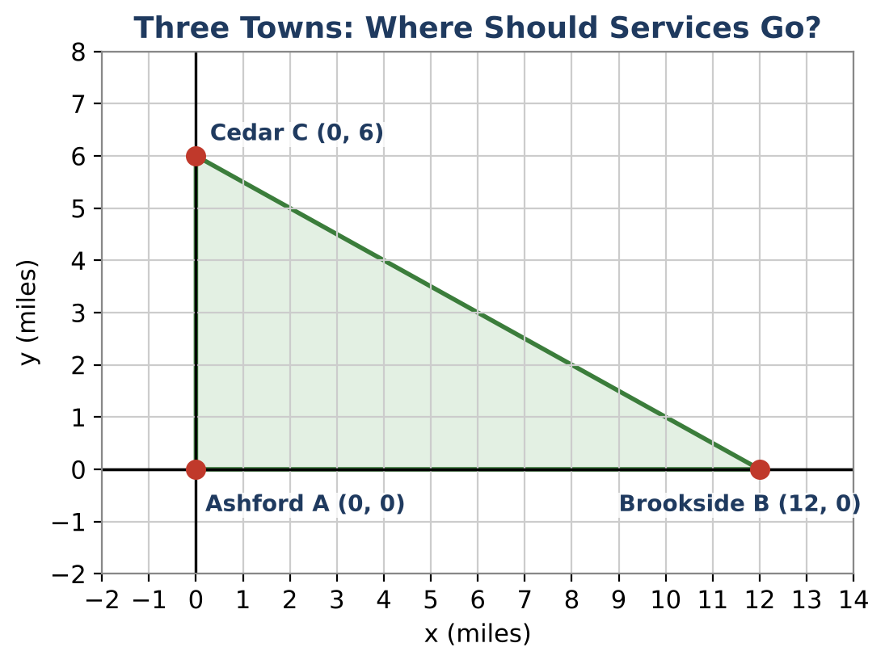
Learning Goals
- I can find the circumcenter and centroid of a triangle on the coordinate plane.
- I can use the Triangle Inequality and midsegments.
- I can relate side lengths to angle sizes.
Project Timeline
When | What you will do
Day 1 | Hospital & Warehouse
Day 2 | Roads & Bridges
Day 3 | Your Proposal
Final | Service Location Proposal + reflection

Part 1: Hospital & Warehouse
Day 1 · Ashford A(0, 0), Brookside B(12, 0), Cedar C(0, 6). Units are miles.
1. Classify triangle ABC by its sides and by its angles.

2. The hospital must be equidistant from all three towns (the circumcenter). In a right triangle, it is the midpoint of the hypotenuse. Find it.

3. Check: find the distance from the hospital to each town.

4. The warehouse goes at the centroid: average the x-coordinates and the y-coordinates of the towns. Find it.

Part 2: Roads & Bridges
Day 2 · Use triangle relationships.
5. Could three roads of 5, 8, and 14 miles form a triangle? Explain.

6. Two roads are 7 and 12 miles long. Write an inequality for the possible length x of the third road.

7. A bridge connects the midpoints of AC and BC. Find the midpoints and the length of the bridge. How does it compare to AB?

8. List the angles of triangle ABC from smallest to largest. Explain using the side lengths.

Part 3: Your Proposal
Day 3 · Three new towns: P(0, 0), Q(8, 0), R(0, 10).
9. Find the hospital (circumcenter) and the warehouse (centroid) for the new towns.

10. Show that the hospital is the same distance from all three new towns.

11. Write a recommendation to the county with a labeled map.

Final Product: Service Location Proposal
Your final product must include:
- Map with towns, hospital, and warehouse labeled
- Distance checks
- Road and bridge analysis
- Recommendation for the new towns
Reflection
R1. Why is the hospital outside or on the edge of some triangles?

R2. What does the centroid represent physically?

Scoring Rubric
Criteria | 4 – Exceeds | 3 – Meets | 2 – Approaching | 1 – Beginning
Mathematical Accuracy | All calculations and solutions are correct; answers include units and are checked. | Nearly all work is correct; minor errors do not change conclusions. | Several errors; some conclusions are affected. | Many errors or missing work.
Reasoning & Justification | Clear, complete explanations connect every answer to the situation; uses precise vocabulary. | Explanations are mostly clear and connected to the situation. | Explanations are brief or partly unclear. | Little or no explanation.
Application & Design | Locations are correct for the stated goal (equidistant from towns, balance point, equidistant from roads). Goes beyond the minimum with a creative, realistic choice. | Locations are correct for the stated goal (equidistant from towns, balance point, equidistant from roads). | Design is incomplete or only partly uses the math from the unit. | Design is missing or unrelated to the unit math.
Communication & Presentation | Proposal shows each point of concurrency on a map with calculations and a recommendation. Polished, organized, and visually engaging. | Proposal shows each point of concurrency on a map with calculations and a recommendation. Organized and easy to follow. | Product is missing required parts or is hard to follow. | Product is mostly missing.

