GEOMETRY · UNIT 4: TRIANGLE RELATIONSHIPS  Emergency Services Locator  Use points of concurrency to place a hospital, a warehouse, and a fire station. | Honors  2–3 class periods

Name: ________________________________ Date: ______________ Period: ______
The Scenario
The towns of Ashford, Brookside, and Cedar are building shared emergency services. The county wants a hospital the same distance from all three towns, a supply warehouse at the balance point of the region, and a fire station the same distance from the three main roads.
Each request matches a point of concurrency of the triangle formed by the towns. You will find the points, check road plans, and write a proposal.
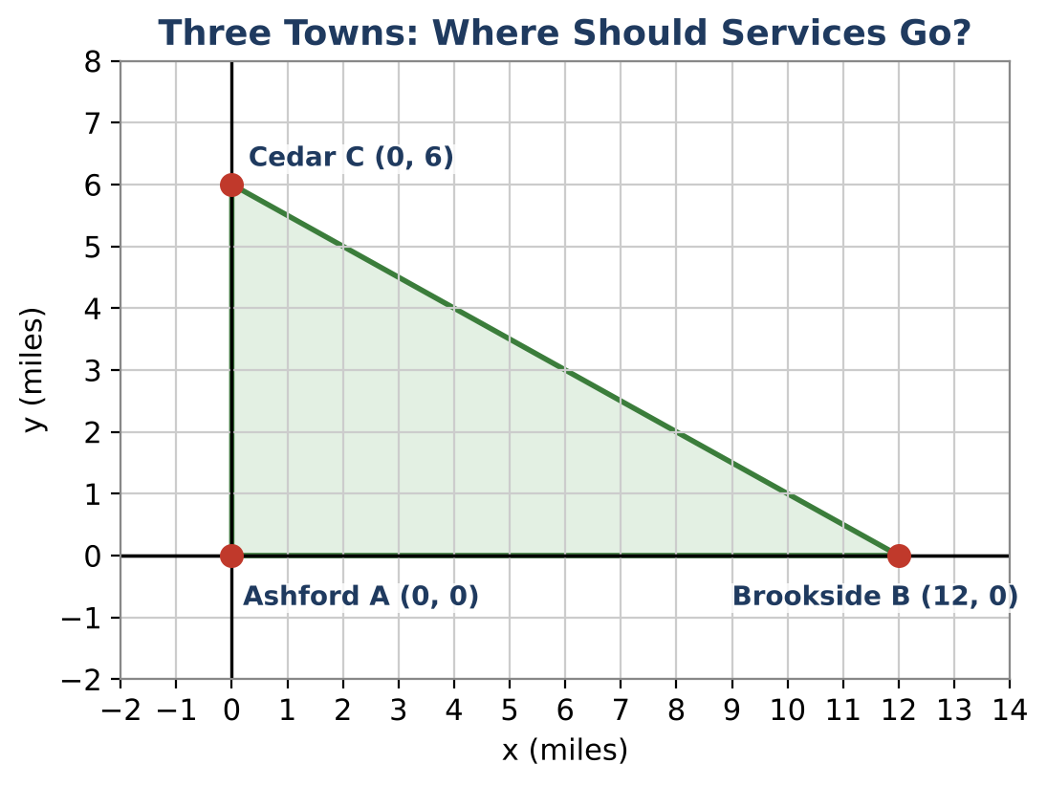
Learning Goals
- I can find the incenter and inradius of a triangle.
- I can verify the Euler line.
- I can choose and justify the right center for each purpose.
Project Timeline
When | What you will do
Day 1 | Three Centers
Day 2 | Proofs & Roads
Day 3 | Proposal for an Obtuse Region
Final | Service Location Proposal + reflection

Part 1: Three Centers
Day 1 · Ashford A(0, 0), Brookside B(12, 0), Cedar C(0, 6).
1. Find the circumcenter and centroid. Justify each.

2. The fire station must be equidistant from the three roads (the sides). For a right triangle with legs a and b and hypotenuse c, the inradius is r = (a + b − c) ÷ 2. Find the incenter exactly.

3. Find the orthocenter. Then show that the orthocenter, centroid, and circumcenter are collinear (the Euler line).

Part 2: Proofs & Roads
Day 2 · Prove and justify.
4. Prove that any point on the perpendicular bisector of AB is equidistant from A and B.

5. Prove that the midsegment joining the midpoints of AC and BC is parallel to AB and half its length, using general coordinates A(0, 0), B(2a, 0), C(2b, 2c).

6. A new road from Cedar to a point D on AB must be shorter than CB and longer than CA. Describe all possible locations of D.

Part 3: Proposal for an Obtuse Region
Day 3 · New towns: P(0, 0), Q(10, 0), R(2, 3).
7. Find the circumcenter and explain why it is outside the triangle.

8. Argue whether the circumcenter is still a good hospital location. Propose an alternative and justify it with distances.

9. Write the full proposal with a map.

Final Product: Service Location Proposal
Your final product must include:
- All four centers with exact coordinates
- Euler line verification
- Two proofs
- Proposal for an obtuse triangle with an alternative plan
Reflection
R1. Why does each center answer a different question?

R2. What happens to the Euler line in an equilateral triangle?

Scoring Rubric
Criteria | 4 – Exceeds | 3 – Meets | 2 – Approaching | 1 – Beginning
Mathematical Accuracy | All calculations and solutions are correct; answers include units and are checked. | Nearly all work is correct; minor errors do not change conclusions. | Several errors; some conclusions are affected. | Many errors or missing work.
Reasoning & Justification | Clear, complete explanations connect every answer to the situation; uses precise vocabulary. | Explanations are mostly clear and connected to the situation. | Explanations are brief or partly unclear. | Little or no explanation.
Application & Design | Locations are correct for the stated goal (equidistant from towns, balance point, equidistant from roads). Goes beyond the minimum with a creative, realistic choice. | Locations are correct for the stated goal (equidistant from towns, balance point, equidistant from roads). | Design is incomplete or only partly uses the math from the unit. | Design is missing or unrelated to the unit math.
Communication & Presentation | Proposal shows each point of concurrency on a map with calculations and a recommendation. Polished, organized, and visually engaging. | Proposal shows each point of concurrency on a map with calculations and a recommendation. Organized and easy to follow. | Product is missing required parts or is hard to follow. | Product is mostly missing.

