GEOMETRY · UNIT 2: ANGLES AND PARALLEL LINES  Parking Lot Designer  Use parallel lines and transversals to design an angled parking lot. | CP1  2–3 class periods

Name: ________________________________ Date: ______________ Period: ______
The Scenario
The school is repaving its parking lot, and the facilities director wants angled spaces that are easier to pull into. The stripes for the spaces must all be parallel, and the curb and aisle edges are parallel too.
That means every stripe is a transversal crossing two parallel lines, so the angles must follow the parallel-line rules. You will check the plan, find the missing angles, and design your own lot.
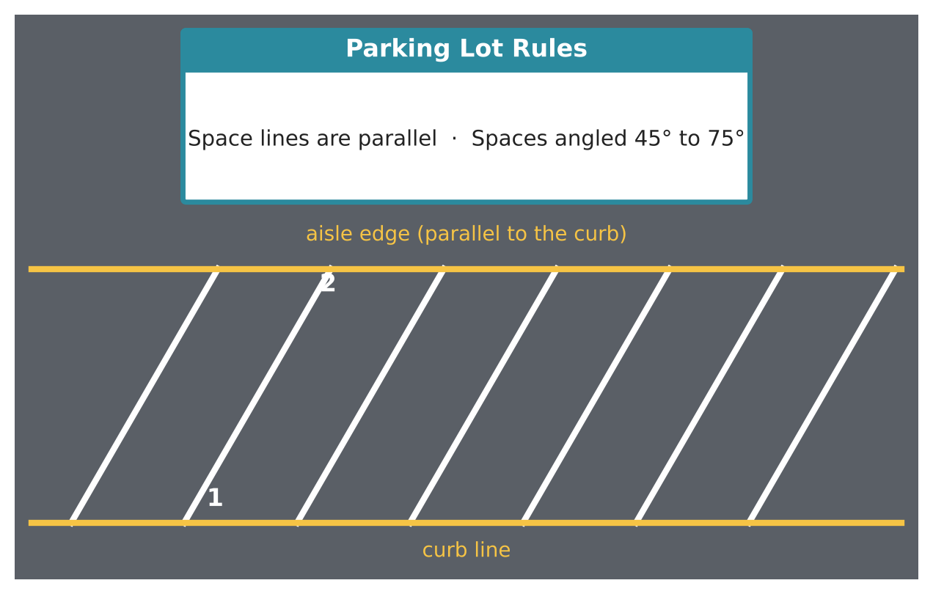
Learning Goals
- I can use parallel-line theorems and their converses.
- I can solve multi-step angle problems with algebra.
- I can use triangle angle sum and exterior angle theorems.
Project Timeline
When | What you will do
Day 1 | Angle Pairs on the Lot
Day 2 | Is It Really Parallel?
Day 3 | Design Your Lot
Final | Parking Lot Blueprint + reflection

Part 1: Angle Pairs on the Lot
Day 1 · Lines m and n are parallel; t is a stripe.
1. If m∠2 = (4x + 8)° and m∠7 = (6x − 12)°, what is the relationship between ∠2 and ∠7? Find x and every angle.
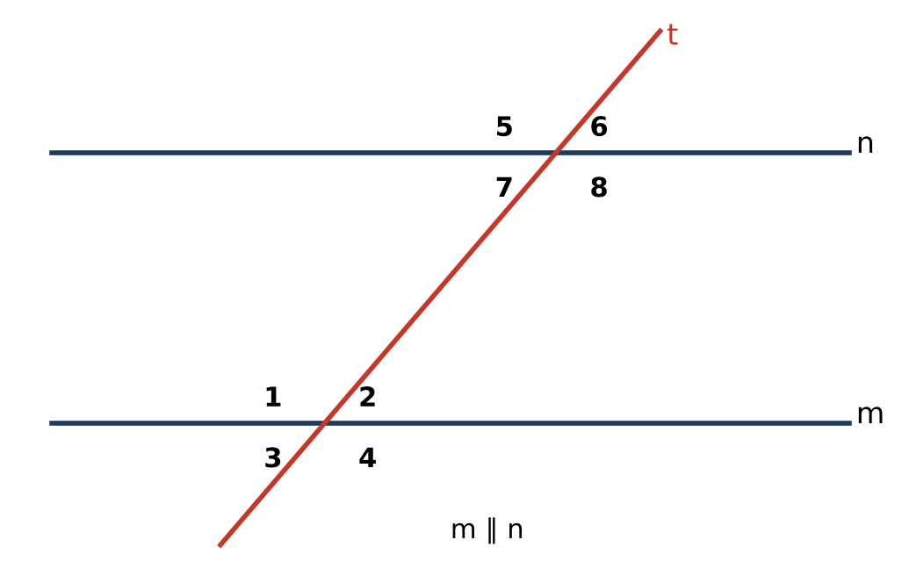

2. If m∠1 = 2a° and m∠7 = (a + 30)°, find a and both angles. Which theorem did you use?

3. Explain why ∠3 and ∠6 are congruent using a chain of two theorems.

Part 2: Is It Really Parallel?
Day 2 · The painters measured some angles. Decide whether the stripes are parallel.
4. Two stripes cross the curb at 62° and 62° as corresponding angles. Are the stripes parallel? Which converse proves it?

5. Same-side interior angles between two stripes and the curb measure 117° and 65°. Are the stripes parallel? Explain.

6. A triangular island has angles (x + 10)°, (2x − 5)°, and (3x + 25)°. Find all three angles and the exterior angle at the largest angle.

7. Stripe angles must be between 45° and 75°. If a stripe makes an angle of (3k + 9)° with the curb, write and solve a compound inequality for k.

Part 3: Design Your Lot
Day 3 · Design a lot with two rows of angled spaces facing a shared aisle.
8. Draw your design and label one stripe's eight angles.

9. Show, using a converse, that your two rows of stripes are parallel to each other.

10. Add an island and label its interior and exterior angles.

Final Product: Parking Lot Blueprint
Your final product must include:
- Blueprint with two rows of parallel stripes
- Angle measures with theorem names
- Converse proof that stripes are parallel
- Island with interior and exterior angles
Reflection
R1. What is the difference between a theorem and its converse? Give an example from the lot.

R2. How did algebra help you check the painters' work?

Scoring Rubric
Criteria | 4 – Exceeds | 3 – Meets | 2 – Approaching | 1 – Beginning
Mathematical Accuracy | All calculations and solutions are correct; answers include units and are checked. | Nearly all work is correct; minor errors do not change conclusions. | Several errors; some conclusions are affected. | Many errors or missing work.
Reasoning & Justification | Clear, complete explanations connect every answer to the situation; uses precise vocabulary. | Explanations are mostly clear and connected to the situation. | Explanations are brief or partly unclear. | Little or no explanation.
Application & Design | Design follows the rules (parallel stripes, angles between 45° and 75°) with every angle justified. Goes beyond the minimum with a creative, realistic choice. | Design follows the rules (parallel stripes, angles between 45° and 75°) with every angle justified. | Design is incomplete or only partly uses the math from the unit. | Design is missing or unrelated to the unit math.
Communication & Presentation | Blueprint shows parallel stripes, labeled angle measures with reasons, and a traffic island. Polished, organized, and visually engaging. | Blueprint shows parallel stripes, labeled angle measures with reasons, and a traffic island. Organized and easy to follow. | Product is missing required parts or is hard to follow. | Product is mostly missing.

