GEOMETRY · UNIT 2: ANGLES AND PARALLEL LINES  Parking Lot Designer  Use parallel lines and transversals to design an angled parking lot. | CP2  2–3 class periods

Name: ________________________________ Date: ______________ Period: ______
The Scenario
The school is repaving its parking lot, and the facilities director wants angled spaces that are easier to pull into. The stripes for the spaces must all be parallel, and the curb and aisle edges are parallel too.
That means every stripe is a transversal crossing two parallel lines, so the angles must follow the parallel-line rules. You will check the plan, find the missing angles, and design your own lot.
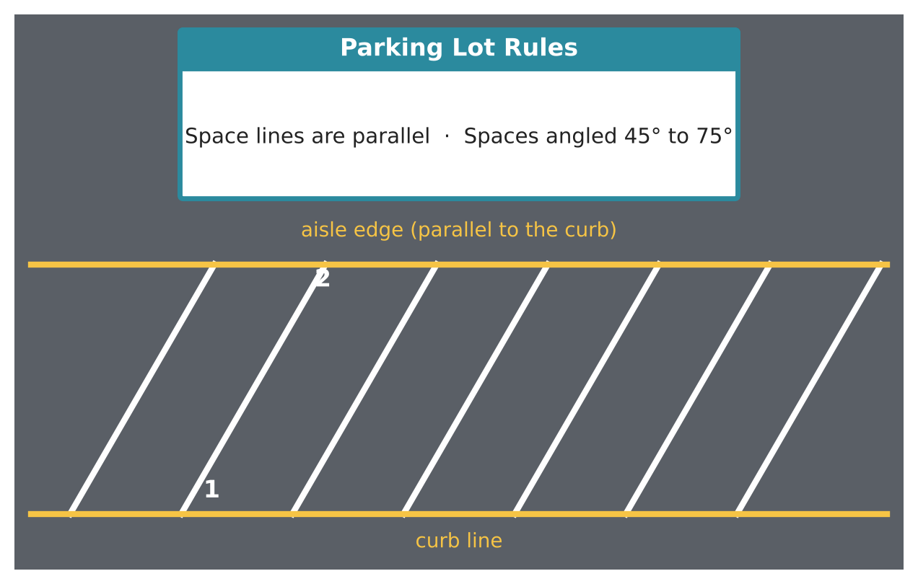
Learning Goals
- I can name angle pairs formed by parallel lines and a transversal.
- I can use angle relationships to find missing angles.
- I can use the triangle angle sum.
Project Timeline
When | What you will do
Day 1 | Angle Pairs on the Lot
Day 2 | Use Algebra
Day 3 | Design Your Lot
Final | Parking Lot Blueprint + reflection

Part 1: Angle Pairs on the Lot
Day 1 · Lines m and n are parallel. Line t is a stripe (transversal).
1. Name a pair of corresponding angles, alternate interior angles, and same-side interior angles in the diagram.
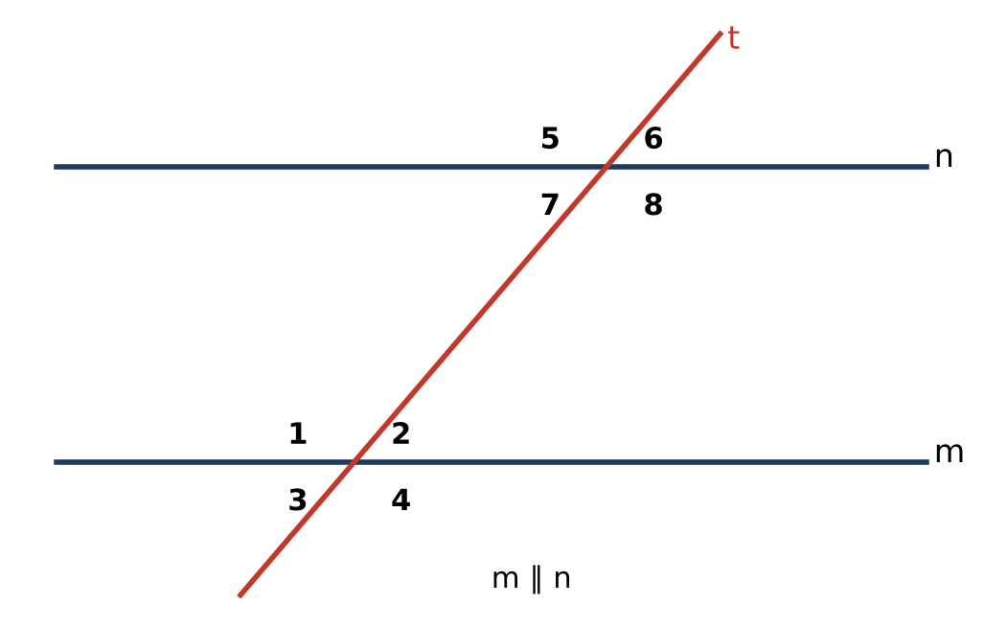

2. If m∠2 = 60°, find the measures of the other seven angles.

3. Which angle pairs are congruent and which are supplementary?

Part 2: Use Algebra
Day 2 · Write and solve an equation for each.
4. Alternate interior angles measure (3x + 15)° and (5x − 25)°. Find x and the angle measure.

5. Same-side interior angles measure (2y + 10)° and (4y − 10)°. Find y and both angles.
Starter: Same-side interior angles add to 180°.

6. A triangular traffic island has angles x°, 2x°, and 3x°. Find each angle.

7. An exterior angle of the island measures 130°. One remote interior angle is 70°. Find the other.

Part 3: Design Your Lot
Day 3 · Rules: stripes are parallel, and spaces make an angle between 45° and 75° with the curb.
8. Draw a curb and an aisle edge that are parallel. Choose an angle for your spaces and draw at least five stripes.

9. Label all eight angles at one stripe and explain how you found them.

10. Add a triangular island and label its angles.

Final Product: Parking Lot Blueprint
Your final product must include:
- Blueprint with parallel stripes and an angle between 45° and 75°
- Labeled angles at one stripe with reasons
- Traffic island with angle measures
- A note to the facilities director
Reflection
R1. Why do all the stripes have to make the same angle with the curb?

R2. Which angle relationship was most useful? Why?

Scoring Rubric
Criteria | 4 – Exceeds | 3 – Meets | 2 – Approaching | 1 – Beginning
Mathematical Accuracy | All calculations and solutions are correct; answers include units and are checked. | Nearly all work is correct; minor errors do not change conclusions. | Several errors; some conclusions are affected. | Many errors or missing work.
Reasoning & Justification | Clear, complete explanations connect every answer to the situation; uses precise vocabulary. | Explanations are mostly clear and connected to the situation. | Explanations are brief or partly unclear. | Little or no explanation.
Application & Design | Design follows the rules (parallel stripes, angles between 45° and 75°) with every angle justified. Goes beyond the minimum with a creative, realistic choice. | Design follows the rules (parallel stripes, angles between 45° and 75°) with every angle justified. | Design is incomplete or only partly uses the math from the unit. | Design is missing or unrelated to the unit math.
Communication & Presentation | Blueprint shows parallel stripes, labeled angle measures with reasons, and a traffic island. Polished, organized, and visually engaging. | Blueprint shows parallel stripes, labeled angle measures with reasons, and a traffic island. Organized and easy to follow. | Product is missing required parts or is hard to follow. | Product is mostly missing.

