GEOMETRY · UNIT 2: ANGLES AND PARALLEL LINES  Parking Lot Designer  Use parallel lines and transversals to design an angled parking lot. | Honors  2–3 class periods

Name: ________________________________ Date: ______________ Period: ______
The Scenario
The school is repaving its parking lot, and the facilities director wants angled spaces that are easier to pull into. The stripes for the spaces must all be parallel, and the curb and aisle edges are parallel too.
That means every stripe is a transversal crossing two parallel lines, so the angles must follow the parallel-line rules. You will check the plan, find the missing angles, and design your own lot.
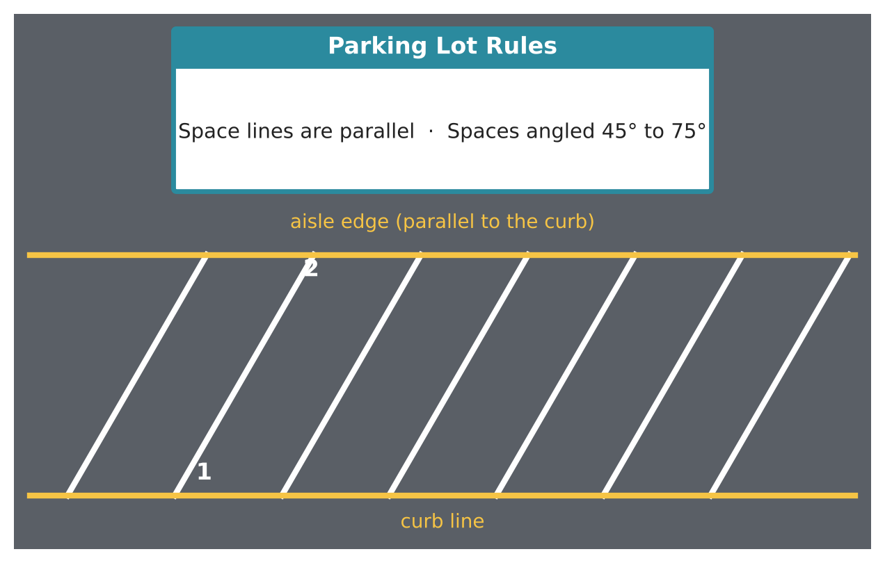
Learning Goals
- I can write two-column proofs about parallel lines.
- I can solve systems of equations that come from angle relationships.
- I can design within constraints and prove the design is correct.
Project Timeline
When | What you will do
Day 1 | Systems from Angles
Day 2 | Proofs & Islands
Day 3 | Design & Prove
Final | Parking Lot Blueprint + reflection

Part 1: Systems from Angles
Day 1 · Lines m and n are parallel; t is a stripe.
1. m∠1 = (3x + y)°, m∠5 = 110°, m∠2 = (2x − y)°, and m∠6 = 70°. Write a system and solve for x and y.
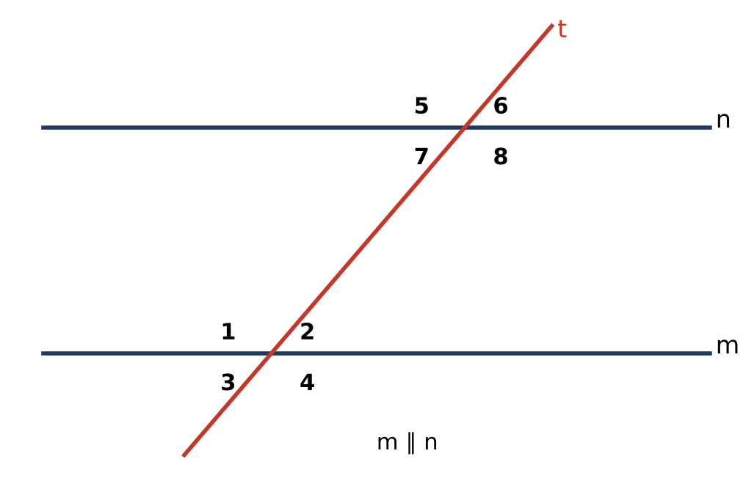

2. m∠3 = (x² − 5x)° and m∠6 = (2x + 18)°. Find all possible values of x that make the angles valid.

3. Prove: If m ∥ n, then ∠1 and ∠7 are supplementary.

Part 2: Proofs & Islands
Day 2 · Justify every step.
4. Prove the Triangle Angle Sum Theorem using a line through one vertex parallel to the opposite side.

5. A triangular island has an exterior angle of (5x − 6)° and remote interior angles of (2x + 8)° and (x + 22)°. Find all interior angles.

6. Two stripes make angles of (4k − 3)° and (2k + 39)° with the curb at corresponding positions. For what k are they parallel? Is that k allowed by the 45° to 75° rule?

Part 3: Design & Prove
Day 3 · Design a lot with stripes at a chosen angle θ, a crosswalk that is a transversal, and a triangular island.
7. Draw the design and give every angle in terms of θ.

8. Write a proof that your crosswalk makes equal angles with every stripe.

9. Choose θ so that the island's angles are θ, 2θ − 30, and a third angle that is a whole number between 45 and 75. Show your work.

Final Product: Parking Lot Blueprint
Your final product must include:
- System and quadratic angle solutions
- Two proofs (parallel lines and triangle sum)
- Design with angles written in terms of θ
- Island design meeting the constraint
Reflection
R1. Why does the Triangle Angle Sum proof need a parallel line?

R2. How did writing angles in terms of θ help your design?

Scoring Rubric
Criteria | 4 – Exceeds | 3 – Meets | 2 – Approaching | 1 – Beginning
Mathematical Accuracy | All calculations and solutions are correct; answers include units and are checked. | Nearly all work is correct; minor errors do not change conclusions. | Several errors; some conclusions are affected. | Many errors or missing work.
Reasoning & Justification | Clear, complete explanations connect every answer to the situation; uses precise vocabulary. | Explanations are mostly clear and connected to the situation. | Explanations are brief or partly unclear. | Little or no explanation.
Application & Design | Design follows the rules (parallel stripes, angles between 45° and 75°) with every angle justified. Goes beyond the minimum with a creative, realistic choice. | Design follows the rules (parallel stripes, angles between 45° and 75°) with every angle justified. | Design is incomplete or only partly uses the math from the unit. | Design is missing or unrelated to the unit math.
Communication & Presentation | Blueprint shows parallel stripes, labeled angle measures with reasons, and a traffic island. Polished, organized, and visually engaging. | Blueprint shows parallel stripes, labeled angle measures with reasons, and a traffic island. Organized and easy to follow. | Product is missing required parts or is hard to follow. | Product is mostly missing.

