CALCULUS · UNIT 6: THE FUNDAMENTAL THEOREM OF CALCULUS  Coffee Shop Rush  Use the Fundamental Theorem of Calculus to track customers, inventory, and wait times at a coffee shop. | CP1  2–3 class periods

Name: ________________________________ Date: ______________ Period: ______
The Scenario
The Daily Grind coffee shop gets slammed from 6 to 10 a.m. Customers arrive at a changing rate, baristas serve at a steady rate, and the line grows and shrinks.
You will use the Fundamental Theorem of Calculus to track the line, the milk supply, and the average wait, and then recommend how many baristas to schedule.
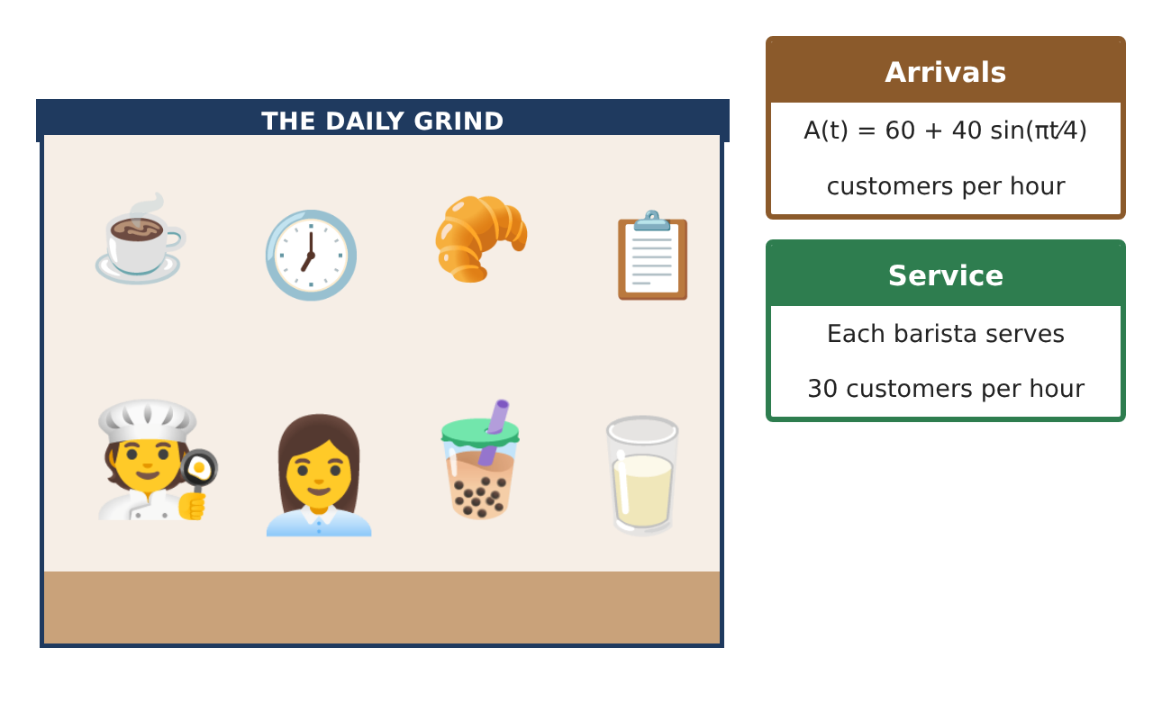
Learning Goals
- I can use the FTC to compute net change and accumulation.
- I can analyze accumulation functions defined by integrals.
- I can find average value and interpret it.
Project Timeline
When | What you will do
Day 1 | Line Length
Day 2 | Milk & FTC
Day 3 | Staffing
Final | Rush-Hour Staffing Plan + reflection
Part 1: Line Length
Day 1 · With 3 baristas (90 per hour) the early line clears quickly. A new line starts when arrivals pass 90 per hour at t ≈ 1.08 (7:05 a.m.), so L(t) = ∫ from 1.08 to t of (A(x) − 90) dx.
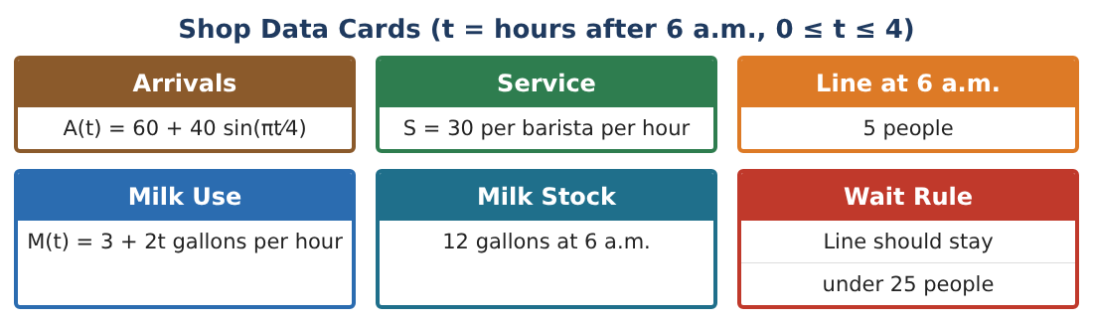
1. Find L′(t) using FTC Part 1. When is the line growing?

2. When is the line longest? Justify.

3. Find the maximum line length (technology allowed).

4. Find L(4) and interpret.

Part 2: Milk & FTC
Day 2 · M(t) = 3 + 2t gallons per hour; 12 gallons at 6 a.m.
5. Write the milk remaining as G(t) = 12 − ∫₀ᵗ M(x) dx and find G(2).

6. Find $\frac{d}{dt}$ ∫₀^(t²) (3 + 2x) dx.

7. A delivery adds 20 gallons at 8 a.m. Write the milk remaining for t > 2 and find when it runs out.

8. Find the average value of A(t) on [0, 4].

Part 3: Staffing
Day 3 · Wait rule: keep the line under 25 people.
9. With 2 baristas (60/hour), write L₂(t) = 5 + ∫₀ᵗ (A − 60) dx and find L₂(4).

10. With 3 baristas, show the line never exceeds 25.

11. Write the staffing plan with the number of baristas by hour and the milk order.

Final Product: Rush-Hour Staffing Plan
Your final product must include:
- Line model with FTC Part 1
- Maximum line and timing
- Milk accumulation with delivery
- Average arrival rate
- Staffing plan
Reflection
R1. How does FTC Part 1 let you find when the line is longest without integrating?

R2. What assumptions in the model break down, and why?

Scoring Rubric
Criteria | 4 – Exceeds | 3 – Meets | 2 – Approaching | 1 – Beginning
Mathematical Accuracy | All calculations and solutions are correct; answers include units and are checked. | Nearly all work is correct; minor errors do not change conclusions. | Several errors; some conclusions are affected. | Many errors or missing work.
Reasoning & Justification | Clear, complete explanations connect every answer to the situation; uses precise vocabulary. | Explanations are mostly clear and connected to the situation. | Explanations are brief or partly unclear. | Little or no explanation.
Application & Design | Integrals of rates, accumulation functions, and average values are correct and support the staffing decision. Goes beyond the minimum with a creative, realistic choice. | Integrals of rates, accumulation functions, and average values are correct and support the staffing decision. | Design is incomplete or only partly uses the math from the unit. | Design is missing or unrelated to the unit math.
Communication & Presentation | Plan includes models, FTC work, graphs, and a clear staffing schedule. Polished, organized, and visually engaging. | Plan includes models, FTC work, graphs, and a clear staffing schedule. Organized and easy to follow. | Product is missing required parts or is hard to follow. | Product is mostly missing.

