CALCULUS · UNIT 6: THE FUNDAMENTAL THEOREM OF CALCULUS  Coffee Shop Rush  Use the Fundamental Theorem of Calculus to track customers, inventory, and wait times at a coffee shop. | CP2  2–3 class periods

Name: ________________________________ Date: ______________ Period: ______
The Scenario
The Daily Grind coffee shop gets slammed from 6 to 10 a.m. Customers arrive at a changing rate, baristas serve at a steady rate, and the line grows and shrinks.
You will use the Fundamental Theorem of Calculus to track the line, the milk supply, and the average wait, and then recommend how many baristas to schedule.
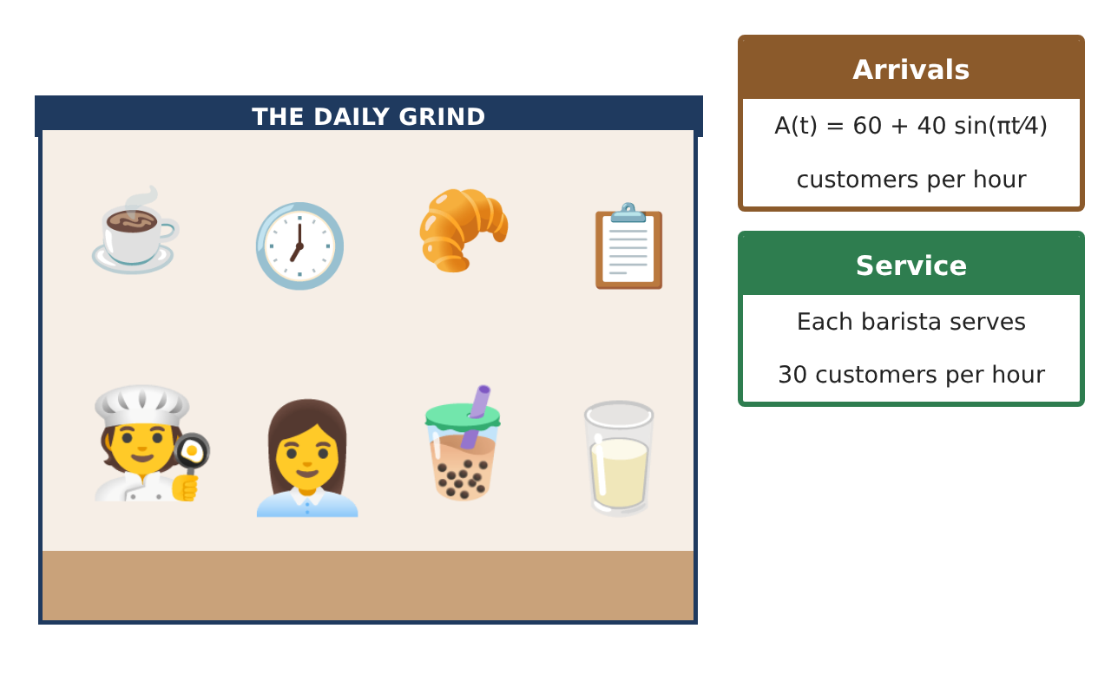
Learning Goals
- I can interpret a definite integral of a rate as a total change.
- I can evaluate definite integrals with the FTC.
- I can find the average value of a function.
Project Timeline
When | What you will do
Day 1 | Milk Supply
Day 2 | Customers
Day 3 | Plan
Final | Rush-Hour Staffing Plan + reflection
Part 1: Milk Supply
Day 1 · Milk is used at M(t) = 3 + 2t gallons per hour.
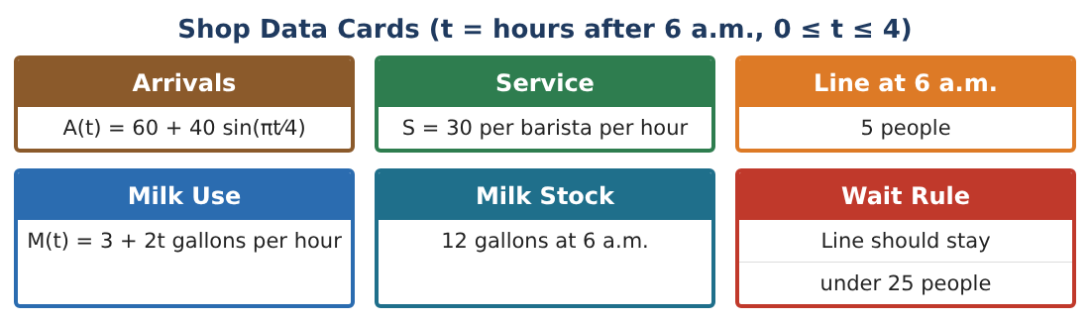
1. Find ∫₀⁴ (3 + 2t) dt. What does it mean?
Starter: Antiderivative: 3t + ___

2. The shop has 12 gallons at 6 a.m. When does it run out? Solve 3t + t² = 12.

3. How many gallons are used from 7 to 9 a.m. (t = 1 to 3)?

4. Find the average rate of milk use from 6 to 10 a.m.

Part 2: Customers
Day 2 · A(t) = 60 + 40 sin($\frac{πt}{4}$) customers per hour.
5. Find A(0), A(2), and A(4). When is the rush the busiest?

6. Find the total number of customers from 6 to 10 a.m.: ∫₀⁴ A(t) dt.

7. With 3 baristas (90 per hour), how many customers can be served in 4 hours?

8. Is 3 baristas enough for the morning? Explain.

Part 3: Plan
Day 3 · Use your results.
9. Find the net change in the line from 6 to 10 a.m. with 3 baristas: ∫₀⁴ (A(t) − 90) dt.

10. The line starts at 5 people. Use 5 + (your net change) to decide how many are in line at 10 a.m. (The line cannot be negative.)

11. Write a staffing and milk plan for the manager.

Final Product: Rush-Hour Staffing Plan
Your final product must include:
- Milk used and the run-out time
- Total customers
- Net change in the line
- Average milk use
- Staffing plan
Reflection
R1. What does the integral of a rate tell you?

R2. Why is the average value of a rate useful to a manager?

Scoring Rubric
Criteria | 4 – Exceeds | 3 – Meets | 2 – Approaching | 1 – Beginning
Mathematical Accuracy | All calculations and solutions are correct; answers include units and are checked. | Nearly all work is correct; minor errors do not change conclusions. | Several errors; some conclusions are affected. | Many errors or missing work.
Reasoning & Justification | Clear, complete explanations connect every answer to the situation; uses precise vocabulary. | Explanations are mostly clear and connected to the situation. | Explanations are brief or partly unclear. | Little or no explanation.
Application & Design | Integrals of rates, accumulation functions, and average values are correct and support the staffing decision. Goes beyond the minimum with a creative, realistic choice. | Integrals of rates, accumulation functions, and average values are correct and support the staffing decision. | Design is incomplete or only partly uses the math from the unit. | Design is missing or unrelated to the unit math.
Communication & Presentation | Plan includes models, FTC work, graphs, and a clear staffing schedule. Polished, organized, and visually engaging. | Plan includes models, FTC work, graphs, and a clear staffing schedule. Organized and easy to follow. | Product is missing required parts or is hard to follow. | Product is mostly missing.

