CALCULUS · UNIT 6: THE FUNDAMENTAL THEOREM OF CALCULUS  Coffee Shop Rush  Use the Fundamental Theorem of Calculus to track customers, inventory, and wait times at a coffee shop. | Honors  2–3 class periods

Name: ________________________________ Date: ______________ Period: ______
The Scenario
The Daily Grind coffee shop gets slammed from 6 to 10 a.m. Customers arrive at a changing rate, baristas serve at a steady rate, and the line grows and shrinks.
You will use the Fundamental Theorem of Calculus to track the line, the milk supply, and the average wait, and then recommend how many baristas to schedule.
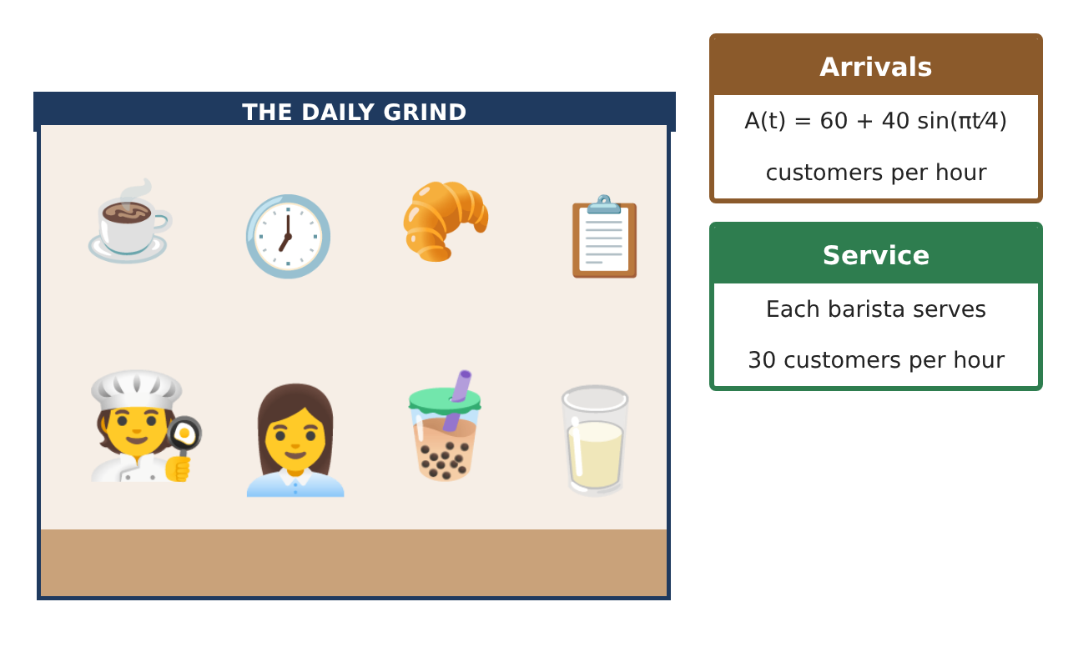
Learning Goals
- I can apply both parts of the FTC to accumulation models.
- I can analyze a function defined by an integral (extrema, concavity).
- I can use average value and net change to make decisions.
Project Timeline
When | What you will do
Day 1 | Accumulation Analysis
Day 2 | Realistic Line
Day 3 | Optimization & Report
Final | Rush-Hour Staffing Plan + reflection
Part 1: Accumulation Analysis
Day 1 · g(t) = ∫₀ᵗ (A(x) − 90) dx, 0 ≤ t ≤ 4.
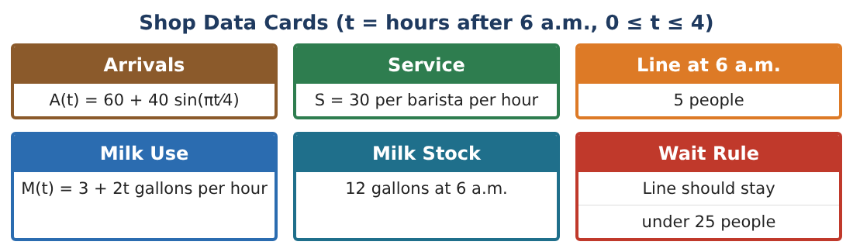
1. Find g′(t) and g″(t).

2. Find the critical points of g and classify them.

3. Find the inflection point of g and interpret.

4. Evaluate g(4) exactly.

Part 2: Realistic Line
Day 2 · The line cannot be negative.
5. Starting with 5 people at 6 a.m. and 3 baristas, when does the line first empty? (Use L(t) = 5 + g(t).)

6. After the line empties it stays 0 until A(t) > 90 at t ≈ 1.08. Find the line length at its peak (t ≈ 2.92).

7. Find the maximum number of baristas that would still let a line form at the peak.

8. Find the average line length from 1.08 to 2.92 hours using technology.

Part 3: Optimization & Report
Day 3 · Each barista costs $22 per hour; each person in line costs the shop about $0.50 per minute in lost sales.
9. Compare total cost for 3 baristas vs. 4 baristas from 6 to 10 a.m.

10. Find $\frac{d}{dx}$ ∫ₓ^(3x) (3 + 2u) du.

11. Write the staffing plan with a schedule by hour, justified with the FTC.

Final Product: Rush-Hour Staffing Plan
Your final product must include:
- Accumulation function analysis
- Realistic line model
- Peak line and staffing threshold
- Cost comparison
- Staffing report
Reflection
R1. Why does a function defined by an integral have its maximum where the integrand changes sign?

R2. How did the real-world constraint (no negative line) change the model?

Scoring Rubric
Criteria | 4 – Exceeds | 3 – Meets | 2 – Approaching | 1 – Beginning
Mathematical Accuracy | All calculations and solutions are correct; answers include units and are checked. | Nearly all work is correct; minor errors do not change conclusions. | Several errors; some conclusions are affected. | Many errors or missing work.
Reasoning & Justification | Clear, complete explanations connect every answer to the situation; uses precise vocabulary. | Explanations are mostly clear and connected to the situation. | Explanations are brief or partly unclear. | Little or no explanation.
Application & Design | Integrals of rates, accumulation functions, and average values are correct and support the staffing decision. Goes beyond the minimum with a creative, realistic choice. | Integrals of rates, accumulation functions, and average values are correct and support the staffing decision. | Design is incomplete or only partly uses the math from the unit. | Design is missing or unrelated to the unit math.
Communication & Presentation | Plan includes models, FTC work, graphs, and a clear staffing schedule. Polished, organized, and visually engaging. | Plan includes models, FTC work, graphs, and a clear staffing schedule. Organized and easy to follow. | Product is missing required parts or is hard to follow. | Product is mostly missing.

