CALCULUS · UNIT 8: DIFFERENTIAL EQUATIONS  Cold Case: Newton’s Cooling  Use differential equations, slope fields, and Euler’s method to solve a mystery with Newton’s Law of Cooling. | CP2  2–3 class periods

Name: ________________________________ Date: ______________ Period: ______
The Scenario
A mug of cocoa was found on the desk of a missing museum key. The temperature of the cocoa was measured twice, and the room temperature is known. Newton’s Law of Cooling says the cocoa cools at a rate proportional to the difference between its temperature and the room.
You will use differential equations to decide when the cocoa was poured and which suspect was in the room at that time.
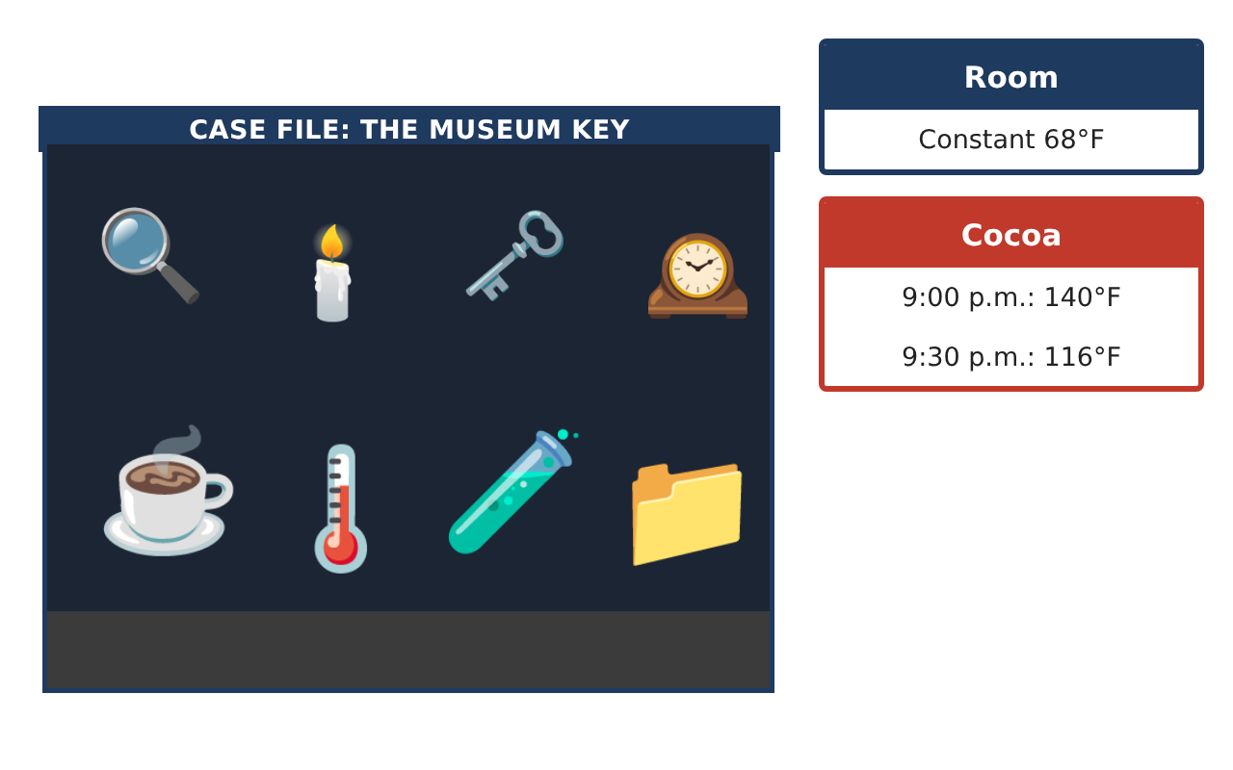
Learning Goals
- I can verify a solution of a differential equation.
- I can read and sketch a slope field.
- I can use an exponential model to solve for time.
Project Timeline
When | What you will do
Day 1 | Rates of Cooling
Day 2 | Slope Field
Day 3 | Solve the Case
Final | Case File Report + reflection
Part 1: Rates of Cooling
Day 1 · Newton’s Law: $\frac{dT}{dt}$ = −k(T − 68).
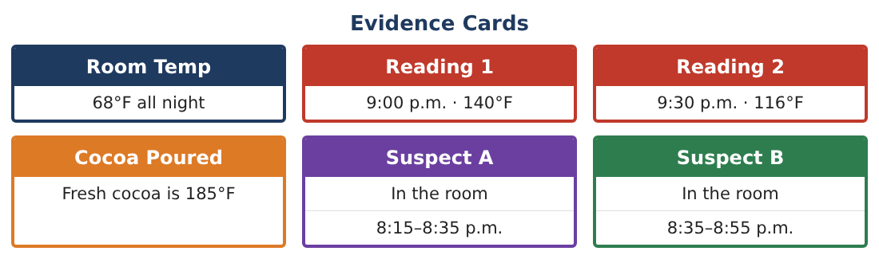
1. Is $\frac{dT}{dt}$ positive or negative when the cocoa is 140°F? What does that mean?

2. Where is the cocoa cooling fastest: at 140°F or 100°F? Why?

3. Verify that T = 68 + 72e^(−kt) satisfies $\frac{dT}{dt}$ = −k(T − 68).
Starter: Differentiate T, then compare with −k(T − 68).

4. What happens to T as t becomes very large?

Part 2: Slope Field
Day 2 · Use k = 0.02 per minute: $\frac{dT}{dt}$ = −0.02(T − 68).
5. Find the slope at T = 140, T = 104, T = 68, and T = 50.

6. Sketch the slope field for 0 ≤ t ≤ 60 and 40 ≤ T ≤ 160. Describe the pattern.

7. Sketch the solution through (0, 140).

8. Explain why the line T = 68 is a solution.

Part 3: Solve the Case
Day 3 · With t = 0 at 9:00 p.m.: T(t) = 68 + 72e^(−kt) and T(30) = 116.
9. Find k.

10. When was the cocoa 185°F? Solve 68 + 72e^(−kt) = 185 (t will be negative).

11. Which suspect was in the room when the cocoa was poured?

Final Product: Case File Report
Your final product must include:
- Verified model
- Slope field with a solution curve
- Value of k
- Time the cocoa was poured
- Case file naming the suspect
Reflection
R1. Why does the cocoa cool more slowly over time?

R2. Why was t negative when solving for 185°F?

Scoring Rubric
Criteria | 4 – Exceeds | 3 – Meets | 2 – Approaching | 1 – Beginning
Mathematical Accuracy | All calculations and solutions are correct; answers include units and are checked. | Nearly all work is correct; minor errors do not change conclusions. | Several errors; some conclusions are affected. | Many errors or missing work.
Reasoning & Justification | Clear, complete explanations connect every answer to the situation; uses precise vocabulary. | Explanations are mostly clear and connected to the situation. | Explanations are brief or partly unclear. | Little or no explanation.
Application & Design | Differential equations are analyzed and solved correctly and used to reach a justified verdict. Goes beyond the minimum with a creative, realistic choice. | Differential equations are analyzed and solved correctly and used to reach a justified verdict. | Design is incomplete or only partly uses the math from the unit. | Design is missing or unrelated to the unit math.
Communication & Presentation | Case file includes the model, slope field, calculations, uncertainty, and verdict. Polished, organized, and visually engaging. | Case file includes the model, slope field, calculations, uncertainty, and verdict. Organized and easy to follow. | Product is missing required parts or is hard to follow. | Product is mostly missing.

