CALCULUS · UNIT 7: APPLICATIONS OF INTEGRALS  Glass Vase Studio  Use area between curves and volumes of revolution to design glass vases and bottles. | CP2  2–3 class periods

Name: ________________________________ Date: ______________ Period: ______
The Scenario
Lumen Glass Studio makes vases, bottles, and paperweights. Each design is a curve spun around an axis, the logo is a region between two curves, and glass is priced by volume.
You will use integrals to calculate the area and volume of each design and price the products.
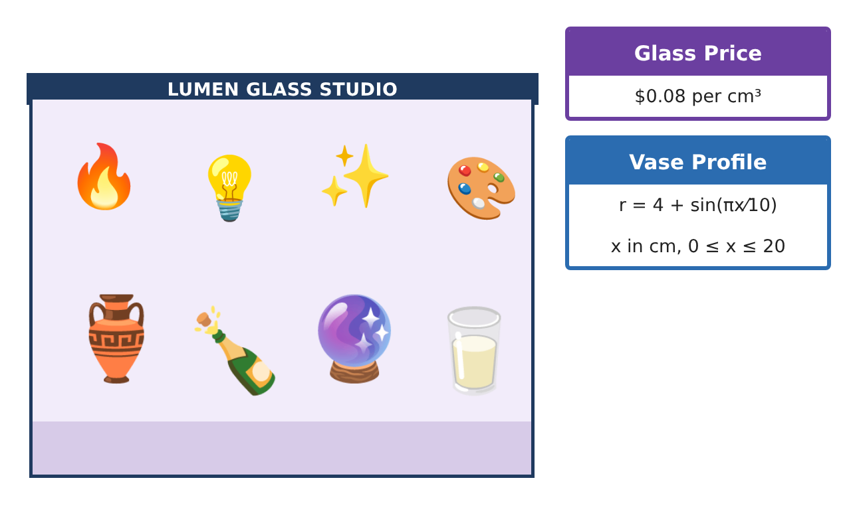
Learning Goals
- I can find the area between two curves.
- I can find a volume with the disc method.
- I can use an integral to find a total from a rate.
Project Timeline
When | What you will do
Day 1 | Studio Logo
Day 2 | Bud Vase
Day 3 | Production
Final | Product Design Portfolio + reflection
Part 1: Studio Logo
Day 1 · The logo is the region between y = √x and y = $\frac{x}{2}$.
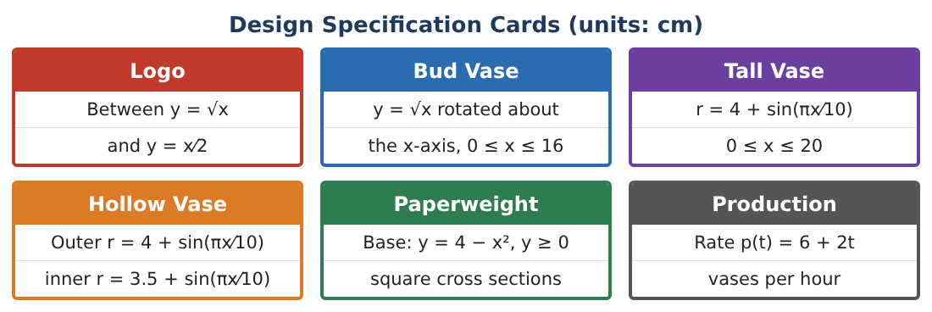
1. Find where the curves intersect.
Starter: Set √x = $\frac{x}{2}$ and square both sides.

2. Which curve is on top between x = 0 and x = 4?

3. Find the area of the logo.

4. The logo is etched at $1.50 per cm². Find the cost.

Part 2: Bud Vase
Day 2 · Rotate y = √x, 0 ≤ x ≤ 16, about the x-axis.
5. Write the volume integral using the disc method.
Starter: V = π∫ [r(x)]² dx

6. Evaluate the volume.

7. Find the cost of the glass at $0.08 per cm³ (solid paperweight version).

8. Why is r(x) = √x the radius?

Part 3: Production
Day 3 · The studio makes p(t) = 6 + 2t vases per hour for 0 ≤ t ≤ 4.
9. Find the total number of vases made in 4 hours.

10. Find the average production rate.

11. Design a logo with two curves of your own and find its area.

Final Product: Product Design Portfolio
Your final product must include:
- Logo area and cost
- Bud vase volume and cost
- Production total and average
- Your own logo
- Design portfolio
Reflection
R1. Why do you subtract the bottom curve from the top curve?

R2. Why does the disc method square the radius?

Scoring Rubric
Criteria | 4 – Exceeds | 3 – Meets | 2 – Approaching | 1 – Beginning
Mathematical Accuracy | All calculations and solutions are correct; answers include units and are checked. | Nearly all work is correct; minor errors do not change conclusions. | Several errors; some conclusions are affected. | Many errors or missing work.
Reasoning & Justification | Clear, complete explanations connect every answer to the situation; uses precise vocabulary. | Explanations are mostly clear and connected to the situation. | Explanations are brief or partly unclear. | Little or no explanation.
Application & Design | Areas and volumes are set up and evaluated correctly and used to price and design products. Goes beyond the minimum with a creative, realistic choice. | Areas and volumes are set up and evaluated correctly and used to price and design products. | Design is incomplete or only partly uses the math from the unit. | Design is missing or unrelated to the unit math.
Communication & Presentation | Portfolio includes diagrams, integrals, results, and prices. Polished, organized, and visually engaging. | Portfolio includes diagrams, integrals, results, and prices. Organized and easy to follow. | Product is missing required parts or is hard to follow. | Product is mostly missing.

