CALCULUS · UNIT 4: APPLICATIONS OF DERIVATIVES  Package Design Studio  Use optimization, related rates, and curve analysis to design packaging for a juice company. | CP1  2–3 class periods

Name: ________________________________ Date: ______________ Period: ______
The Scenario
Fresh Squeeze Juice is launching a new drink and needs packaging that uses as little material as possible. The bottling plant fills cone-shaped tanks, and the marketing team wants to understand the sales curve.
You will use derivatives to design the package, control the filling process, and analyze sales.
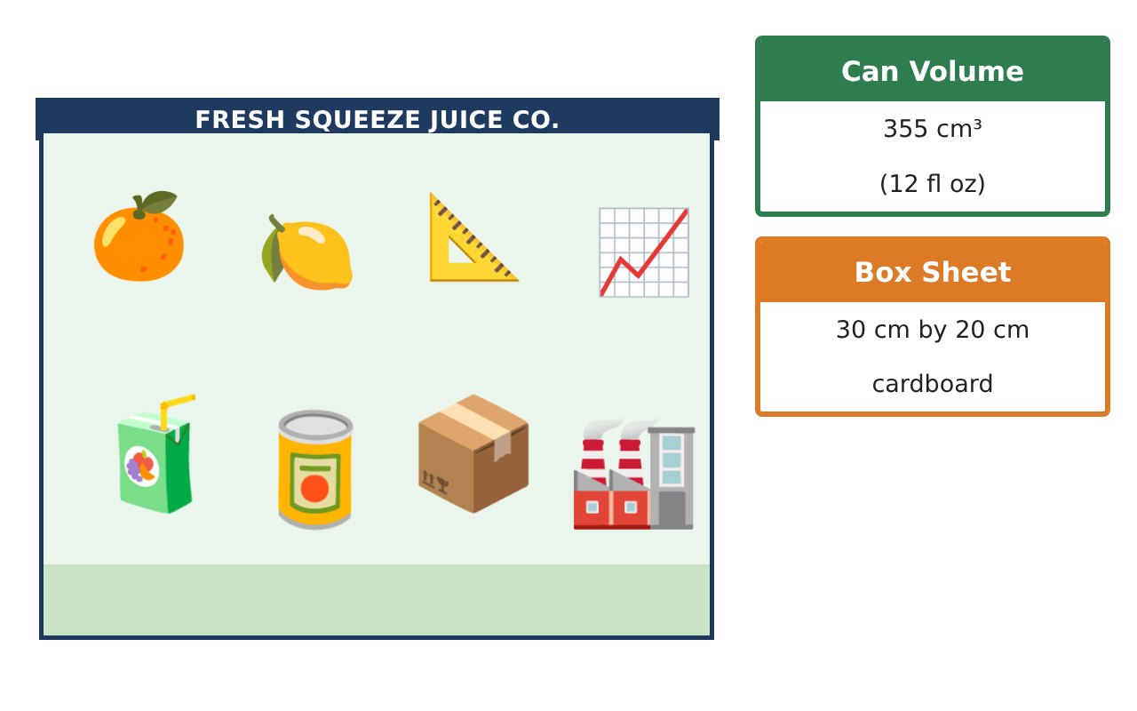
Learning Goals
- I can solve optimization problems and justify extrema.
- I can solve related-rates problems.
- I can analyze a function with first and second derivatives.
Project Timeline
When | What you will do
Day 1 | Optimize the Can
Day 2 | Cone Tank
Day 3 | Sales Analysis
Final | Design Proposal + reflection
Part 1: Optimize the Can
Day 1 · A can holds 355 cm³. Minimize the surface area A = 2πr² + 2πrh.
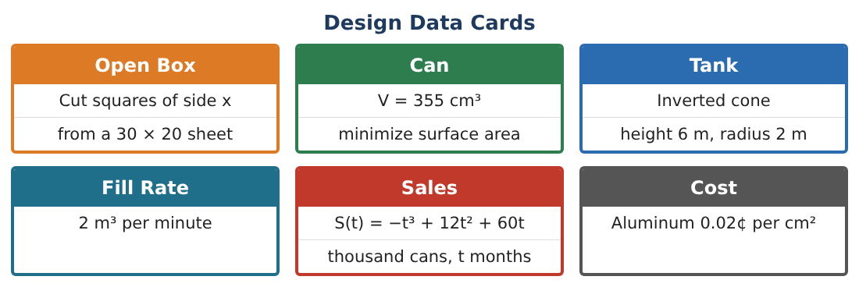
1. Write h in terms of r and A as a function of r alone.

2. Find A′(r) and the critical point.

3. Find h and compare h with the diameter. Justify that this is a minimum.

4. Real cans have r ≈ 3.3 cm and h ≈ 10.4 cm. How much more aluminum do they use (in cm²)?

Part 2: Cone Tank
Day 2 · Inverted cone: height 6 m, radius 2 m. Fill rate 2 m³/min.
5. Use similar triangles to write r in terms of h and V in terms of h.

6. Find $\frac{dh}{dt}$ when h = 3 m.

7. Find how fast the radius of the juice surface is increasing at h = 3.

8. Find how fast the surface area of the juice top is increasing at h = 3.

Part 3: Sales Analysis
Day 3 · S(t) = −t³ + 12t² + 60t, 0 ≤ t ≤ 12.
9. Find intervals of increase/decrease and concavity, and the inflection point.

10. Interpret the inflection point for the marketing team.

11. Use the MVT on [0, 10] to show that sales grew at exactly 80 thousand cans/month at some time. Find it.

Final Product: Design Proposal
Your final product must include:
- Optimal can with justification and cost comparison
- Cone-tank related rates
- Full sales curve analysis
- MVT application
- Design proposal
Reflection
R1. Why do real cans not use the optimal shape?

R2. What is the difference between where S is maximum and where S′ is maximum?

Scoring Rubric
Criteria | 4 – Exceeds | 3 – Meets | 2 – Approaching | 1 – Beginning
Mathematical Accuracy | All calculations and solutions are correct; answers include units and are checked. | Nearly all work is correct; minor errors do not change conclusions. | Several errors; some conclusions are affected. | Many errors or missing work.
Reasoning & Justification | Clear, complete explanations connect every answer to the situation; uses precise vocabulary. | Explanations are mostly clear and connected to the situation. | Explanations are brief or partly unclear. | Little or no explanation.
Application & Design | Optimization, related rates, and curve analysis are set up, solved, and justified correctly. Goes beyond the minimum with a creative, realistic choice. | Optimization, related rates, and curve analysis are set up, solved, and justified correctly. | Design is incomplete or only partly uses the math from the unit. | Design is missing or unrelated to the unit math.
Communication & Presentation | Proposal includes diagrams, derivative work, justifications, and recommendations. Polished, organized, and visually engaging. | Proposal includes diagrams, derivative work, justifications, and recommendations. Organized and easy to follow. | Product is missing required parts or is hard to follow. | Product is mostly missing.

