ALGEBRA 1 · UNIT 6: SYSTEMS OF EQUATIONS AND INEQUALITIES  Drone Delivery Zones  Map delivery zones with inequalities so every house gets its package. | CP1  2–3 class periods

Name: ________________________________ Date: ______________ Period: ______
The Scenario
SkyDrop, a new drone delivery company, has launched in the town of Riverton. Each drone covers a zone, and every zone is the solution region of an inequality on the town's coordinate map.
Customers are complaining that some houses never get deliveries! Your team will figure out which houses are in each zone, find the gaps, and design new zones so that every house is served.
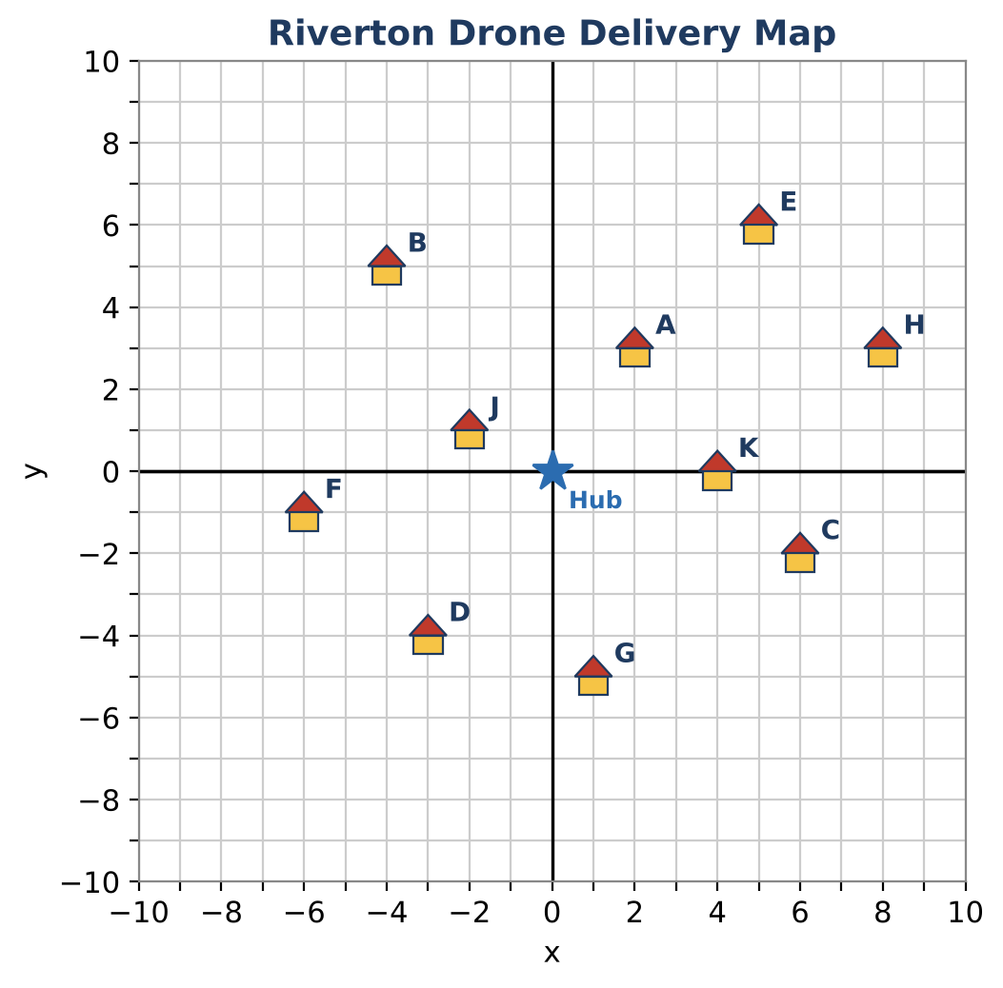
Learning Goals
- I can write a linear inequality from its graph.
- I can find points that satisfy two inequalities at once.
- I can design inequalities whose boundaries pass through chosen points.
Project Timeline
When | What you will do
Day 1 | Read the Zones
Day 2 | No-Fly Rules
Day 3 | Design Full Coverage
Final | Delivery Zone Map + reflection

Part 1: Read the Zones
Day 1 · Use the Two Delivery Zones graph.
1. Write the inequality for Zone P (blue). Explain how you chose the symbol.
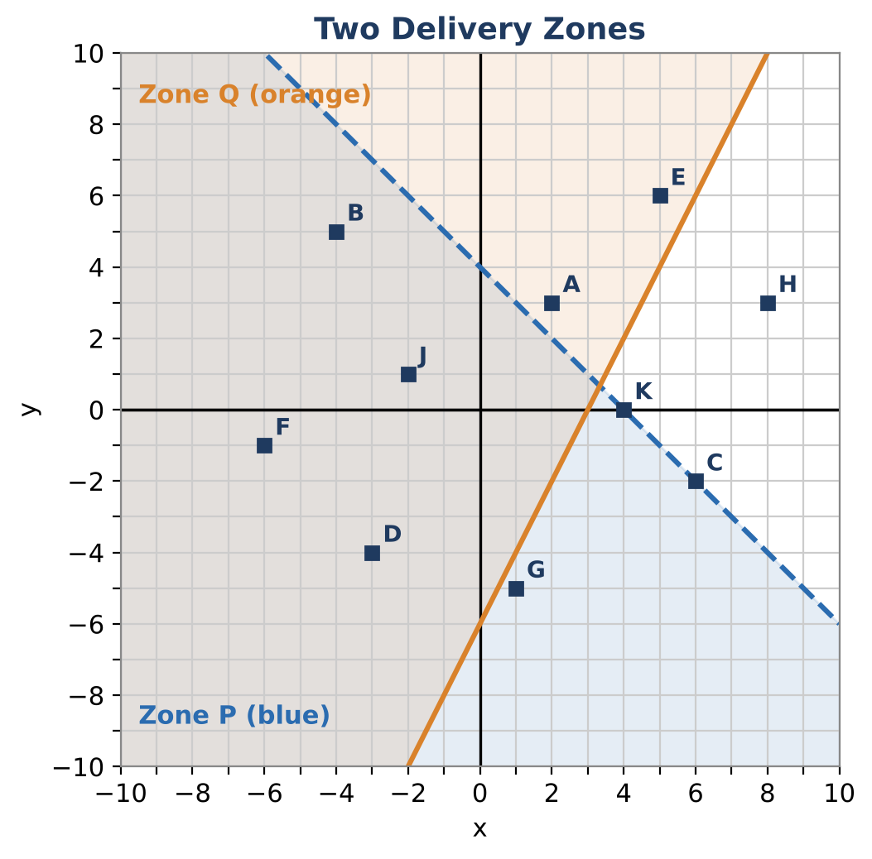

2. Write the inequality for Zone Q (orange).

3. Which houses are in BOTH zones? Show your checks.

4. Houses C and K lie exactly on the boundary of Zone P. Are they served by Zone P? Explain.

Part 2: No-Fly Rules
Day 2 · Riverton adds two rules. Graph each on the town map.
5. Drones may not fly over the stadium, which is everywhere with y > 7. Write the inequality for where drones may fly and graph it.
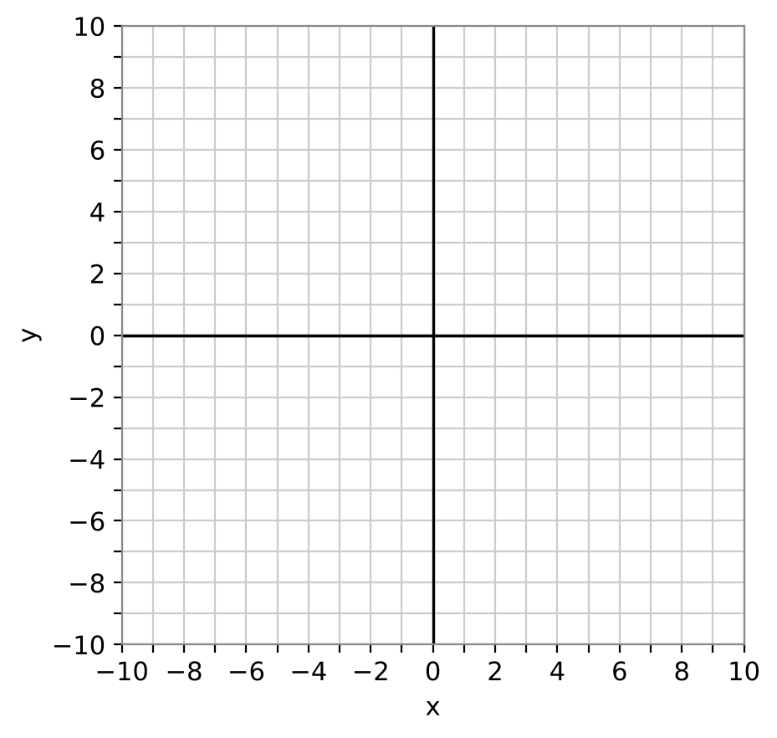

6. A drone flies along the river path from (−6, −9) to (3, 9). Write the equation of the river line, then write the inequality for the region to the right of (below) the river.

7. Which houses are on the right side of the river? Show your checks.

8. Write an inequality that describes houses with x-coordinates between −5 and 5. Which houses are in that strip?

Part 3: Design Full Coverage
Day 3 · Design a new set of zones so every house is served.
9. Design two new zones. Each boundary must pass through two houses or the hub (0, 0). Write each inequality.

10. Graph your zones and make a table showing each house's zone(s).

11. Explain one choice of solid vs. dashed line in your design.

Final Product: Delivery Zone Map
Your final product must include:
- Inequalities for Zones P and Q
- The river and stadium rules graphed
- Two new zones with boundaries through chosen points
- A coverage table for every house
- A map poster with a legend
Reflection
R1. How do you choose the inequality symbol from a graph?

R2. What changes when a zone's inequality is solved for y versus left in standard form?

Scoring Rubric
Criteria | 4 – Exceeds | 3 – Meets | 2 – Approaching | 1 – Beginning
Mathematical Accuracy | All calculations and solutions are correct; answers include units and are checked. | Nearly all work is correct; minor errors do not change conclusions. | Several errors; some conclusions are affected. | Many errors or missing work.
Reasoning & Justification | Clear, complete explanations connect every answer to the situation; uses precise vocabulary. | Explanations are mostly clear and connected to the situation. | Explanations are brief or partly unclear. | Little or no explanation.
Application & Design | New zones cover every unserved house, with correct boundaries and shading. Goes beyond the minimum with a creative, realistic choice. | New zones cover every unserved house, with correct boundaries and shading. | Design is incomplete or only partly uses the math from the unit. | Design is missing or unrelated to the unit math.
Communication & Presentation | Zone map shows every zone as a graphed inequality, lists the houses each zone serves, and shows full coverage. Polished, organized, and visually engaging. | Zone map shows every zone as a graphed inequality, lists the houses each zone serves, and shows full coverage. Organized and easy to follow. | Product is missing required parts or is hard to follow. | Product is mostly missing.

