ALGEBRA 1 · UNIT 6: SYSTEMS OF EQUATIONS AND INEQUALITIES  Drone Delivery Zones  Map delivery zones with inequalities so every house gets its package. | CP2  2–3 class periods

Name: ________________________________ Date: ______________ Period: ______
The Scenario
SkyDrop, a new drone delivery company, has launched in the town of Riverton. Each drone covers a zone, and every zone is the solution region of an inequality on the town's coordinate map.
Customers are complaining that some houses never get deliveries! Your team will figure out which houses are in each zone, find the gaps, and design new zones so that every house is served.
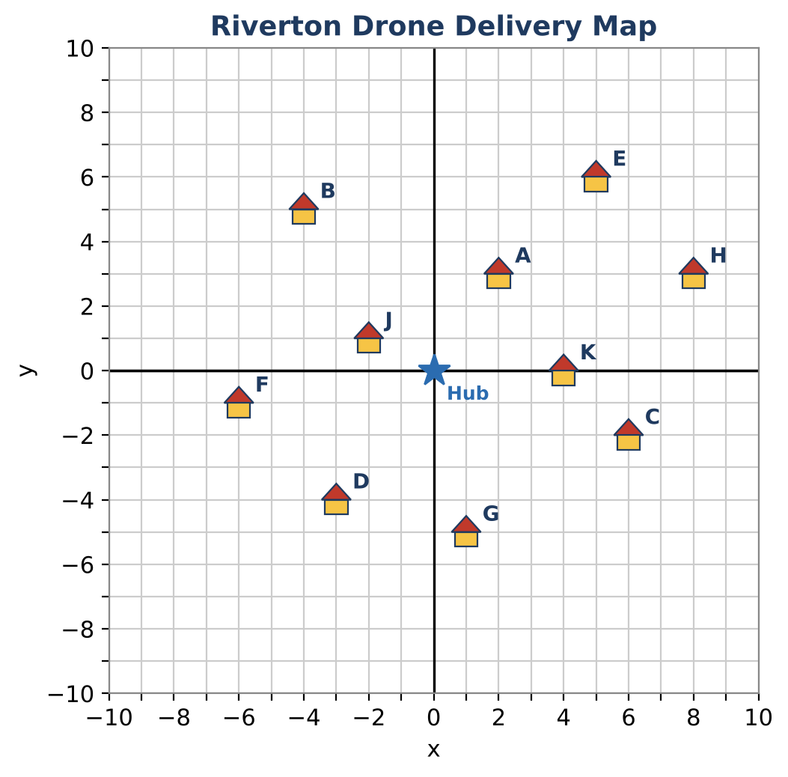
Learning Goals
- I can test whether a point is a solution of an inequality.
- I can graph linear inequalities, including vertical lines.
- I can write a new inequality that covers chosen points.
Project Timeline
When | What you will do
Day 1 | Zone 1
Day 2 | More Zones
Day 3 | Fill the Gaps
Final | Delivery Zone Map + reflection

Part 1: Zone 1
Day 1 · Drone Red serves Zone 1: y ≥ x − 2.
1. Is house A (2, 3) in Zone 1? Substitute to check.
Starter: Is 3 ≥ 2 − 2 true?

2. Test every house. Write yes or no.
House | A | B | C | D | E | F | G | H | J | K
In Zone 1?

3. Graph Zone 1 on the town map. Use a solid or dashed line and shade.

4. Do your graph and table agree? Explain.

Part 2: More Zones
Day 2 · Drone Blue serves Zone 2: y < −½x + 1. Drone Green serves Zone 3: x ≤ −3.
5. Is the boundary of Zone 2 solid or dashed? House C (6, −2) is exactly on this line. Does it get a delivery from Drone Blue?

6. List the houses in Zone 2. Show your checks.

7. Graph Zone 3 on the grid. Which houses are in Zone 3?
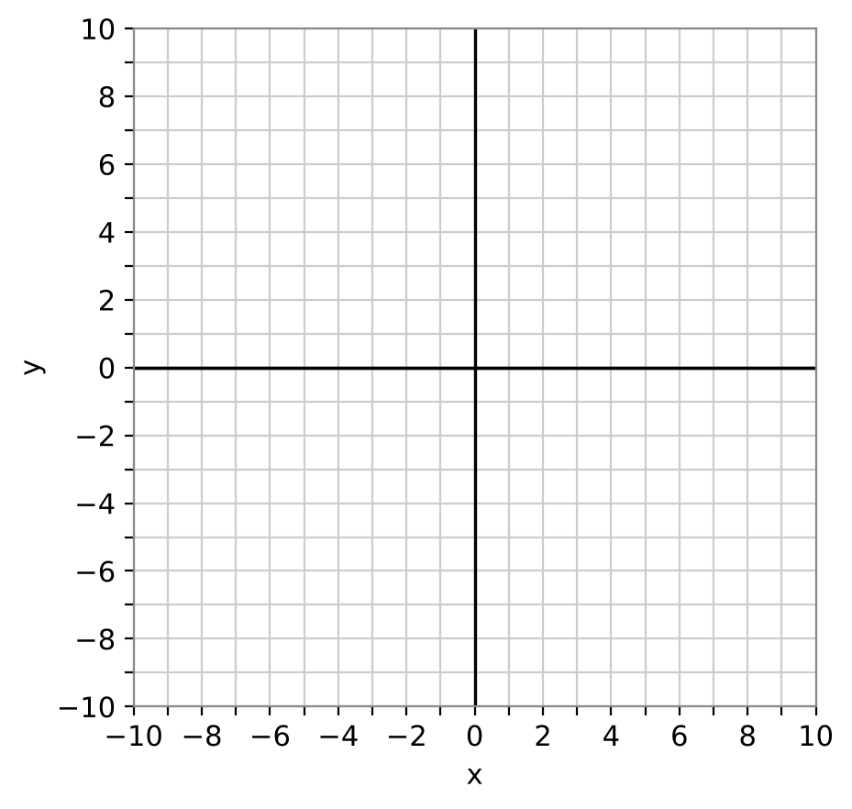

8. Which houses are not in any zone?

Part 3: Fill the Gaps
Day 3 · Design Zone 4 so that every unserved house gets deliveries.
9. Write one inequality for Zone 4. Show that each unserved house makes it true.

10. Graph Zone 4 and explain why you chose a solid or dashed line.

11. Make a final list showing which zone(s) serve each house.

Final Product: Delivery Zone Map
Your final product must include:
- Town map with all four zones graphed in different colors
- Table showing which zone serves each house
- Your Zone 4 inequality with checks
- A short message to SkyDrop customers
Reflection
R1. How does a test point help you decide where to shade?

R2. Why did house C not get a delivery from Drone Blue?

Scoring Rubric
Criteria | 4 – Exceeds | 3 – Meets | 2 – Approaching | 1 – Beginning
Mathematical Accuracy | All calculations and solutions are correct; answers include units and are checked. | Nearly all work is correct; minor errors do not change conclusions. | Several errors; some conclusions are affected. | Many errors or missing work.
Reasoning & Justification | Clear, complete explanations connect every answer to the situation; uses precise vocabulary. | Explanations are mostly clear and connected to the situation. | Explanations are brief or partly unclear. | Little or no explanation.
Application & Design | New zones cover every unserved house, with correct boundaries and shading. Goes beyond the minimum with a creative, realistic choice. | New zones cover every unserved house, with correct boundaries and shading. | Design is incomplete or only partly uses the math from the unit. | Design is missing or unrelated to the unit math.
Communication & Presentation | Zone map shows every zone as a graphed inequality, lists the houses each zone serves, and shows full coverage. Polished, organized, and visually engaging. | Zone map shows every zone as a graphed inequality, lists the houses each zone serves, and shows full coverage. Organized and easy to follow. | Product is missing required parts or is hard to follow. | Product is mostly missing.

