ALGEBRA 1 · UNIT 6: SYSTEMS OF EQUATIONS AND INEQUALITIES  Drone Delivery Zones  Map delivery zones with inequalities so every house gets its package. | Honors  2–3 class periods

Name: ________________________________ Date: ______________ Period: ______
The Scenario
SkyDrop, a new drone delivery company, has launched in the town of Riverton. Each drone covers a zone, and every zone is the solution region of an inequality on the town's coordinate map.
Customers are complaining that some houses never get deliveries! Your team will figure out which houses are in each zone, find the gaps, and design new zones so that every house is served.
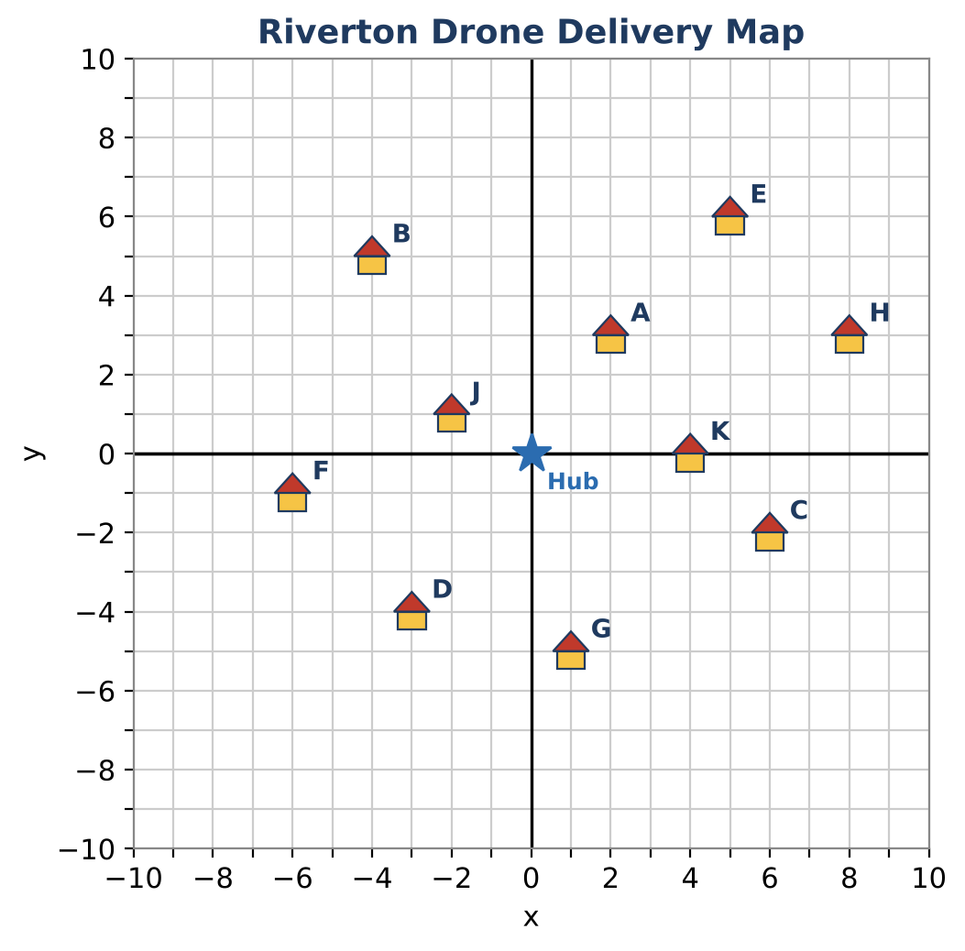
Learning Goals
- I can write a system of inequalities from the vertices of a region.
- I can model a distance limit with absolute value inequalities.
- I can design a region that includes some points and excludes others.
Project Timeline
When | What you will do
Day 1 | The Express Zone
Day 2 | Battery Range
Day 3 | Design a Second Hub
Final | Delivery Zone Map + reflection

Part 1: The Express Zone
Day 1 · The Express Zone is the triangle with vertices (−2, −2), (6, −2), and (2, 6), boundaries included.
1. Write the equation of each side of the triangle.
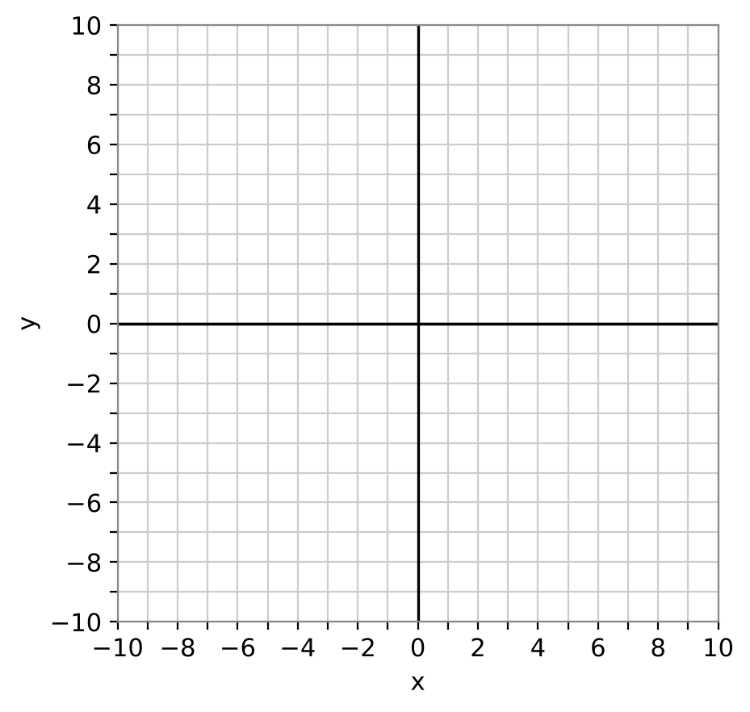

2. Write a system of three inequalities for the Express Zone. Use a test point to choose each symbol.

3. Which houses are in the Express Zone? Show your checks.

4. Write a system for the same triangle with the boundaries NOT included. Which house changes?

Part 2: Battery Range
Day 2 · Drones fly only along streets (horizontal and vertical). From the hub (0, 0), the trip to (x, y) is |x| + |y| blocks. Batteries allow at most 8 blocks.
5. Write the battery rule as an inequality. Test houses A, B, and C.

6. In Quadrant I, |x| + |y| ≤ 8 becomes x + y ≤ 8. Write the inequality for each of the other three quadrants.

7. Graph the region |x| + |y| ≤ 8. What shape is it? List every house inside it.

8. Which houses are inside the battery range but outside the Express Zone?

Part 3: Design a Second Hub
Day 3 · SkyDrop will build a second hub so every house is within 8 blocks of a hub.
9. Choose a location (h, k) for the new hub. Write its battery range as |x − h| + |y − k| ≤ 8.

10. Show that every house is within range of at least one hub.

11. Graph both diamonds and explain how you chose (h, k).

Final Product: Delivery Zone Map
Your final product must include:
- The Express Zone system and graph
- The battery-range diamond with its four inequalities
- A coverage table for both hubs
- Second-hub design with justification
- A final service map with legend
Reflection
R1. How do four linear inequalities combine to make the diamond |x| + |y| ≤ 8?

R2. How did you use the houses that were farthest from the first hub to choose the second hub?

Scoring Rubric
Criteria | 4 – Exceeds | 3 – Meets | 2 – Approaching | 1 – Beginning
Mathematical Accuracy | All calculations and solutions are correct; answers include units and are checked. | Nearly all work is correct; minor errors do not change conclusions. | Several errors; some conclusions are affected. | Many errors or missing work.
Reasoning & Justification | Clear, complete explanations connect every answer to the situation; uses precise vocabulary. | Explanations are mostly clear and connected to the situation. | Explanations are brief or partly unclear. | Little or no explanation.
Application & Design | New zones cover every unserved house, with correct boundaries and shading. Goes beyond the minimum with a creative, realistic choice. | New zones cover every unserved house, with correct boundaries and shading. | Design is incomplete or only partly uses the math from the unit. | Design is missing or unrelated to the unit math.
Communication & Presentation | Zone map shows every zone as a graphed inequality, lists the houses each zone serves, and shows full coverage. Polished, organized, and visually engaging. | Zone map shows every zone as a graphed inequality, lists the houses each zone serves, and shows full coverage. Organized and easy to follow. | Product is missing required parts or is hard to follow. | Product is mostly missing.

