ALGEBRA 1 · UNIT 2: SOLVING LINEAR EQUATIONS  Escape Room Designer  Crack a chain of equation locks, then build your own escape room. | CP1  2–3 class periods

Name: ________________________________ Date: ______________ Period: ______
The Scenario
The drama club is turning a classroom into an escape room called The Vault, and they need puzzle designers. Each lock opens with a number code, and every code is the solution to an equation.
The catch: the locks are chained. The answer to Lock 1 is used inside the equation for Lock 2, and so on. One wrong answer and every lock after it stays shut! First you will break out of The Vault. Then you will design a room of your own.
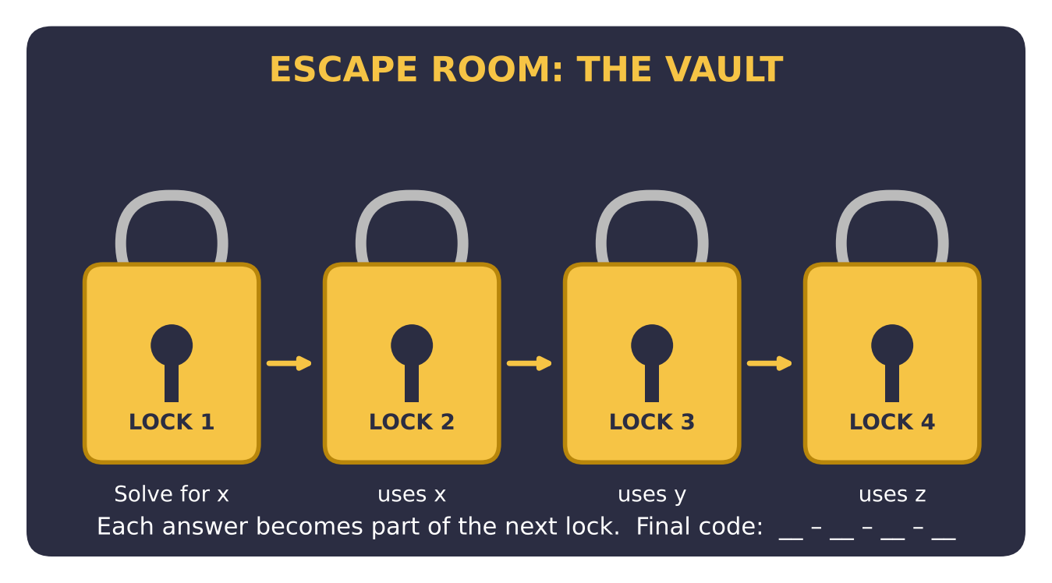
Learning Goals
- I can solve multi-step equations with fractions, parentheses, and variables on both sides.
- I can recognize equations with no solution or infinitely many solutions.
- I can write equations from word problems and design equations with a given solution.
Project Timeline
When | What you will do
Day 1 | Break Out of The Vault
Day 2 | Word Locks
Day 3 | Design Your Own Room
Final | Escape Room Kit + reflection

Part 1: Break Out of The Vault
Day 1 · Solve each lock in order. Each code is used in the next lock.
1. Lock 1: Solve 4(x − 3) + 2 = 2x + 8.

2. Lock 2: Let A be the Lock 1 code. Solve ½(y + A) = y − 6.

3. Lock 3: Let B be the Lock 2 code. Solve 3(z − 2) − (z + 4) = B − 7.

4. Lock 4 is a decoy. Only one of these locks has a single code: (a) 5w − 2(w + 4) = 3w + 1, (b) 6w + 4 = 2(3w + 2), (c) 7w − 12 = 3w + 16. Solve all three, describe each result, and give the real code.

5. Write the final code.

Part 2: Word Locks
Day 2 · Write an equation for each lock, solve, and check.
6. The sum of three consecutive integers is 72. The code is the smallest integer.

7. The game master is 3 times as old as her nephew. In 12 years, she will be twice as old as he will be. How old is each person now?

8. A rectangular trapdoor has a length 4 inches more than twice its width. Its perimeter is 50 inches. Find its dimensions.

9. A teammate solved 6 − 2(x + 5) = 3x + 1 and got x = 1. Without solving, show how substitution proves the answer is wrong. Then solve correctly.

Part 3: Design Your Own Room
Day 3 · Build a four-lock room for another group to solve.
10. Write a theme and story. Choose your codes first.

11. Build four chained locks: one with fractions, one with variables on both sides, one word problem, and one decoy set (one no-solution lock, one identity, one real lock).
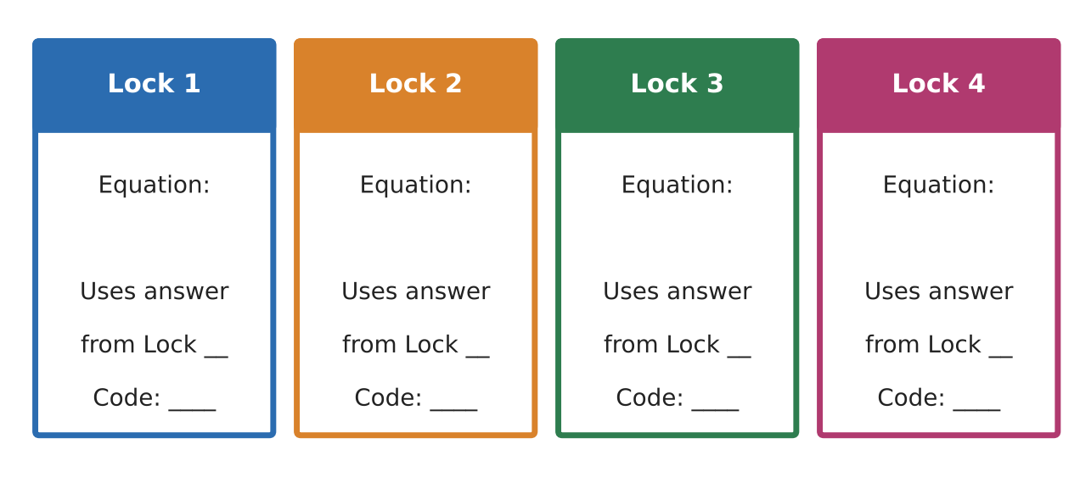
12. Write a full answer key. Trade rooms with another group, then record their time and any lock that caused trouble. Revise one lock.

Final Product: Escape Room Kit
Your final product must include:
- Room name and story
- Four lock cards including a decoy set
- Answer key with complete steps and checks
- Testing log and a revised lock with an explanation
Reflection
R1. How can you build an equation backwards so that it has the solution you want?

R2. Explain how you can tell from the final step whether an equation has no solution, one solution, or infinitely many.

Scoring Rubric
Criteria | 4 – Exceeds | 3 – Meets | 2 – Approaching | 1 – Beginning
Mathematical Accuracy | All calculations and solutions are correct; answers include units and are checked. | Nearly all work is correct; minor errors do not change conclusions. | Several errors; some conclusions are affected. | Many errors or missing work.
Reasoning & Justification | Clear, complete explanations connect every answer to the situation; uses precise vocabulary. | Explanations are mostly clear and connected to the situation. | Explanations are brief or partly unclear. | Little or no explanation.
Application & Design | Locks are correctly chained and meet every equation requirement. Goes beyond the minimum with a creative, realistic choice. | Locks are correctly chained and meet every equation requirement. | Design is incomplete or only partly uses the math from the unit. | Design is missing or unrelated to the unit math.
Communication & Presentation | Escape room kit includes a story, lock cards, an answer key, and test results. Polished, organized, and visually engaging. | Escape room kit includes a story, lock cards, an answer key, and test results. Organized and easy to follow. | Product is missing required parts or is hard to follow. | Product is mostly missing.

