ALGEBRA 1 · UNIT 2: SOLVING LINEAR EQUATIONS  Escape Room Designer  Crack a chain of equation locks, then build your own escape room. | CP2  2–3 class periods

Name: ________________________________ Date: ______________ Period: ______
The Scenario
The drama club is turning a classroom into an escape room called The Vault, and they need puzzle designers. Each lock opens with a number code, and every code is the solution to an equation.
The catch: the locks are chained. The answer to Lock 1 is used inside the equation for Lock 2, and so on. One wrong answer and every lock after it stays shut! First you will break out of The Vault. Then you will design a room of your own.
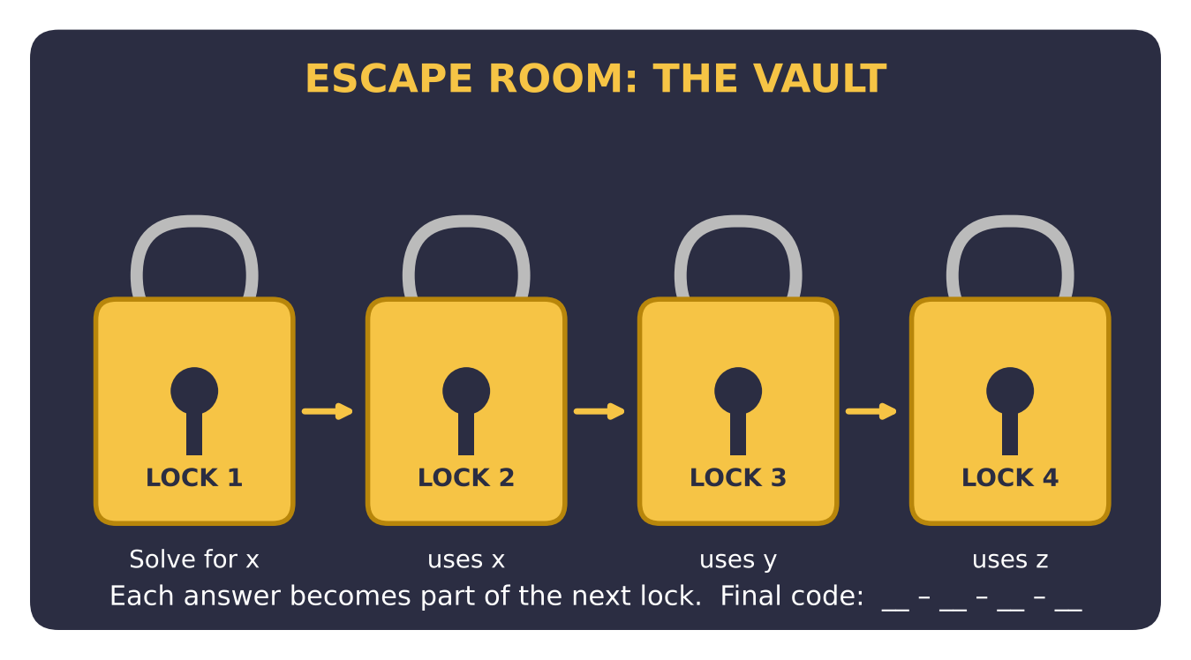
Learning Goals
- I can solve one-step, two-step, and multi-step equations.
- I can use the answer from one equation inside another.
- I can create my own equations that have a chosen solution.
Project Timeline
When | What you will do
Day 1 | Break Out of The Vault
Day 2 | Word Locks & Trick Locks
Day 3 | Design Your Own Room
Final | Escape Room Kit + reflection

Part 1: Break Out of The Vault
Day 1 · Solve each lock in order. Write the code in the box before moving on.
1. Lock 1: Solve 3x + 7 = 31.

2. Lock 2: Let A be your Lock 1 answer. Solve 2(y − A) = 10.
Starter: Replace A with your Lock 1 code first.

3. Lock 3: Let B be your Lock 2 answer. Solve 5z − B = 2z + 2.

4. Lock 4: Use your Lock 3 answer for z. Solve (w + z) ÷ 3 = 4.

5. Write the final four-number code. Check one of your answers by substituting it back into its equation.

Part 2: Word Locks & Trick Locks
Day 2 · These locks are written in words. Write an equation, then solve.
6. The keypad lock says: "Triple my number, then subtract 4. The result is 20." What is the number?

7. The clock lock: "Twice the hour plus 3 equals the hour plus 10." What hour opens the lock?

8. A teammate solved 4(x − 2) = 20 like this: 4x − 2 = 20, 4x = 22, x = 5.5. Find the mistake and solve correctly.

9. Two trick locks: (a) 2(x + 3) = 2x + 6 and (b) 2x + 5 = 2x + 1. Simplify each. Which lock opens with ANY number? Which lock can NEVER open?

Part 3: Design Your Own Room
Day 3 · Use the lock template to build a three-lock room for another group.
10. Pick a theme and write a 2–3 sentence story for your escape room.

11. Choose your three codes first. Then build: Lock 1 = a two-step equation; Lock 2 = an equation with parentheses that uses the Lock 1 code; Lock 3 = an equation with variables on both sides.
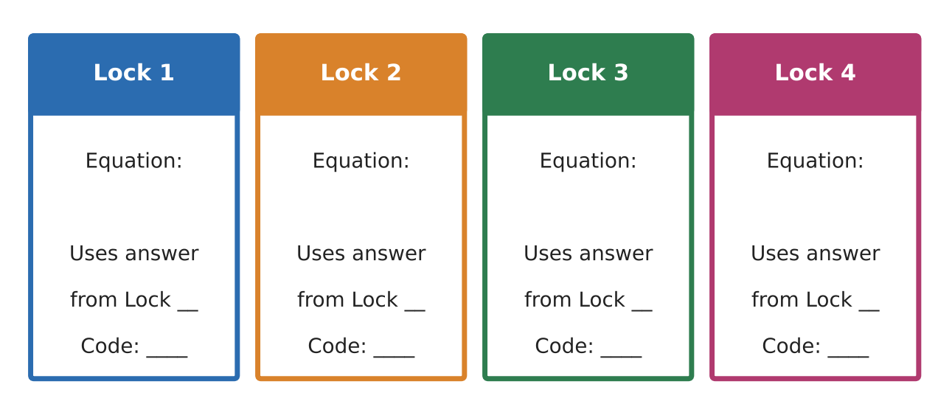
12. Write your answer key and show that each code checks. Then trade with another group and record how long it took them.

Final Product: Escape Room Kit
Your final product must include:
- A room name and short story
- Three lock cards (equations only on the front)
- An answer key with every step shown
- Test results from another group and one change you made
Reflection
R1. How did the chain of locks help you know when you made a mistake?

R2. What is the difference between a lock with no solution and a lock with every number as a solution?

Scoring Rubric
Criteria | 4 – Exceeds | 3 – Meets | 2 – Approaching | 1 – Beginning
Mathematical Accuracy | All calculations and solutions are correct; answers include units and are checked. | Nearly all work is correct; minor errors do not change conclusions. | Several errors; some conclusions are affected. | Many errors or missing work.
Reasoning & Justification | Clear, complete explanations connect every answer to the situation; uses precise vocabulary. | Explanations are mostly clear and connected to the situation. | Explanations are brief or partly unclear. | Little or no explanation.
Application & Design | Locks are correctly chained and meet every equation requirement. Goes beyond the minimum with a creative, realistic choice. | Locks are correctly chained and meet every equation requirement. | Design is incomplete or only partly uses the math from the unit. | Design is missing or unrelated to the unit math.
Communication & Presentation | Escape room kit includes a story, lock cards, an answer key, and test results. Polished, organized, and visually engaging. | Escape room kit includes a story, lock cards, an answer key, and test results. Organized and easy to follow. | Product is missing required parts or is hard to follow. | Product is mostly missing.

