ALGEBRA 1 · UNIT 2: SOLVING LINEAR EQUATIONS  Escape Room Designer  Crack a chain of equation locks, then build your own escape room. | Honors  2–3 class periods

Name: ________________________________ Date: ______________ Period: ______
The Scenario
The drama club is turning a classroom into an escape room called The Vault, and they need puzzle designers. Each lock opens with a number code, and every code is the solution to an equation.
The catch: the locks are chained. The answer to Lock 1 is used inside the equation for Lock 2, and so on. One wrong answer and every lock after it stays shut! First you will break out of The Vault. Then you will design a room of your own.
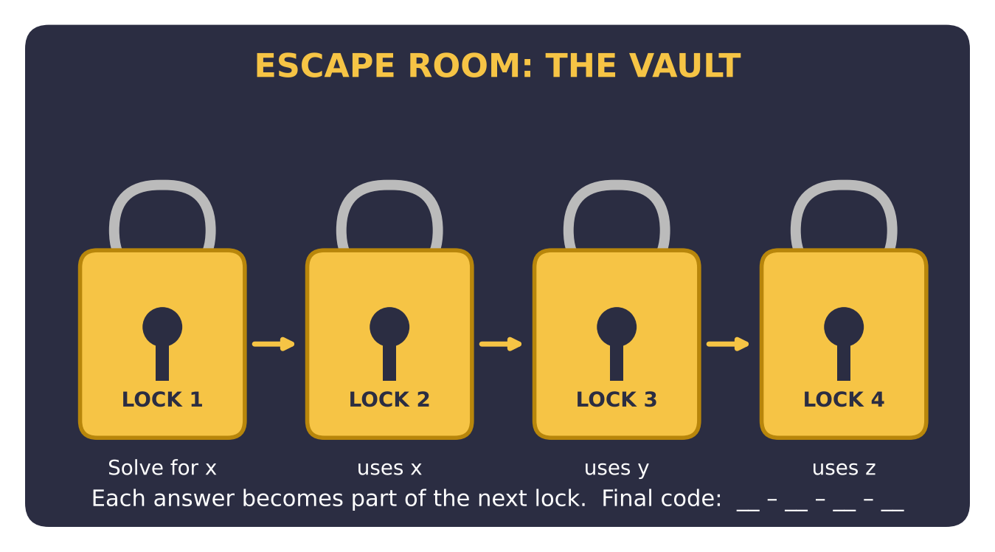
Learning Goals
- I can solve rational and literal equations and explain each step.
- I can choose parameters so an equation has one, none, or infinitely many solutions.
- I can prove a general rule about linear equations and design puzzles that use it.
Project Timeline
When | What you will do
Day 1 | Break Out of The Vault
Day 2 | Advanced Locks
Day 3 | Design Your Own Room
Final | Escape Room Kit + reflection

Part 1: Break Out of The Vault
Day 1 · Solve each lock in order. Each code feeds the next lock.
1. Lock 1: Solve (2x + 1) ÷ 3 = (x + 4) ÷ 2.

2. Lock 2: The lock uses the formula d = rt + k. Solve the formula for t. Then find t when d = 94, r = 7, and k is your Lock 1 code.

3. Lock 3 (parameter lock): The code is the value of k that makes 3(x − k) = 3x − 12 true for every x. Find k and explain.

4. Lock 4: Solve 0.4(5w − 20) = 1.5w − 2 + 0.25w. Then write the four-number code.

Part 2: Advanced Locks
Day 2 · Write and solve an equation for each lock.
5. The coin vault holds 30 coins, all dimes and quarters, worth $5.10. The code is the number of quarters.

6. Guard A leaves the door walking 2 m per second. Guard B leaves the same door 9 seconds later, walking 3.5 m per second in the same direction. How many seconds after Guard B starts does B catch A?

7. For what value of m does mx + 5 = 4x − 1 have no solution? Explain why.

8. Prove: ax + b = cx + d has exactly one solution when a ≠ c. Find a formula for that solution.

Part 3: Design Your Own Room
Day 3 · Build a five-lock room for another group.
9. Write a story and pick your codes first. Your five locks must include: a rational equation, a literal equation (solve a formula), a parameter lock, a word problem, and a decoy set.
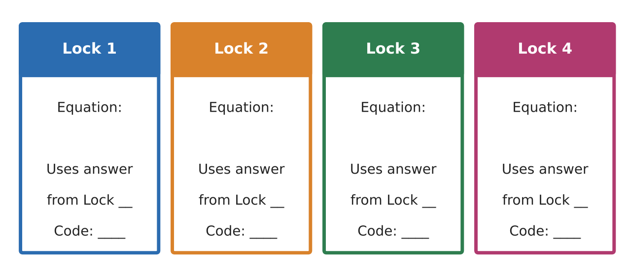
10. Write a full answer key with every step justified (name the property you use).

11. Swap with another group. Record their time and the hardest lock. Revise one lock so that it is more challenging but still has a single integer code, and explain how you guaranteed that.

Final Product: Escape Room Kit
Your final product must include:
- Room story and five lock cards
- Justified answer key (properties named)
- Proof of the one-solution rule used in your parameter lock
- Testing log and revision with explanation
Reflection
R1. How did you use the rule a ≠ c when designing your parameter lock?

R2. Which lock was hardest to design so that its code was an integer? How did you solve that?

Scoring Rubric
Criteria | 4 – Exceeds | 3 – Meets | 2 – Approaching | 1 – Beginning
Mathematical Accuracy | All calculations and solutions are correct; answers include units and are checked. | Nearly all work is correct; minor errors do not change conclusions. | Several errors; some conclusions are affected. | Many errors or missing work.
Reasoning & Justification | Clear, complete explanations connect every answer to the situation; uses precise vocabulary. | Explanations are mostly clear and connected to the situation. | Explanations are brief or partly unclear. | Little or no explanation.
Application & Design | Locks are correctly chained and meet every equation requirement. Goes beyond the minimum with a creative, realistic choice. | Locks are correctly chained and meet every equation requirement. | Design is incomplete or only partly uses the math from the unit. | Design is missing or unrelated to the unit math.
Communication & Presentation | Escape room kit includes a story, lock cards, an answer key, and test results. Polished, organized, and visually engaging. | Escape room kit includes a story, lock cards, an answer key, and test results. Organized and easy to follow. | Product is missing required parts or is hard to follow. | Product is mostly missing.

