ALGEBRA 1 · UNIT 2: SOLVING LINEAR EQUATIONS  Food Truck Startup  Use expressions and equations to plan a profitable festival food truck. | CP1  2–3 class periods

Name: ________________________________ Date: ______________ Period: ______
The Scenario
Your group has been chosen to run a taco truck at the town's summer festival. Before the festival, the town council wants a business plan that shows how many items you must sell to cover your costs and how much money you expect to make.
Every item costs money to make, and you also pay fixed costs that do not change no matter how much you sell. Your job is to model the business with expressions and equations and then pitch your plan.
You sell tacos (t) and burritos (b). Your fixed costs are the $120 booth fee plus a $30 generator rental.
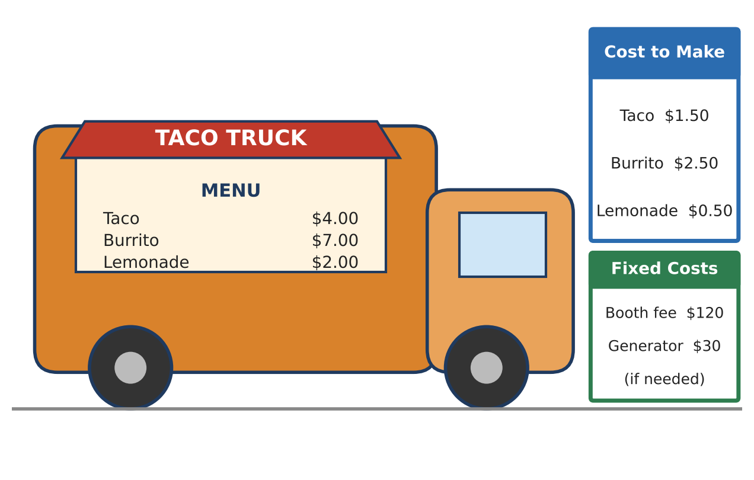
Learning Goals
- I can write and simplify expressions that model a two-item business.
- I can solve multi-step equations, including variables on both sides.
- I can use equations to compare options and make a recommendation.
Project Timeline
When | What you will do
Day 1 | Build the Business Model
Day 2 | Answer the Council's Questions
Day 3 | Face the Competition & Pitch
Final | Food Truck Pitch Poster + reflection

Part 1: Build the Business Model
Day 1 · Use the menu and cost cards to write your model.
1. Write an expression for the total cost C of making t tacos and b burritos (include all fixed costs).

2. Write an expression for the revenue R from selling t tacos and b burritos.

3. Write and simplify an expression for the profit, R − C.

4. Evaluate your profit expression for 30 tacos and 20 burritos. What does the answer tell you?

5. Jordan wrote the profit as 4t + 7b − 150 + 1.50t + 2.50b = 5.50t + 9.50b − 150. Explain Jordan's mistake and how to fix it.

Part 2: Answer the Council's Questions
Day 2 · Write and solve an equation for each question. Round in a way that makes sense.
6. If you sold only tacos, how many would you need to sell to break even?

7. At past festivals, trucks sold twice as many tacos as burritos (t = 2b). Rewrite the profit using only b. Then find how many of each item you must sell to make $420 in profit.

8. Suppose you sell 120 tacos and 60 burritos. What burrito price p would give a profit of exactly $480? (Tacos stay at $4.00.)

Part 3: Face the Competition & Pitch
Day 3 · A rival truck, Burger Barn, has only $90 in fixed costs and makes $2 profit on each burger.
9. Write a profit expression for Burger Barn and one for your truck if you sold only tacos. Write and solve an equation to find when the two trucks have the same profit.

10. Graph both profit expressions on the grid. Who is ahead before the tie point? After?
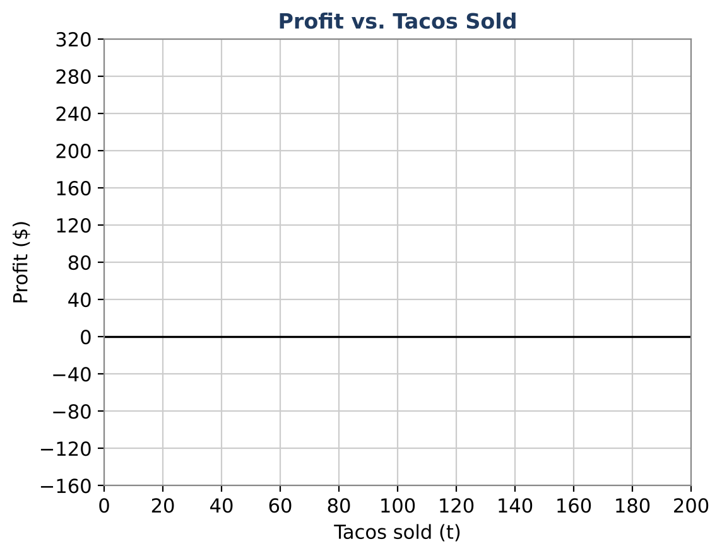

11. Add a third menu item of your own design. Write the new profit expression and find two different combinations of items that would earn $500.

Final Product: Food Truck Pitch Poster
Your final product must include:
- Truck name and a full menu (including your new item)
- The simplified profit expression and what each term means
- Break-even and $420 goal solutions
- The rival comparison graph with the tie point labeled
- A recommendation to the council supported by your equations
Reflection
R1. Explain how the coefficient and the constant in your profit expression connect to the menu and cost cards.

R2. Why might a business owner care about the tie point with a competitor?

Scoring Rubric
Criteria | 4 – Exceeds | 3 – Meets | 2 – Approaching | 1 – Beginning
Mathematical Accuracy | All calculations and solutions are correct; answers include units and are checked. | Nearly all work is correct; minor errors do not change conclusions. | Several errors; some conclusions are affected. | Many errors or missing work.
Reasoning & Justification | Clear, complete explanations connect every answer to the situation; uses precise vocabulary. | Explanations are mostly clear and connected to the situation. | Explanations are brief or partly unclear. | Little or no explanation.
Application & Design | Original menu item has a realistic cost and price with a correct profit equation. Goes beyond the minimum with a creative, realistic choice. | Original menu item has a realistic cost and price with a correct profit equation. | Design is incomplete or only partly uses the math from the unit. | Design is missing or unrelated to the unit math.
Communication & Presentation | Pitch poster shows the menu, profit model, break-even point, and a recommendation. Polished, organized, and visually engaging. | Pitch poster shows the menu, profit model, break-even point, and a recommendation. Organized and easy to follow. | Product is missing required parts or is hard to follow. | Product is mostly missing.

